

|  |  |  |  |
| --- | --- | --- | --- |
| **Qualification** | | **Module Number and Title** | |
| HND in Computing/ HND in Software Engineering(Level 5) | | Programming in PHP | |
| **Student Name & No.** | | **Assessor** | |
| Widana Gamage Avindi Premaratne – ST/HNDCOM/19/15 | | Aruna Indika | |
| **Hand out date** | | | **Submission Date** |
| 00/00/00 | | | 00/00/00 |
| **Assessment type**  Course work | **Duration/Length of**  **Assessment Type**  Practical project/report | | **Weighting of Assessment**  100% |

|  |  |
| --- | --- |
| **Learner declaration** | |
| I certify that the work submitted for this assignment is my own and research sources are fully acknowledged. | |
| |  |  |  |  | | --- | --- | --- | --- | | **Marks Awarded** | | | | | First assessor | |  | | | IV marks | |  | | | Agreed grade | |  | | | Signature of the assessor |  | Date |  | |

**Feedback Form**

**International College of Business & Technology**

**Module:**

**Student: Widana Gamage Avindi Premaratne**

**Assessor:**

**Assignment:**

**Strong features of your work:**

**Areas for improvement:**

**Marks Awarded:**

**Course work**

**Learning outcomes covered**

1. Understand the fundamentals of PHP Programming and its role in web application development.
2. Plan and design database driven web application
3. Implement Database driven web application using PHP
4. Evaluate and test the web application

**Scenario and the Task**

**Assignment Brief.**

Read the following scenario to develop dynamic web application system for given organization and write a report covering the given tasks. The web system documentation also needs to be included according to the given content within the report.

Note that the students would be assessed for the originality effectiveness and quality of the application development.

**Scenario**

The “Success EDU” Education institute is one of the leading institutes who offer HNDs and MBAs. Here students based on different parts of the country engaged in different occupations. Most of the time, they conduct classes during the weekend, for the working students. But, these students face difficulties when submitting assignments because sometimes, they need to submit them during week days. Therefore, the management has decided to implement an online assignment submission system, to combine with their course management system. The students should be able to log in to the system and be able to see submitted and pending assignments with deadlines. If the deadline has been passed, system should not allow the student to submit the assignment.

As a web developer, you need to analyze the system to find out exact requirements and prepare a detailed design of the system. Implement the web application for this system following the tasks given below.

**Web site should full fill bellow mentioned requirements**

* Authentication levels. (ex: Admin levels and user levels)
* Backend functionality (data base)
* Online registration
* Course searching
* Proper error handling.

Note: More functionalities can added with clearly mentioned assumptions

1. Web server and Server-side scripts play major role in web development process. Identify popular server side scripting languages and compare them. Discuss and compare different web server environments. explain what is web server and why it is important **(Marks 10)**
2. The requirements specification document is used to record the user requirements for the web site. Build detailed requirements specification document for the given situation. **(Marks 10)**
3. Design a suitable web solution to meet the given requirements. Provide necessary diagrams including ER diagram and normalized relational schema. Necessary user interfaces to interact with users (**Marks 20** )
4. Implement a database driven web application based on the design (**Marks 10**).
5. Demonstrate the developed system. ***(*Marks 20)**
6. Organizations are always need to [test and evaluate their web-based applications](http://www.testingexcellence.com/web-testing-tips-how-to-test-web-applications/) before the launch Discuss web application testing methods prepare a test plan and possible test cases, test the system according to the test plan, and identify inconsistencies. ***(*Marks 10)**
7. Prepare the documentation covering given tasks. ***(*Marks 20)**

|  |  |
| --- | --- |
| **This submission will be assessed as follows** | **Depth of the task** |
| TASK 1 | Identify popular server side scripting languages and compare them. Compare different web server environments. Explaining what is web server and why it is important. |
| TASK 2 | Detailed requirements specification document using proper format |
| TASK 3 | UML diagram, ER diagram and normalized relational schema. Necessary user interfaces to interact with users |
| TASK 4 | Use of slandered codes ,naming conventions, special features |
| TASK 5 | Well prepared fully functional system demonstration. |
| TASK 6 | System testing with proper test pan and possible test cases |
| TASK 7 | Provide technical documentation covering all the tasks |

|  |  |  |
| --- | --- | --- |
| **This submission will be assessed as follows** | **Total marks Allocated** | **Marks obtained by the student for the answer provided** |
| TASK 1 | 10 |  |
| TASK 2 | 10 |  |
| TASK 3 | 20 |  |
| TASK 4 | 10 |  |
| TASK 5 | 20 |  |
| TASK 6 | 10 |  |
| TASK 7 | 20 |  |
| **Total Marks** | **100** |  |

**Assessment Criteria**

|  |  |  |
| --- | --- | --- |
| **This submission will be assessed as follows** | **Total marks Allocated** | **Marks obtained by the student for the answer provided** |
| **Task 1 Understand the basics** | Marks 10 |  |
| **Poor**   * lacking in identification of server side languages and web server environment | 0-4 |  |
| **Satisfactory**   * Identify two server side-scripting languages with basic comparison. * Identification one web server environment and basic explanation. | 4-6 |  |
| **Good**   * Use of proper format and criteria’s for the comparison * Identifying different server side scripting languages (minimum 3.) Good comparison * Identify more than one webserver and detailed explanation by comparing environments. | 6-7 |  |
| **Excellent**   * Use of proper criteria and critical evaluation * Proper justification for the selections with own arguments(web server and server side scripting) | 7-10 |  |
| **Task 2 Requirement gathering** | Marks 10 |  |
| **Poor**   * SRS no proper format and contents | 0-4 |  |
| **Satisfactory**   * SRS document with project scope, solution, functional and non-functional requirements. | 4-6 |  |
| **Good**   * Use of proper format for the SRS document * Appropriate detailed contents under each heading of the SRS document | 6-7 |  |
| **Excellent**   * Critical evaluation all the functions mentioned in the SRS documents. | 7-10 |  |
| **Task 3 System design** | Marks 20 |  |
| **Poor**   * Lack of understanding the basic principles of design database driven web site * Poor logical design and lack of user friendliness * No proper identification of entity, attributes and relationships in ER diagram * Use of wrong notations | 0-8 |  |
| **Satisfactory**   * Satisfactory level of understanding the basic principles of design database driven web site * logical design with minor mistakes and less user-friendliness * identification of relevant entity, attributes and relationships in ER diagram * Use of notations with miner mistakes | 8-12 |  |
| **Good**   * Good level of understanding the basic principles of design database driven web site * Proper logical design and user friendliness * Basic explanation with justification of the given diagrams. * Completeness, correctness and use of proper symbols | 12-14 |  |
| **Excellent**   * Use of effective judgments in designing database driven web site * Innovative ideas and clear assumptions with proper justifications * Use of own valid arguments with all the justifications | 14-20 |  |
| **Task 4 System implementation** | Marks 10 |  |
| **Poor**   * No proper standard coding * Inefficient code wrong use of program logic. | 0-4 |  |
| **Satisfactory**   * Code samples from own program with basic explanations | 4-6 |  |
| **Good**   * Use of structured codings .enhance the readability and maintainability use of comments and proper naming conventions * Very clear examples of important code parts and other screen shots appropriately from own system. Proper justification of why it is important | 6-7 |  |
| **Excellent**   * Use of specific features of the language with proper justification of how it is useful in the given program implementation.(arrays structures, functions) * Use of very clear innovative assumptions * Use of frame work with justification | 7-10 |  |
| **Task 5 System demonstration** | Marks 20 |  |
| **Poor**   * System with errors | 0-8 |  |
| **Satisfactory**   * Error free functional web site. * Demonstrate the system without proper preparation. | 8-12 |  |
| **Good**   * Well-designed error free fully functional interactive system with proper data base handling transactions. * Well prepared system demonstration with good communication skills. * User friendliness of the interfaces use of appropriate user-friendly messages and instructions * Appropriate use of validation techniques * Use of error handling * Use of security features | 12-14 |  |
| **Excellent**   * Implementation of innovative ideas with valid arguments * Use of advanced security features * completeness, consistency | 14-20 |  |
| **Task 6 System testing** | Marks 10 |  |
| **Poor**   * No evidence for testing | 0-4 |  |
| **Satisfactory**   * Selecting testing technique * Basic level of testing test plan with few test cases. * Test results attached with the document. | 4-6 |  |
| **Good**   * Use of appropriate testing techniques with proper justification for the selection. * Use of proper test pan and all the possible test cases. * Screen shots and other evidence for the test results | 6-7 |  |
| **Excellent**   * Evidence of critical analysis of test results and conclusion. Any discrepancy and the given solution. * Use of different tools for testing. | 7-10 |  |
| **Task 7 Technical documentation** | Marks 20 |  |
| **Poor**   * Poor document structure no clear examples and ambiguous contents. * No evidence of referring range of sources * Poor conclusion * No proper user manual | 0-8 |  |
| **Satisfactory**   * Acceptable standard of documentation with page numbering and table of contents. * Evidence for referring range of sources to complete given tasks * Acceptable conclusion * Basic user manual without proper format | 8-12 |  |
| **Good**   * Professional standard of documentation backed by clear examples and good explanation * Body citation reference and bibliography using Harvard reference. * Proper conclusion with clearly mentioned program strengths and weakness. * Use of time line for the management of the project * User manual with proper format and clear instructions | 12-14 |  |
| **Excellent**   * Excellent academic writing throughout the documentation. * No ambiguity * Detailed timeline with proper justification | 14-20 |  |
| **Total Marks** | **100** |  |

**Submission Guidelines**

* Submission format Report
* Paper Size: A4
* Words: 3000 words
* Printing Margins: LHS; RHS: 1 Inch
* Binding Margin: ½ Inch
* Header and Footer: 1 Inch
* Basic Font Size: 12
* Line Spacing: 1.5
* Font Style: Times New Roman
* **Referencing should be done strictly using Harvard system**

# Acknowledgement

First of all, I would like to express my deep gratitude to my parents who advised me to enroll to the Dual HND in Software Engineering + Computing and Systems Development, offered by the ICBT Southern Campus Matara. They were always guiding me to the correct path to achieve my goals.

Also, I would thank to our Programming in PHP lecturer, Mr.Aruna Indika, for giving me guidance to prepare this assignment. His lecturers have been educative and very interesting. The production of this assignment has helped me to expand the knowledge on programming in PHP. As well as improve my skills in research, designing and communication. It would not have been possible for me to produce this assignment in the professional way in which I have done it without his guidance and advice.

In addition, I thank to the ICBT Campus for offering this course in Matara in the first place, which has enabled me as well as many others living in the Southern Province to join it.

I acknowledge with thanks all the authors, experts and other professionals from whose publications I have used for referencing information for this assignment.

# Executive Summary

This assignment is about developing an online assignment submission system for the Success EDU education institute. This institute offers courses from HND’s to MBA’s and conducts courses in weekdays and weekends. The students face difficulties when submitting assignments because sometimes they need to submit them during week days. Therefore, the Success EDU management has decided to implement this system, to combine with their course management system.

First of all, in task 1, the learner must compare some server scripting languages and select a suitable language to develop the system. Also, he should define about web server, its importance and compare some web servers and select a suitable one to develop the system.

Next, in task 02, the learner should make a requirement specification document for this system including the user requirements. Then, in task 3 the system should be designed to meet the given requirements. ER diagram, UML diagram and normalized relational schema should be provided.

Then in task 4, the learner should implement a database driven system with the screenshots of the codes and in task 5, the developed system should be demonstrated with screenshots of the interfaces.

In task 06 the system needs to be tested providing a test plan with test cases and testing them according to the plan. Finally, in task 07, the documentation should be prepared covering all the tasks with a user manual of the system.

# Table of Contents

Contents

Acknowledgement i

Executive Summary ii

Table of Contents iii

List of Figures vi

List of Tables x

1. Introduction 2

2. Task 01 3

2.1. Comparing Different Server - Side Scripting Languages 3

2.1.1. PHP 4

2.1.2. ASP.Net 4

2.1.3. Python 5

2.2. Selecting a suitable server – scripting language for the web application system 5

2.3. Comparing different web server environments 6

2.3.1. What is a Web Server? 6

2.3.2. WampServer 6

2.3.3. Apache Web Server 7

2.3.4. Microsoft Internet Information Services (IIS) 7

2.4. Selecting a suitable web server for web application system 8

3. Task 02 9

3.1. Requirement Specification Document 9

3.1.1. Introduction 9

3.1.2. Project Purpose 9

3.1.3. Project Scope 10

3.1.4. Definitions, acronyms, and abbreviations 10

3.1.5. References 11

3.1.6. Overview 11

3.1.7. Overall Description 11

3.1.8. System Requirements 11

4. Task 03 14

4.1. Entity Relationship Diagram 14

4.2. Normalized Relational Schema 15

4.3. Use Case Diagram 16

4.4. Sequence Diagram 17

5. Task 04 33

5.1. Implementing a database driven web application based on the design 33

5.1.1. Connecting the database to the system 33

5.1.2. Login 34

5.1.3. Administrator Main Page 37

5.1.4. Student Main Page 70

6. Task 05 81

6.1. Demonstrating the developed system 81

7. Task 06 119

7.1. System Testing 119

7.2. Test Case 120

7.1.1. Actual Test Results 127

8. Task 07 160

8.1. User Manual 160

How to Login into the system? 161

For Administrator Users 162

2.1 How to Add New Student? 162

2.2 How to Update, Delete and Search Student? 164

2.3 How to Add New Course? 168

2.4 How to Search, Update and Delete Course? 170

2.5. How to Add New Batch? 174

2.5 How to Update, Delete and Search Batch? 176

2.6. How to Add New Assignment? 180

2.7 How to Update, Delete and Search Assignment? 182

3. For Student 187

How to view your profile details? 187

8.2. Conclusion 193

8.3. Recommendation 194

8.4. Gantt Chart 195

8.5. References 196

# List of Figures

Figure 1 - ERD 14

Figure 2 - Normalized Relational Schema 15

Figure 3 - Use Case Diagram 16

Figure 4 - Sequence Diagram Login 17

Figure 5 - Sequence Diagram Add Student 18

Figure 6 - Sequence Diagram Update Student 19

Figure 7 - Sequence Diagram Delete Student 20

Figure 8 - Sequence Diagram Add Course 21

Figure 9 - Sequence Diagram Update Course 22

Figure 10 - Sequence Diagram Delete Course 23

Figure 11 - Sequence Diagram Add Batch 24

Figure 12 - Sequence Diagram Update Batch 25

Figure 13 - Sequence Diagram Delete Batch 26

Figure 14 - Sequence Diagram Add Assignment 27

Figure 15 - Sequence Diagram Update Assignment 28

Figure 16 - Sequence Diagram Assignment Delete 29

Figure 17 - Sequence Diagram Assignment Schedules 30

Figure 18 - Sequence Diagram Assignment Submission 31

Figure 19- Sequence Diagram View Course Details 32

Figure 20 - dbconnect.php code (Database Connection Page) 34

Figure 21 - Login Check Code 35

Figure 22 - Login Check Code 36

Figure 23 - Student Registration Code 1 38

Figure 24 - Student Registration Code 2 (Insert) 38

Figure 25 - Student Registration Combo Box code 39

Figure 26 - Search Student Code 40

Figure 27 - Student Displaying Table Code 41

Figure 28 - JavaScript Code in Student Registration 42

Figure 29 - Code for calling cookie and setting text to the text boxes 43

Figure 30 - Redirect Page of Manage Student 44

Figure 31 - Student Update Code 45

Figure 32 - Student Delete Code 46

Figure 33 - Add Course Insert query code 47

Figure 34 - Search Course combo box code 48

Figure 35 - Courses Displaying Code Combo box 49

Figure 36 - JavaScript Code 50

Figure 37 - Code for calling cookie and setting text to the textboxes 51

Figure 38 - Course Redirect Page 52

Figure 39 - Course Update Query Code 53

Figure 40 - Course Delete Code 53

Figure 41 - Batch Insert Query code 54

Figure 42 - Course Name Combo box code 55

Figure 43 - Search Batch Code 56

Figure 44 - Batch Displaying Table Code 57

Figure 45 - JavaScript code for Batch 58

Figure 46 - Calling cookie and setting text to the text boxes 59

Figure 47 - Batch Redirect page 60

Figure 48 - Batch Update Code 60

Figure 49 - Batch Delete Code 61

Figure 50 - Assignment Upload Insert Query code 62

Figure 51 - Assignment Search Page Combo box code 64

Figure 52 - Assignment Displaying Table Code 65

Figure 53 - JavaScript Code 66

Figure 54 - Calling Cookie and setting text to the text boxes 67

Figure 55 - Redirect Assignment Page 68

Figure 56 - Assignment Update Code 68

Figure 57 - Assignment Delete Code 69

Figure 58 - Student Profile code 70

Figure 59 - Search Assignment Schedules Combo Box 72

Figure 60 - Assignment Displaying Table code 73

Figure 61 - Assignment Submission Displaying Table code 75

Figure 62 - JavaScript Code 76

Figure 63 - Calling Cookie and setting text to the text boxes 77

Figure 64 - Assignment Submission insert code and file uploading 78

Figure 65 - Course Details Search Code 79

Figure 66 - Login Page 81

Figure 67 - Login Error message 82

Figure 68 - Administrator Main Page 83

Figure 69 -Add New Student Page 84

Figure 70 - Add New Student Error message 85

Figure 71 - Add New Student Message if Successful 86

Figure 72 - Add Student Database record 87

Figure 73 - Search Student 87

Figure 74 - Search Student showing results 89

Figure 75 - Manage Students 90

Figure 76 - Update Message 91

Figure 77 - Delete Message 91

Figure 78 - Add Course 92

Figure 79 - Add Course Message 93

Figure 80 - Search course 93

Figure 81 - Search Couse details in table 94

Figure 82 - Manage Course 95

Figure 83 - Update Message 96

Figure 84 - Delete message 97

Figure 85 - Add New Batch 97

Figure 86 - Add Batch Message 98

Figure 87 - Error Message 98

Figure 88 - Search Batch 100

Figure 89 - Batch Table results 100

Figure 90 - Manage Batch 101

Figure 91 - Batch Delete Message 101

Figure 92 -Batch Delete Message 102

Figure 93 - Add Assignment 103

Figure 94 - Add Assignment Message 104

Figure 95 - Add Assignment Error 104

Figure 96 - Search Assignment 105

Figure 97 - Assignment Details 106

Figure 98 - Manage Assignments 107

Figure 99 - Assignment Update Message 108

Figure 100 - Assignment Delete Message 108

Figure 101 - Student Main 109

Figure 102 - Student Profile 110

Figure 103 - Search Assignment 111

Figure 104 - Assignments View 112

Figure 105 - Assignment Download 113

Figure 106 - Search Assignment 114

Figure 107 - Assignment Submission Table 115

Figure 108 - Assignment Submission 116

Figure 109 - Assignment Submit Message 116

Figure 110 - Search Course Details 117

Figure 111 - Course Details 118

# List of Tables

Table 1 - Test Case 1 121

Table 2 - Test Case 2 123

Table 3 - Test Case 3 124

Table 4 - Test Case 4 125

Table 5 - Test Case 5 126

# Introduction

This assignment is based on creating a web based application system for the Success EDU education institute. This institute offers courses from HND’s to MBA’s and conducts courses in weekdays and weekends. The students face difficulties when submitting assignments because sometimes they need to submit them during week days. Therefore, the Success EDU management has decided to implement an online assignment submission system, to combine with their course management system. As a web developer, the learner needs to analyze the system to find out exact requirements, prepare a detailed design of the system and implement the web application for this system.

We have to develop the web application using one of the famous server- side scripting web development language, PHP. It stands for Hypertext Preprocessor which is known as a general purpose programming language in web development created by Rasmus Leadoff in 1994. Ajax, ASP.net, JavaScript, ColdFusion, Perl are some other famous scripting languages in Web application development. After analyzing the system and finding out the requirements, the learner has to compare server – scripting languages and select the popular language. Then he has to compare web servers, explaining what is a web server and its significance in web application development. Then in next task of this assessment the learner has to create a requirement specification document and create the design of the application using ERD and normalized relational schema.

After designing the system, the learner has to implement database driven web application based on the design and demonstrate the developed web application. Finally, the system has to be tested and the documentation should be prepared.

# Task 01



## Comparing Different Server - Side Scripting Languages

In this section we are going to discuss about some examples of server – scripting languages and compare each of them and select the most popular one to build up the online assignment submission system for the Success EDU. Server side scripting language is one of the methods used in web development to design websites. In server scripting, codes are executed using a web server. All the user’s requests are running directly to the webserver by scripts. Basically it is used to interact with the back end storages like database and process user’s inputs. These scripts are not visible to the user. Also, they are converted to HTML codes after processing in webserver. There are many types of server side scripting languages like

* ASP.NET
* ColdFusion Markup Language
* JavaScript
* Perl
* PHP
* Python
* Ruby



### PHP

PHP is one of the most famous server scripting languages designed for web application development which was created by Rasmus Leadoff. It stands for Hypertext Preprocessor. Previously it was known as Personal Home Page. PHP is an open source programming language which can learn very easily. You can download it and use it for free of charge. It’s platform independent. You can run PHP scripts in Windows, Linux or Mac OS. It supports for database servers like MySQL, Oracle and Microsoft SQL Server. Using PHP, we can create dynamic webpages. In PHP data types aren’t necessary when declaring variables. It decides the relevant data type for the variables. It supports all the major web servers; be it Apache or Microsoft IIS. It also supports Netscape and personal web server. As this is a very popular language, it is trusted by many web developers. PHP does not use a lot of a system’s resources in order to run, it operates much faster than other scripting languages. Using PHP, we can access data from the databases for webpages.

### ASP.Net

ASP.Net is another famous open source server side web application framework developed by Microsoft Corporation. It was first released on January 2002. ASP stands for Active Server Pages. We can create dynamic web pages using ASP.net. It supports code written in compiled languages such as Visual Basic, C++, C#, and Perl. ASP.net uses .Net framework like C#.Net. It supports many development models like Classic ASP, ASP.NET Web Forms, ASP.NET MVC, ASP.NET Web Pages, ASP.NET API, ASP.NET Core.

### Python

Python is a well famous high level programming language. It is basically used for general purpose programming. Created by Guido Van Rossum, it was first released in 1991. It’s a multi-paradigm programming language which supports object oriented programming and structural programming. Codes written in python language can be interpreted in a number of [operating system](http://searchcio-midmarket.techtarget.com/definition/operating-system)s, including UNIX-based systems, Mac OS, MS-DOS, [OS/2](http://whatis.techtarget.com/definition/OS-2), and various versions of Microsoft Windows 98. Also, as other languages we can download it with free of charge. It’s very simple and easy to learn. Also it’s portable which means it runs in many platforms. Python also provides interfaces to all major commercial databases.

## Selecting a suitable server – scripting language for the web application system

So now we have discussed few server scripting languages PHP, ASP.Net and Python. After comparing each of them in detail it’s the time now to select a suitable language to develop the online assignment system of Success EDU Institute. After considering PHP, ASP.Net and Python the learner selects PHP as the suitable server scripting language for the web application. PHP is the most popular server scripting languages used by many web developers. PHP is known as the scripting language which is simple easy to learn so we can make the system very easily. Also it’s platform independent. We can run PHP scripts on any server, Apache or IIS. Considering these advantages, the learner selects PHP as the server scripting language to develop Success EDU online assignment submission system.

## Comparing different web server environments

Now we are going to discuss about web servers that we are going to use to develop the web application system. First of all, let’s see what is a web server and its importance.

### What is a Web Server?

A web server is a computer that process and displays webpages on user’s request. It uses HTTP (Hypertext Transfer Protocol) to deliver webpages. When you type a web address in your web browser, the browser request from the web server and then it provides the webpages to the client. Any computer can be made into a web server by installing a server software like Apache, IIS or Wampserver. Web server can store large number webpages which is a significant feature of it. Also it stores all website data securely preventing from unauthorized access and provides web database access. Now will discuss few examples of famous web servers widely used in web application development.

### WampServer

**WAMP** stands for **Windows, Apache, MySQL, PHP/Python/Perl** which shows that these features are included in this server. It was first released on November 19, 2014 created by Romain Bourdon It’s an open source software stack built for Microsoft Windows OS which are used web development environments. Basically, WampServer can be used for web developments, internal testing and for live websites. The most significant feature in WampServer is Apache which helps to run the web server in Windows platforms. So the developer can test the web pages in a web browser without publishing them to the Internet. WampServer also includes PHP which is a server scripting language and MySQL a high speed database management system. WampServer is called a software stack because it includes an OS which is the Microsoft Windows, Web server which is the Apache, MySQL which is the database and scripting languages like PHP, Python and Perl.

### Apache Web Server

This the most famous web server software used by web developers. It was developed by Apache Software Foundation. It’s an open source web server software which runs on many operating systems like UNIX, Windows, Linux, Mac OS. It supports multiple programming languages like PHP, Perl. This web server is widely used by Web hosting companies. It also supported by several graphical user interfaces. It also consists of configurable error messages, DBMS-based authentication databases, and content negotiation

### Microsoft Internet Information Services (IIS)

Internet Information Services is a web server developed by Microsoft Corporation for Windows OS and Windows NT. It supports HTTP, HTTPS, FTP, FTPS, SMTP, NNTP. IIS provides access to .NET framework & ASPX scripts. But it’s not an open source software like WampServer and Apache Web Server.

## Selecting a suitable web server for web application system

So now we have discussed few web servers such as Wamp Server, Apache and Microsoft Information Services. After comparing each of them in detail it’s the time now to select a suitable web server to test our online assignment system web pages. After considering WampServer, Apache Web server and Microsoft Internet Information Services, the learner selects WampServer as the suitable web server for the web application. It is because WampServer is a software stack which includes an OS which is Microsoft Windows, Web server which is the Apache, MySQL which is the database and scripting languages like PHP, Python and Perl. WampServer can be used for web developments, internal testing and for live websites. Also it is an open source software. Considering these advantages, the learner selects WampServer as the web server to develop Success EDU online assignment submission system.

# Task 02



## Requirement Specification Document

### Introduction

This section now introduces the requirement specification document of the Success EDU Online Assignment Submission System. In here the project purpose, scope, functional and non – functional requirements are discussed here.

### Project Purpose

Success EDU is an education institute which provides from HND’s to MBA’s. The students face difficulties when submitting assignments because sometimes they need to submit them during week days. Therefore, the Success EDU management has decided to implement an online assignment submission system This document is created to analyze the details. As a web developer, the learner is going to build up an online assignment submission system for them. So, this document is prepared to identify the requirements of the system, how the system is designed, how the users interact with the system and so on. Also by looking at this you can identify the functionality of the web application system. By making this document web developer can achieve the goals of this system with less time and effort.

### Project Scope

This project will replace the manual assignment submission of the Success EDU combining with their course management system. There are two user levels in this system as students and administrator. Students can upload their assignments online to this system on the deadline give when this system is implemented. Also, the students can see the new assignments, submitted assignments and pending assignments also. If the students fail to submit the assignments on time, the assignment submit will become invisible. Administrator can add new assignments for the system and also check the submitted assignments. Not only that, administrator can modify or add new students, courses, modules, batch and assignments. When the students or administrators enters the system first they would see the login page. In here the user should give the correct username and password to enter into the system’ s main window. Students will have a separate main window while administrators will have another one. So, the administrator will be key user of the system who would have full access to system’s component.

### Definitions, acronyms, and abbreviations

|  |  |
| --- | --- |
| **Term** | **Definition** |
| Student / User | The user who uses the system to submit the assignments of their relevant course |
| Admin /Administrator | The key user of the system who has the full access rights in the system. |
|  |  |

### References

SearchSoftwareQuality. (2017). *What is software requirements specification (SRS)? - Definition from WhatIs.com*. [online] Available at: http://searchsoftwarequality.techtarget.com/definition/software-requirements-specification [Accessed 21 Mar. 2017].

### Overview

Next, the rest of the document includes the description of the system, functional and non - requirements of the system.

### Overall Description

### System Requirements

In this section, we are going to discuss about the functional and non – functional requirements of the system.

#### Functional Requirements

1. Login page to the system with two authentication levels in the system as administrator and user.
2. Online of registration of students and modifications
3. Assignment Submissions and pending assignments
4. Add Assignments with modifications
5. Course Searching
6. **Login page to the system with two authentication levels in the system as administrator and user.**

In here, when the web application system is loaded on to the computer, first it would display the login page. Then, the user has to input the correct username or password to proceed. There are two tables included inside the database as administrator and student. After the user press “Login”, the system checks whether the username and password is there in these tables. If it is then, the system will display the relevant main window as students, student main and administrators, administrator main.

1. **Online of registration of students and modifications**

Inserting, updating and deleting students is another requirement of this system. This feature will be only available for administrators. In the main menu there will be a button to add new students. User has to click that, enter the details and click “Add” button to insert into the database. To update and delete a student, first user has to select that option. Then, he will be directed to a search menu. In there, user has to select the batch code and click “Search”. Next the relevant students’ details will be displayed. Next user has to select one of them by clicking “Manage” button. After that user can update or delete the record.

1. **Assignment Submissions and pending assignments**

This was the basic requirement of this system. For students, to submit their assignments what all they need to do is select the option, then upload the file and click the button to add it to the system. Also in there itself students can see the assignments that they haven’t submitted yet.

1. **Add Assignments with modifications**

Administrators only will have this feature. First the user has to select the option and then add the necessary details, upload the file and click the button. To modify them user has another button to select in the main for those options. Then like in students’ update and delete a search menu will appear and the user has to search the record. After that the records will be displayed, user have to select a one. Finally, update and delete page comes.

1. **Course Searching, Insert, Update and Delete**

To insert a course there will be a separate button to enter into it. Like mentioned before in previous sections, user have to select the button and enter the data. Update and deleting of courses can be done like previously which was mentioned on update and delete of students and assignments.

# Task 03

## Entity Relationship Diagram

Figure 1 - ERD

## Normalized Relational Schema

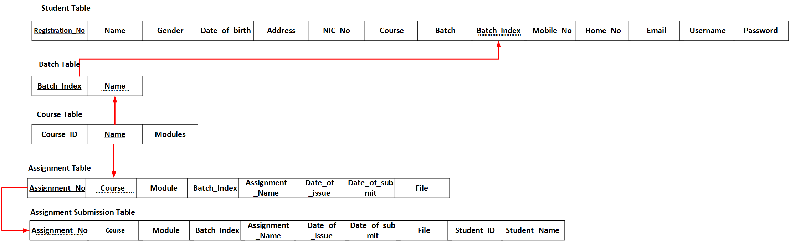

Figure 2 - Normalized Relational Schema

## Use Case Diagram

Figure 3 - Use Case Diagram

## Sequence Diagram

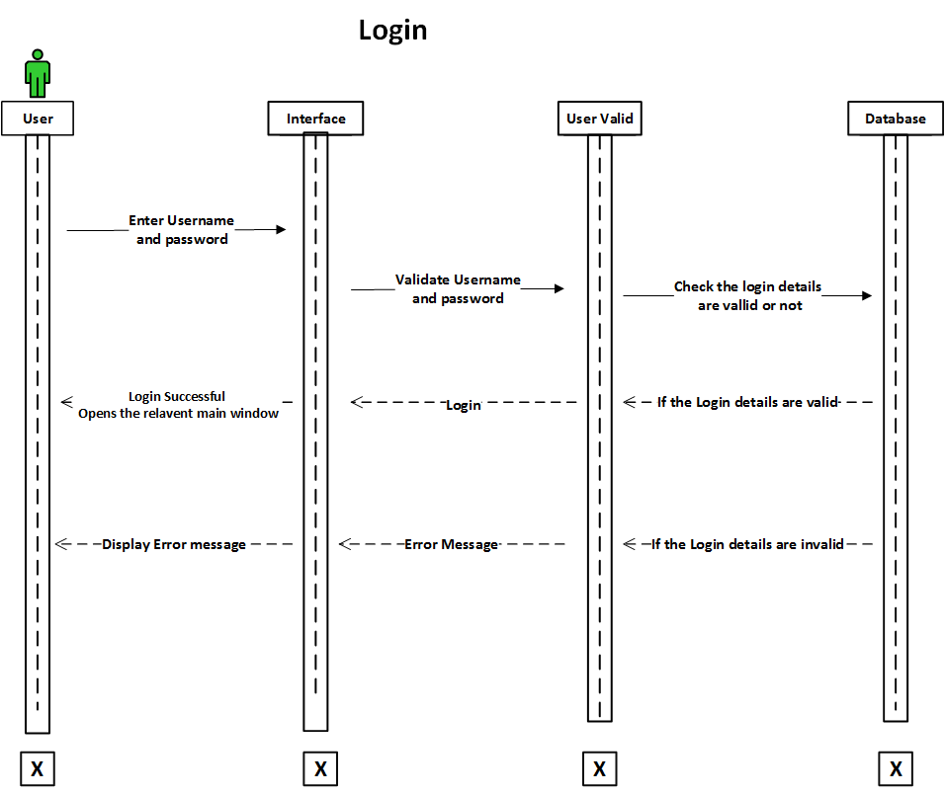

Figure 4 - Sequence Diagram Login

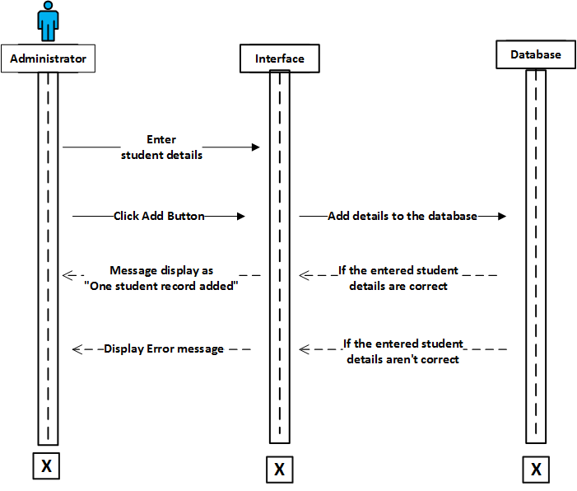

Figure 5 - Sequence Diagram Add Student

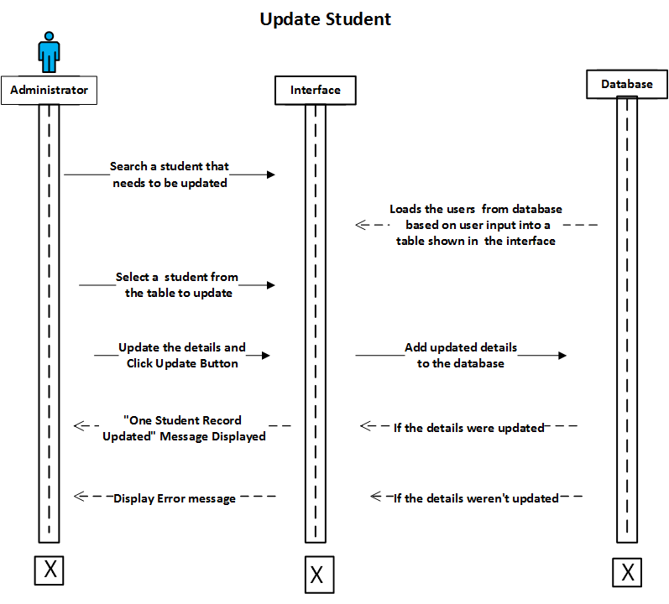

Figure 6 - Sequence Diagram Update Student

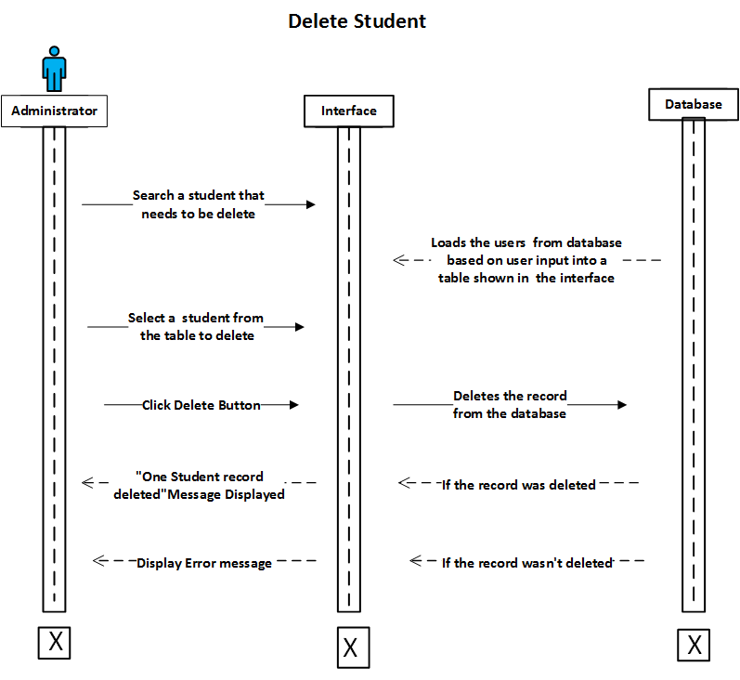

Figure 7 - Sequence Diagram Delete Student

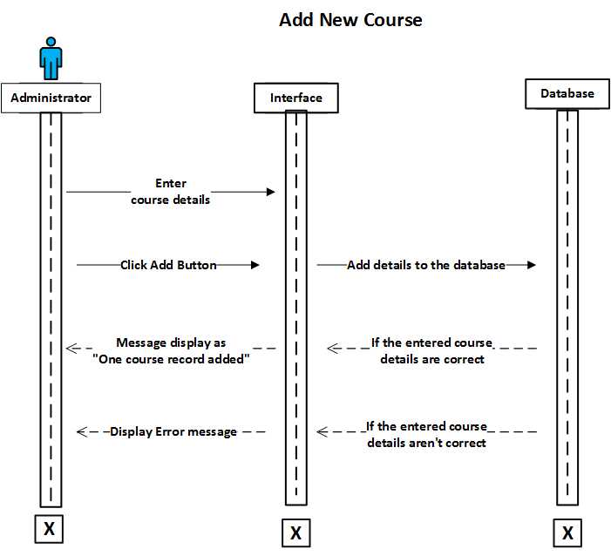

Figure 8 - Sequence Diagram Add Course

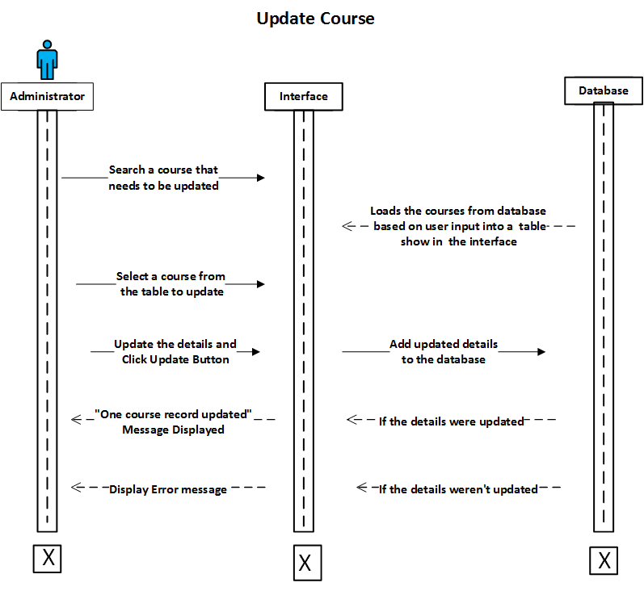

Figure 9 - Sequence Diagram Update Course

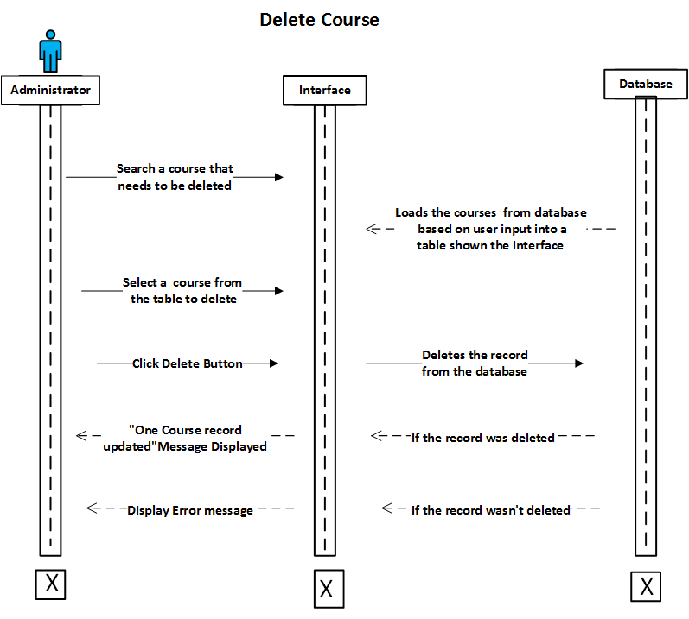

Figure 10 - Sequence Diagram Delete Course

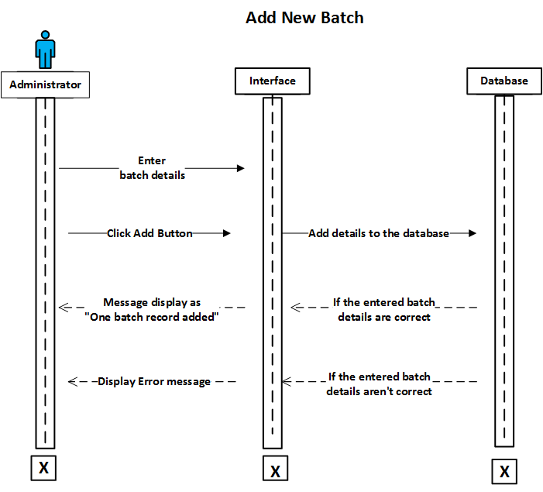

Figure 11 - Sequence Diagram Add Batch

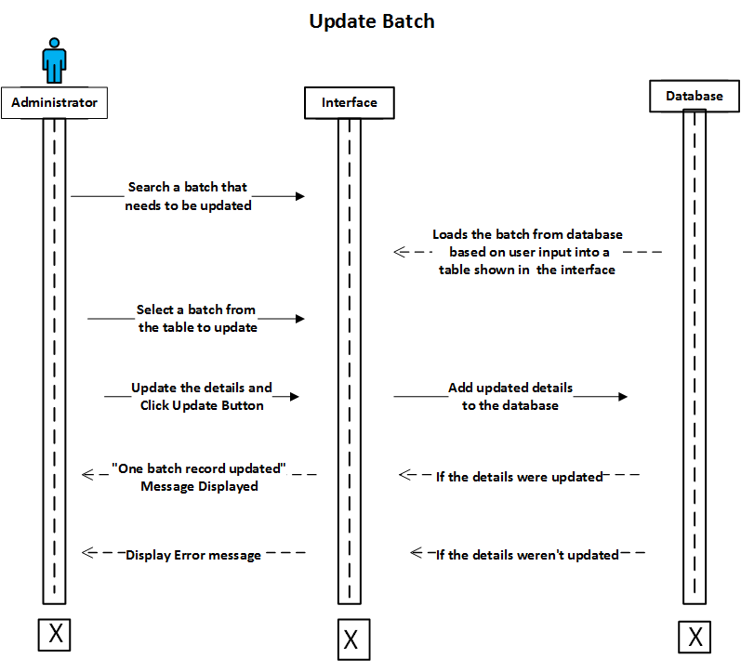

Figure 12 - Sequence Diagram Update Batch

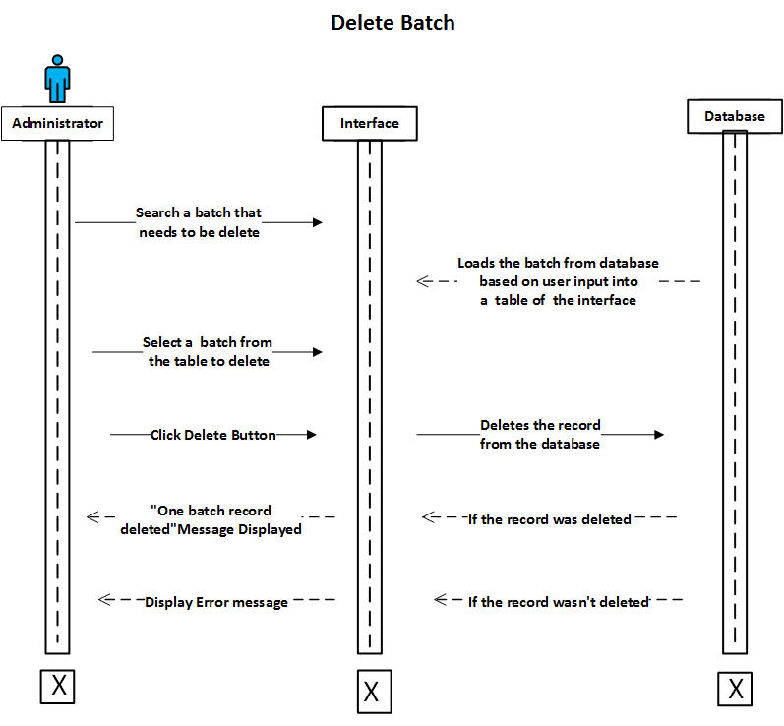

Figure 13 - Sequence Diagram Delete Batch

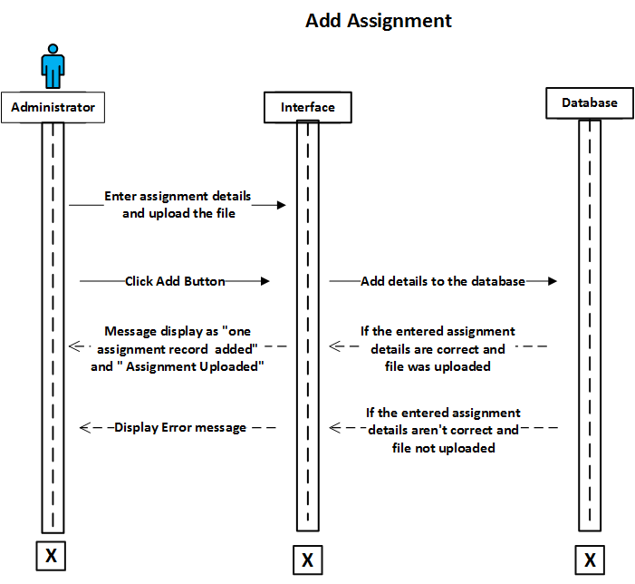

Figure 14 - Sequence Diagram Add Assignment

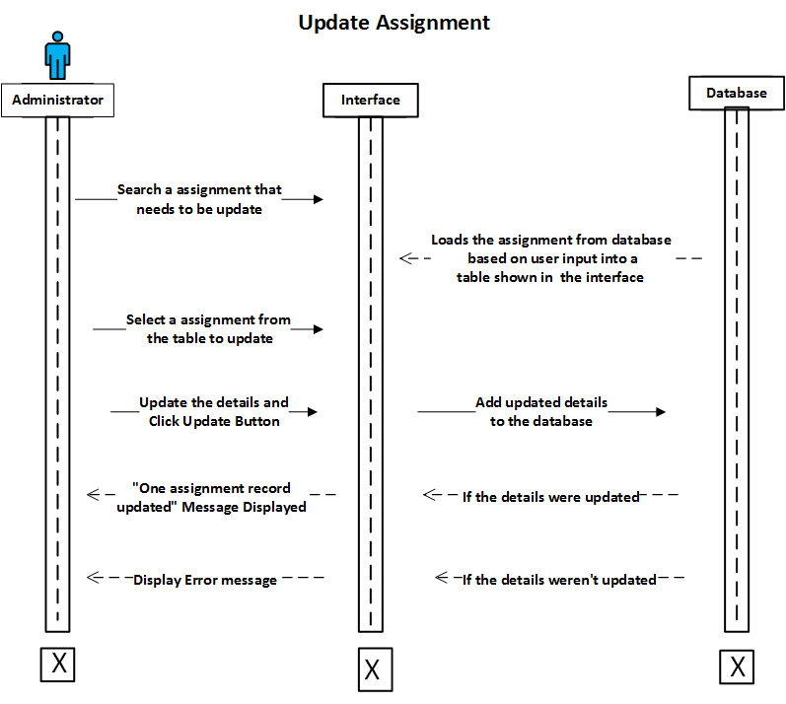

Figure 15 - Sequence Diagram Update Assignment

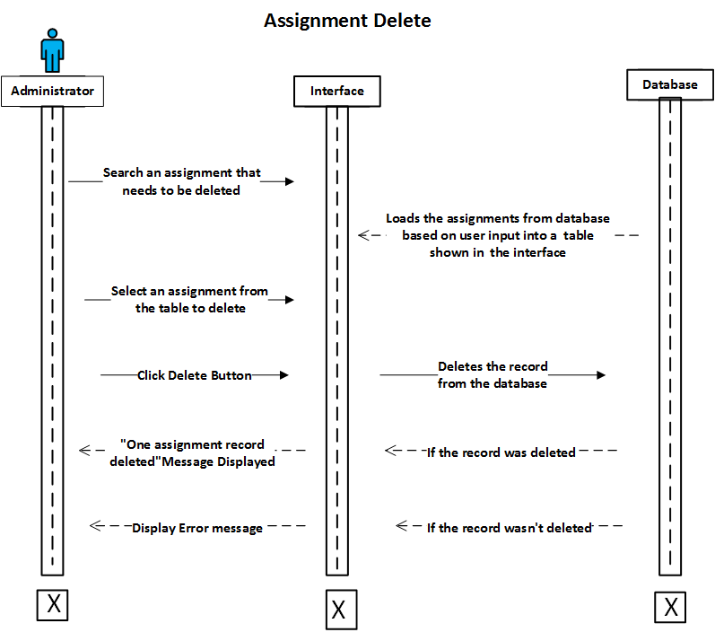

Figure 16 - Sequence Diagram Assignment Delete

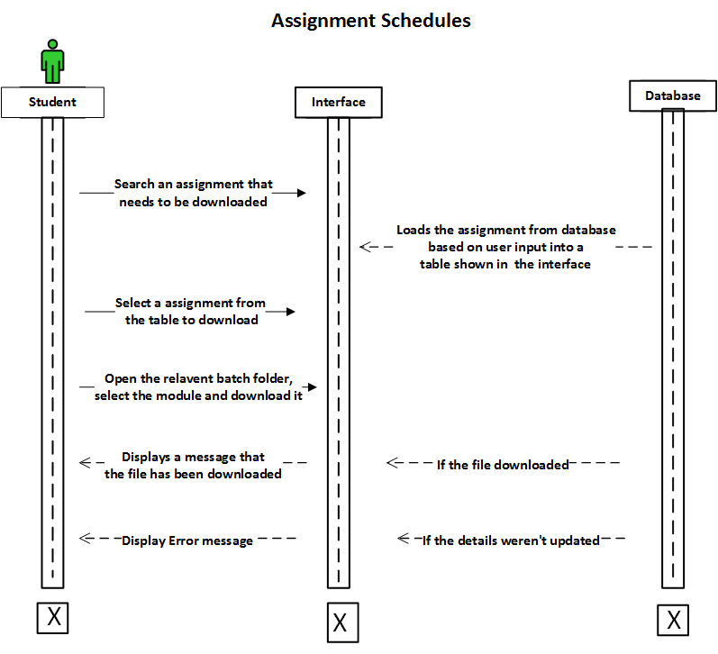

Figure 17 - Sequence Diagram Assignment Schedules

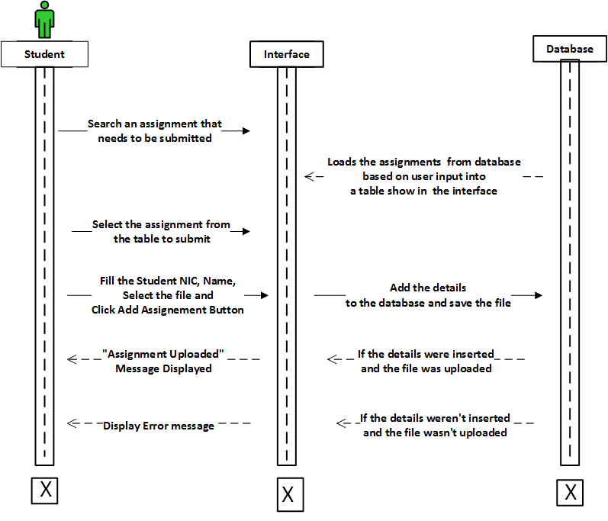

Figure 18 - Sequence Diagram Assignment Submission

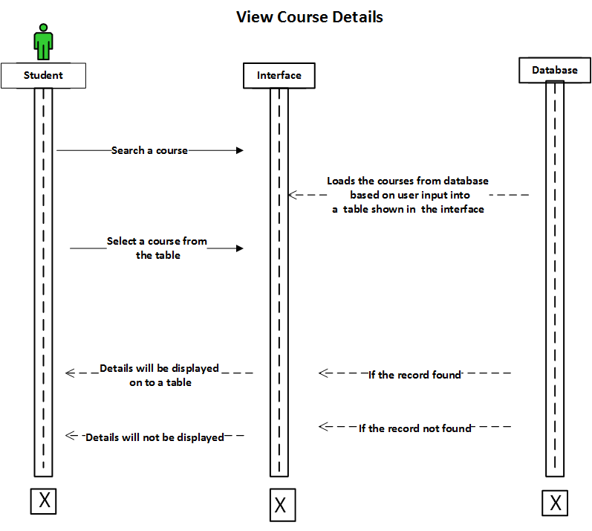

Figure 19- Sequence Diagram View Course Details

# **Task 04**

## Implementing a database driven web application based on the design

In the task, we are going to implement the web application system of the Success EDU online assignment submission system. To build this system we have used HTML, PHP, CSS and JavaScript. All the codes are written with these languages. An IDE was also needed to create the interfaces of this system. We used Adobe Dreamweaver as the IDE for the designing of interfaces of the web application system. Also, we used WampServer as the web server for testing of webpages. To store records of the user logins, assignments, students, courses and batch details we need a database management system. As WampServer has MySQL in built we selected it as the database management software for our system. Now let’s see how this system functions.

### Connecting the database to the system

Records of the user logins, assignments, students, courses and batch details are stored in MySQL database. When the user requests something such as updating assignment or student. To do that so, the database needs to be connected to pass the details given by the user to the database. Below image shows the code that we have written to connect the database.

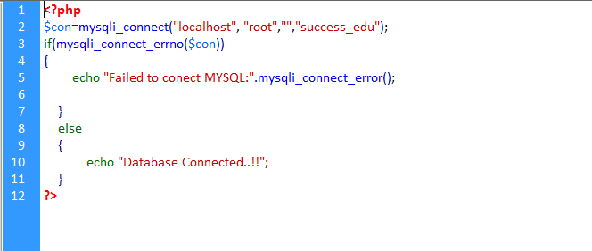

Figure 20 - dbconnect.php code (Database Connection Page)

This is an image of the page **dbconnect.php** which we used to connect the database for the system. The code is written in PHP language. **$con** is a variable which contains the server name, username and the database of the system. **mysqli_connect** is the function that helps to connect the database.Using an IF function it checks that if the connection was unsuccessful, it will display or echo a message as **“Failed to connect MYSQL”**. If it is successful, it will display a message as **“Database Connected”**.

### Login

After opening of the online assignment submission system, first the user will see the Login page. Above image shows an image of it. User has to enter valid username or password to enter into the system. There are two user levels as student and administrator. If a student logs into the system, he would be directed to the student main page. If it is administrator, he would be directed to the administrator page for the password text box we have enabled password char to hide characters. Below is are the images of the codes which are written **Logincheck.php** page.

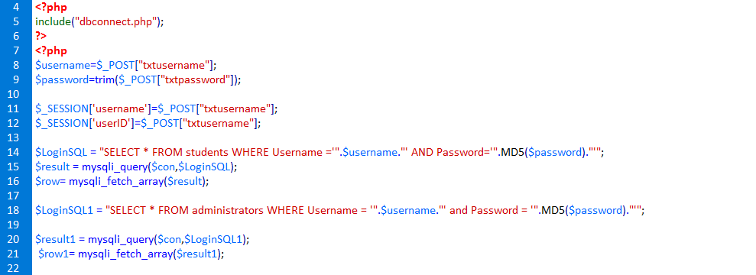

Figure 21 - Login Check Code

In here a PHP tag is there to start a session between two pages**. include(“dbconnect.php”)** makes the connection established between the login page and the database. When the user enters the username and password in the text boxes the values are stored in variables. Then in **$LoginSQL** variable includes the query to select all from the students table where the username and password are equal to the username and password given by the user in the textboxes. **$LoginSQL1** includes the same query written for administrator. When creating users, we have used the MD5 feature to encrypt user’s passwords. When the user logs in the password isn’t encrypted. But in the database there is an encrypted password So when, the user logs in here we have called the MD5 feature to convert the user’s password to encrypted password so it would match the encrypted password in the database

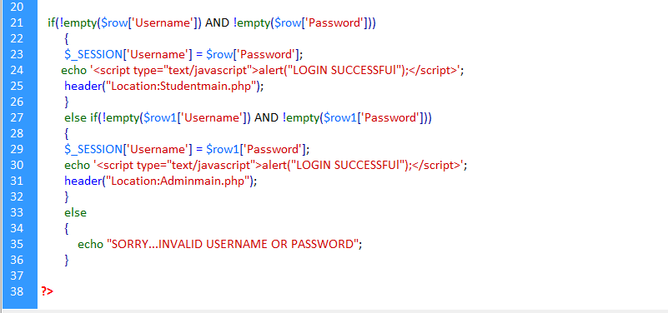

Figure 22 - Login Check Code

Using an IF function the system checks that if the username and password are found in students table. If so, the system will direct to the student main page. If not again the system checks if the values are found in administrator page. If so, the system would direct into the administrator main page. Else it would display an error message as login unsuccessful.

## Administrator Main Page

Now we are going to discuss about administrator main page. There are some buttons which shows the options that the administrator can do. Administrator can add, update, delete or search students, assignments, course and batch into the system. Also administrator has the chance to logout from the system. So let’s discuss its components now.

##### Student Registration

As there are many students who are following courses in Success EDU, the students should be registered in order to submit assignments for students. As student is one of the users in this system, by registering them then can log into the system submit their assignments and also can check the assignment that they haven’t submitted yet. First of all, lets discuss about adding new students

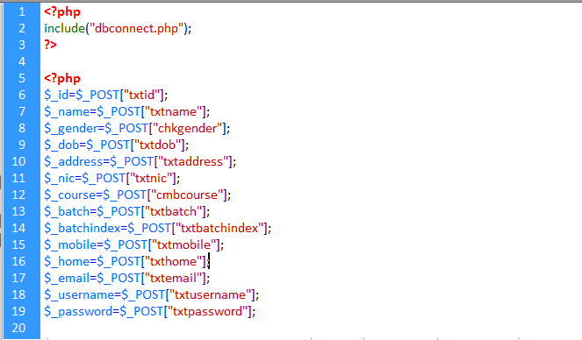

Figure 23 - Student Registration Code 1

To insert data into the database, first the page and the and database should establish the connection. So, like in login page, again the code **include(“dbconnect.php**”) has been written. There are textboxes added in the registration page for the users to add details which are to be inserted ion the database. Then variables have been declared to store values given by the user.

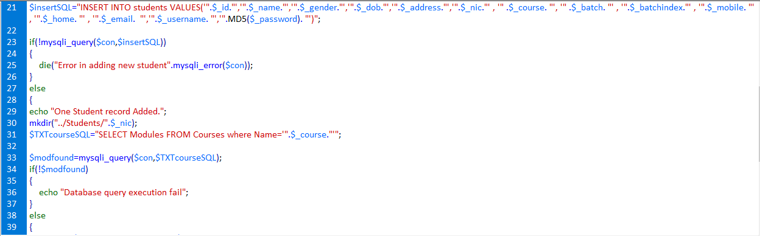

Figure 24 - Student Registration Code 2 (Insert)

Then an insert query has been written to insert values which are stored inside the variables. When inserting password to the database we have used the MD5 feature in here to encrypt the password and then insert that to the database. Using this feature the password would be more secure. Using an IF function it checks that if the query execution is successful. If so it will display a message as **“One student record added”.** Else it would display an error message as **“Error in adding new student”.** In student registration design a combo box has been added to select the course of the student. Below is an image of how the values in combo box has been added.

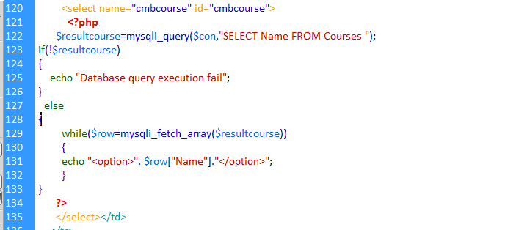

Figure 25 - Student Registration Combo Box code

Inside the select tag of combo box a PHP code has been included. Inside of it a query has been written to select the course name from the courses table. Using IF condition if the query execution was successful it would add each values into the combo box. Else it will show a message as **“Database execution query fail”.**

##### Student Search, Update and Delete

Now we are going to discuss about how the student search, update and delete works in the system. Student search is necessary in case if the administrator needs to get a student details. Also, update and delete is necessary if the user wants to update a student detail or remove the student. To search, update and delete a student first the user must click “Manage Students” button on the administrator main page. After clicking that first the user comes to search page. So, first let’s see how search works.

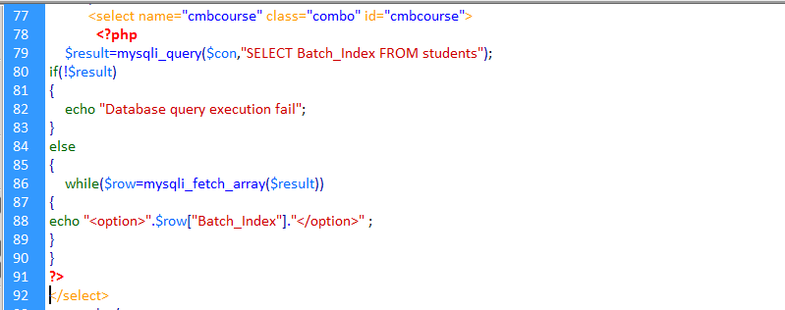

Figure 26 - Search Student Code

Above image shows the code written when the user searches student details. After user comes into search page, there’s a combo box which includes Batch index of the students in the student table. By selecting one of those batch indexes it would display the students who have that batch index value. The same process happens in here like the courses combo box in student registration interface. A SQL query is written here to get the batch indexes into the combo box. If the query isn’t successful it would display an error message.

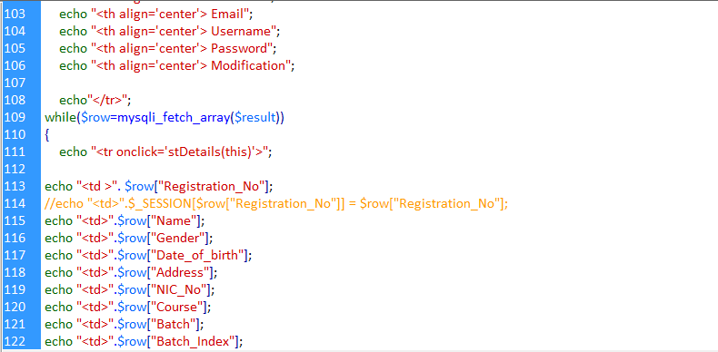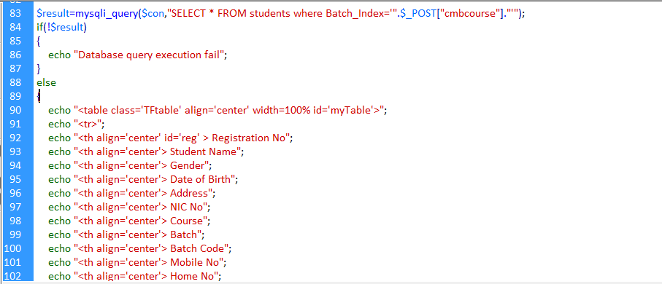

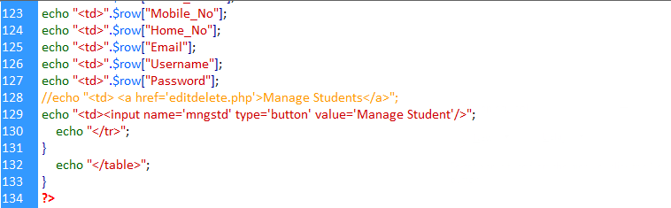

Figure 27 - Student Displaying Table Code

After the user selects a batch index from the combo box, the relevant students will be displayed in a table with their full details. Above image shows its code. A query has been written here to select all the students where the batch index should be equal to the value that the user selected in the combo box. If the query is executing successfully, the table will be created showing the columns first. After the details are added inside an array, they will be added in each row. By naming the field names in the student table will bring each detail to the relevant row.

Then there will be another button named “Manage Student” which will direct to the edit and delete page and the selected student’s details will be set to the text boxes for editing purposes. To do that so, we need the registration number to bring those values to the text boxes. So for that a JavaScript code has been written which is shown below

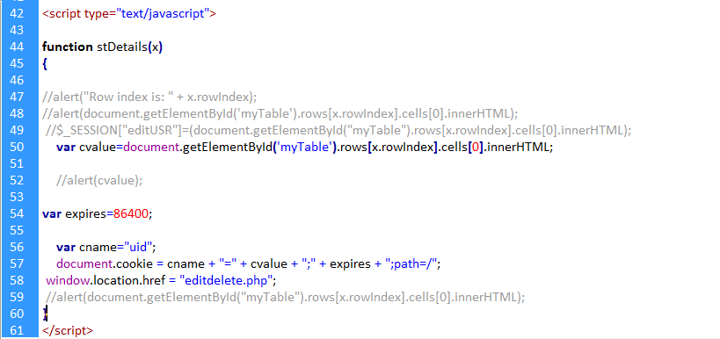

Figure 28 - JavaScript Code in Student Registration

In here **cvalue** variable takes the value which are in 0th row index. It means it contains the Registration Number. After that it is assign to a cookie and passes it to the update delete page.

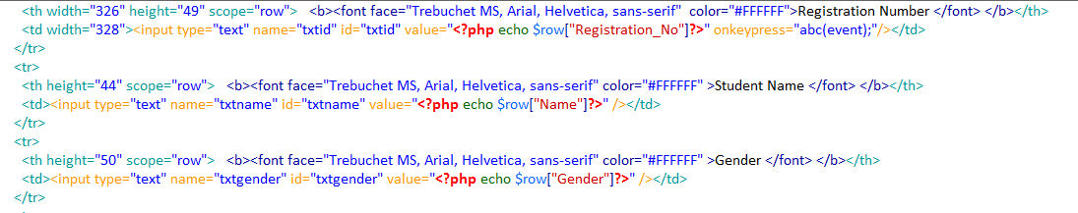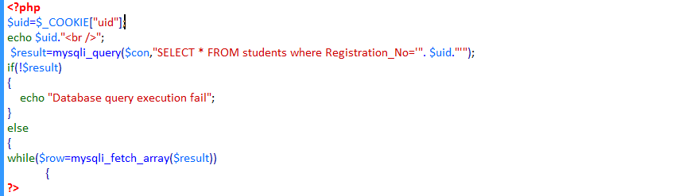

Figure 29 - Code for calling cookie and setting text to the text boxes

Above image shows the code written to call the cookie which is need to extract the details to the text box. The cookie is assigned to variable. Then, SQL query is written here to select all the students where the Registration Number is equal to the cookie value. If the query is successful it will display the full details of the relevant student into the text boxes by setting the column names into the relevant text boxes. Else it will show an error message

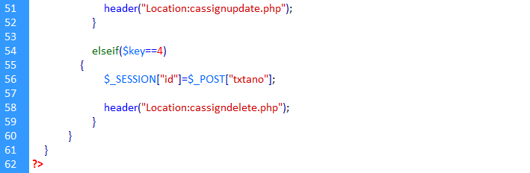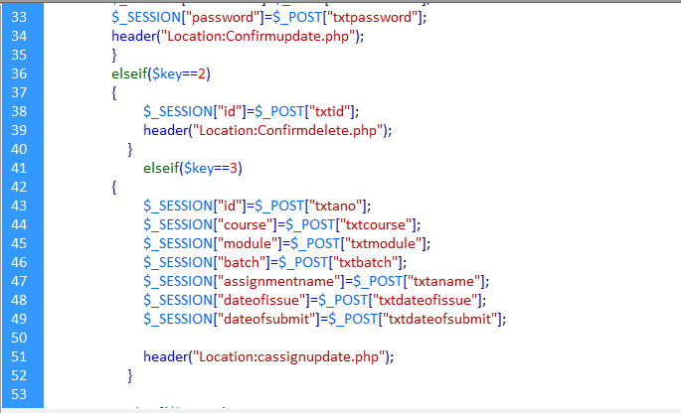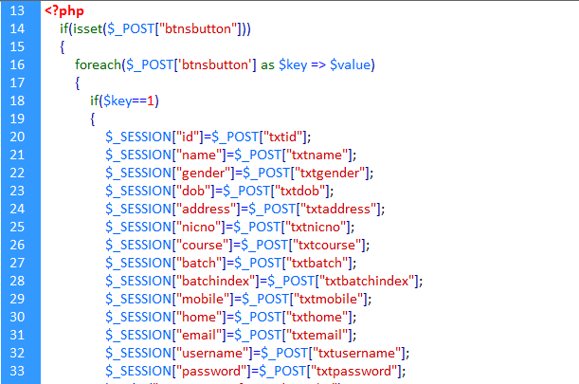

Figure 30 - Redirect Page of Manage Student

As there are two buttons named update and delete we need a redirect page to proceed it. Above image shows the codes which are included in the redirect page. We have used session variables here to pass the text box values in update and delete page to the next page which contains the update SQL query. Using an IF function we have controlled it. When the relevant button is clicked only the values will be passed.

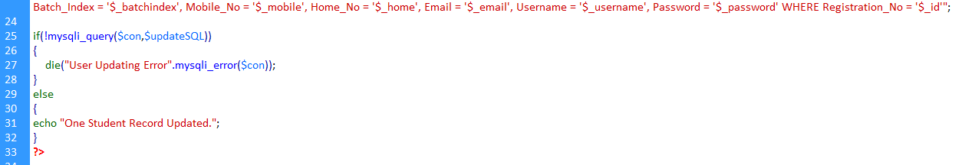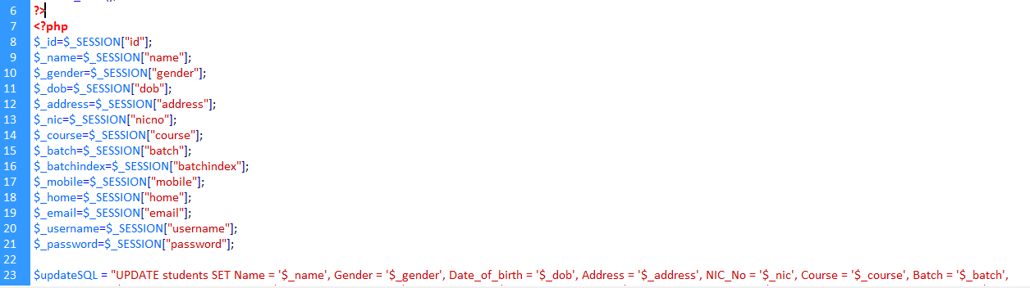

Figure 31 - Student Update Code

Above image shows the update query given for the student. In here those session variables in redirect are called in here again and assigned into another variable, so we can write the query easily. After that update query is written to update the details in students table by setting each column with the values given in the variable. If the query is successful it will show a successful message.

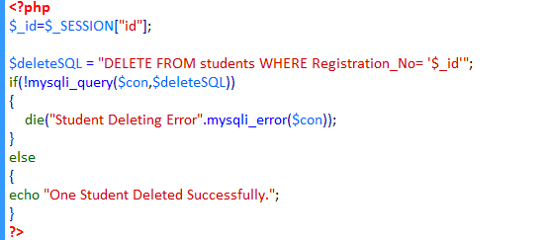

Figure 32 - Student Delete Code

Above image shows the code written to delete a record. Again the session variables are called and assigned to another variable. Then, SQL query is written here to delete the record where the Registration _No is equal to the session variable value. If it is successful it will show a message as **“One student deleted successfully”**

##### Course Adding

There are many courses from HND’s to MBA’s which are offered in Success EDU institute. In this section we are going to discuss about course adding updating, delete and search. So let’s see how the process happens.

To insert data into the database, first the page and the and database should establish the connection. So, like in login page, again the code **include(“dbconnect.php**”) has been written. There are textboxes added in the add course page for the users to add details which are to be inserted ion the database. Then variables have been declared to store values given by the user in the textboxes.

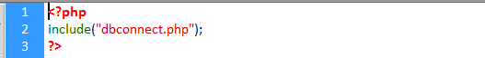

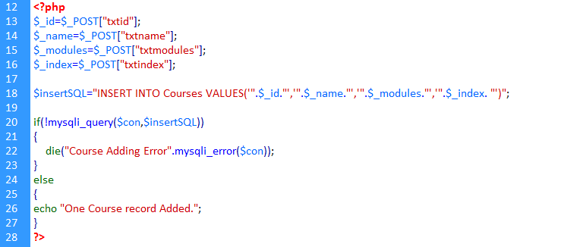

Figure 33 - Add Course Insert query code

Then an insert query has been written to insert values which are stored inside the variables. Using an IF function it checks that if the query execution is successful. If so it will display a message as **“One student record added”.** Else it would display an error message as **“Error in adding new student”.** In student registration design a combo box has been added to select the course of the student. Below is an image of how the values in combo box has been added.

##### Course Search, Update and Delete

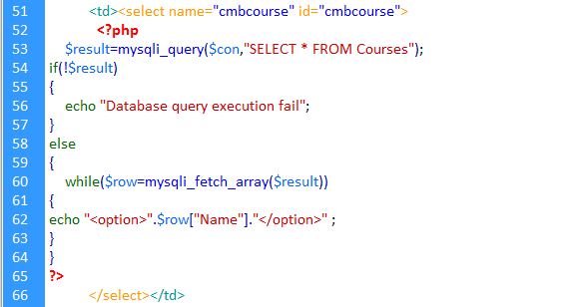Now we are going to discuss about how the course search, update and delete works in the system. To search, update and delete a course first the user must click “Manage Course” button on the administrator main page. After clicking that first the user comes to search page. So, first let’s see how search works.

Figure 34 - Search Course combo box code

Above image shows the code written when the user searches course details. After user comes into search page, there’s a combo box which includes Course details of the student table. By selecting one of those courses it would display the courses. A SQL query is written here to get the courses into the combo box. If the query isn’t successful it would display an error message.

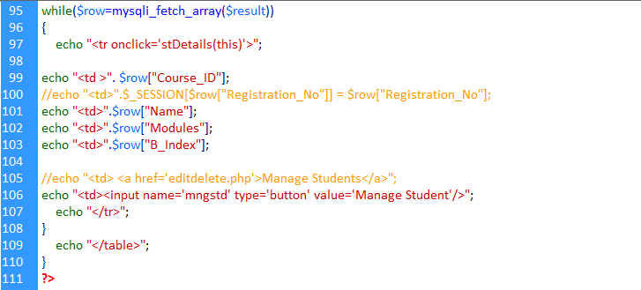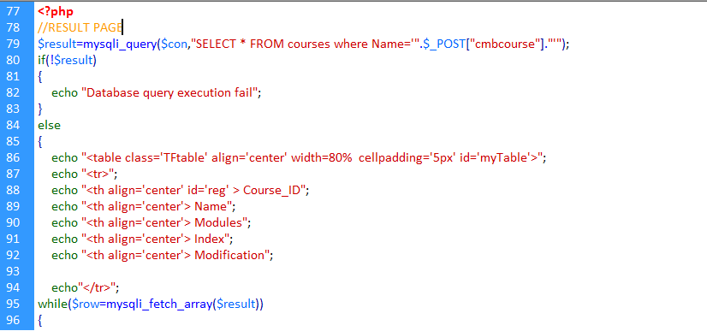

Figure 35 - Courses Displaying Code Combo box

After the user selects a course from the combo box, the relevant courses will be displayed in a table with their full details. Above image shows its code. A query has been written here to select all the courses where the name should be equal to the value that the user selected in the combo box. If the query is executing successfully, the table will be created showing the columns first. After the details are added inside an array, they will be added in each row. By naming the field names in the course table will bring each detail to the relevant row.

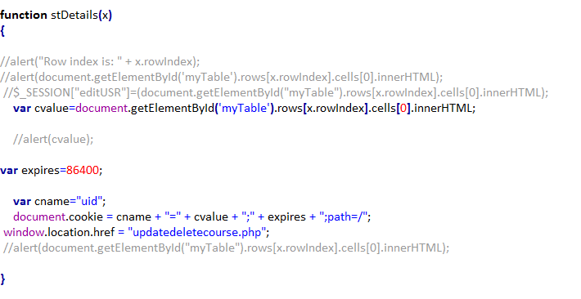Then there will be another button named “Manage Course” which will direct to the edit and delete page and the selected course detail values will be set to the text boxes for editing purposes. To do that so, we need the Course ID to bring those values to the text boxes. So for that a JavaScript code has been written which is shown below

Figure 36 - JavaScript Code

In here **cvalue** variable takes the value which are in 0th row index. It means it contains the Course ID. After that it is assign to a cookie and passes it to the update delete page.

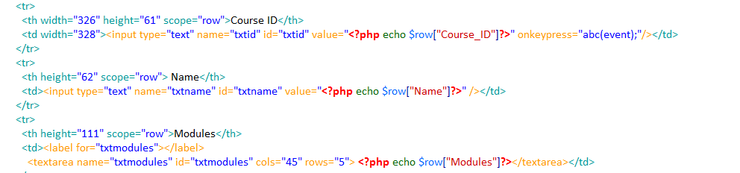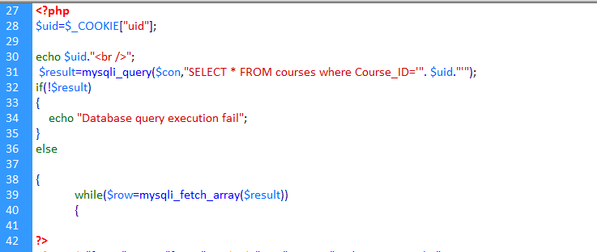

Figure 37 - Code for calling cookie and setting text to the textboxes

Above image shows the code written to call the cookie which is need to extract the details to the text box. The cookie is assigned to variable. Then, SQL query is written here to select all the students where the Course ID is equal to the cookie value. If the query is successful it will display the full details of the relevant course into the text boxes by setting the column names into the relevant text boxes. Else it will show an error message

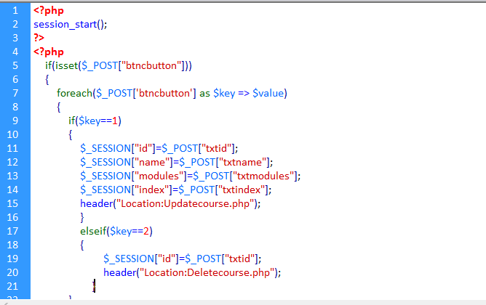

Figure 38 - Course Redirect Page

As there are two buttons named update and delete we need a redirect page to proceed it. Above image shows the codes which are included in the redirect page. We have used session variables here to pass the text box values in update and delete page to the next page which contains the update SQL query. Using an IF function we have controlled it. When the relevant button is clicked only the values will be passed.

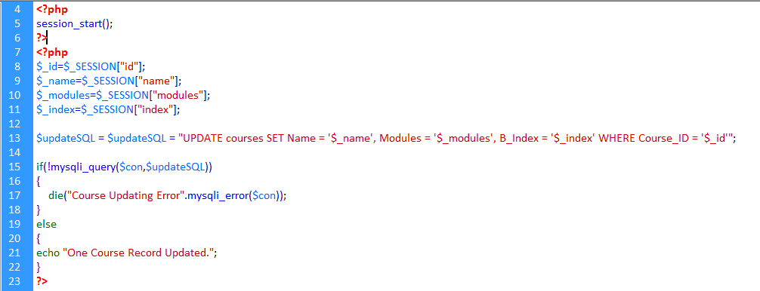Above image shows the update query given for the course. In here those session variables in redirect are called in here again and assigned into another variable, so we can write the query easily. After that update query is written to update the details in courses table by setting each column with the values given in the variable. If the query is successful it will show a successful message.

Figure 39 - Course Update Query Code

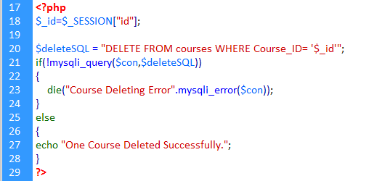

Figure 40 - Course Delete Code

Above image shows the code written to delete a record. Again the session variables are called and assigned to another variable. Then, SQL query is written here to delete the record where the Course ID is equal to the session variable value. If it is successful it will show a message as **“One course deleted successfully”**

##### Batch Adding

There are many students in different batches who follow same course in Success EDU institute. In this section we are going to discuss about course adding updating, delete and search. So let’s see how the process happens.

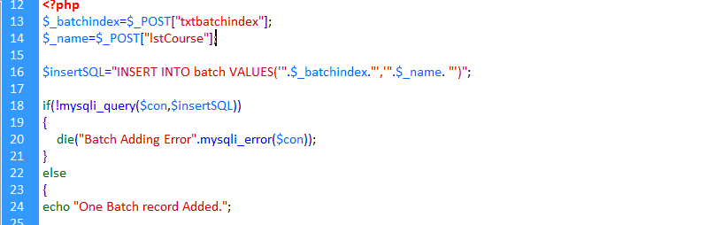To insert data into the database, first the page and the and database should establish the connection. So, like in login page, again the code **include(“dbconnect.php**”) has been written. There are textboxes added in the add batch page for the users to add details which are to be inserted in the database. Then variables have been declared to store values given by the user in the textboxes.

Figure 41 - Batch Insert Query code

Then an insert query has been written to insert values which are stored inside the variables. Using an IF function it checks that if the query execution is successful. If so it will display a message as **“One Batch record added”.** Else it would display an error message as **“Batch Adding Error”.** In batch design a combo box has been added to select the course of the student. Below is an image of how the values in com box has been added.

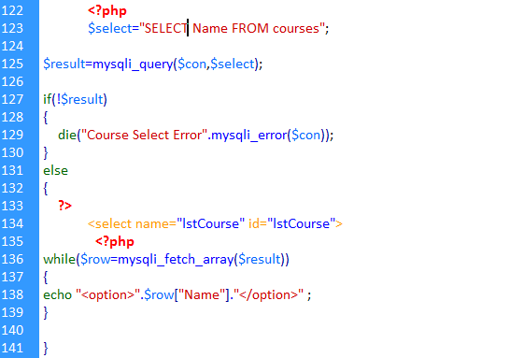Figure 42 - Course Name Combo box code

Inside the select tag of combo box a PHP code has been included. Inside of it a query has been written to select the course name from the courses table. Using IF condition if the query execution was successful it would add each values into the combo box. Else it will show a message as **“Database execution query fail”.**

##### Batch Search, Update and Delete

Now we are going to discuss about how the batch search, update and delete works in the system. To search, update and delete a batch first the user must click “Manage Batch” button on the administrator main page. After clicking that first the user comes to search page. So, first let’s see how search works.

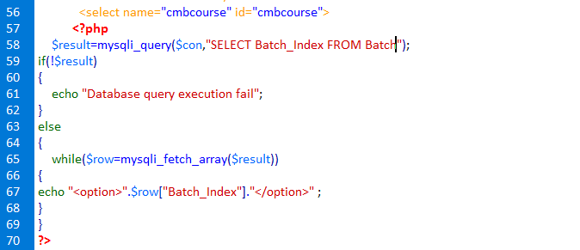

Figure 43 - Search Batch Code

Above image shows the code written when the user searches batch details. After user comes into search page, there’s a combo box which includes batch indexes. By selecting one of those values it would display the full batch details. A SQL query is written here to get the batch names into the combo box. If the query isn’t successful it would display an error message.

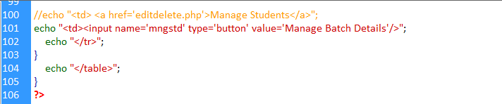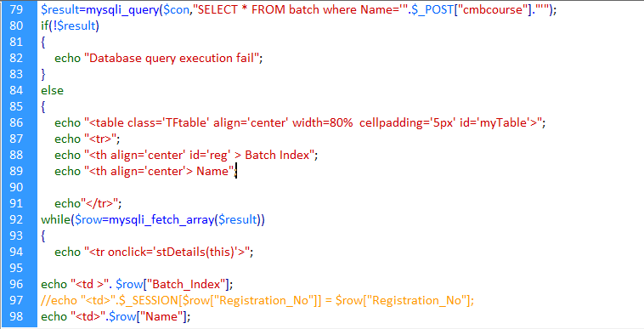

Figure 44 - Batch Displaying Table Code

After the user selects a batch name from the combo box, the relevant batches will be displayed in a table with their full details. Above image shows its code. A query has been written here to select all the batches where the name should be equal to the value that the user selected in the combo box. If the query is executing successfully, the table will be created showing the columns first. After the details are added inside an array, they will be added in each row. By naming the field names in the course table will bring each detail to the relevant row.

Then there will be another button named “Manage Batch” which will direct to the edit and delete page and the selected course detail values will be set to the text boxes for editing purposes. To do that so, we need the Batch Index to bring those values to the text boxes. So for that a JavaScript code has been written which is shown below.



Figure 45 - JavaScript code for Batch

In here **cvalue** variable takes the value which are in 0th row index. It means it contains the Batch Index. After that it is assign to a cookie and passes it to the update delete page.

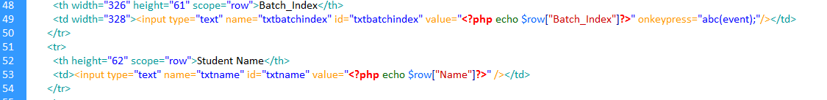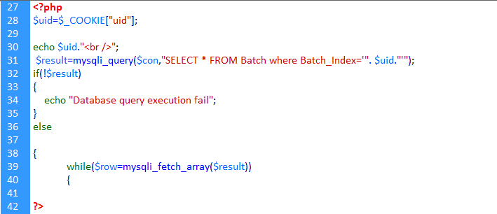

Figure 46 - Calling cookie and setting text to the text boxes

Above image shows the code written to call the cookie which is need to extract the details to the text box. The cookie is assigned to variable. Then, SQL query is written here to select all the students where the Batch Index is equal to the cookie value. If the query is successful it will display the full details of the relevant course into the text boxes by setting the column names into the relevant text boxes. Else it will show an error message.

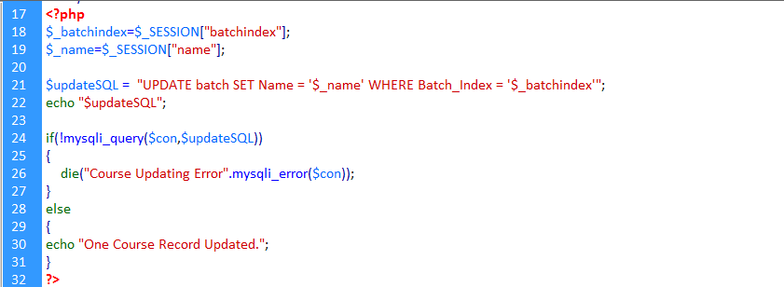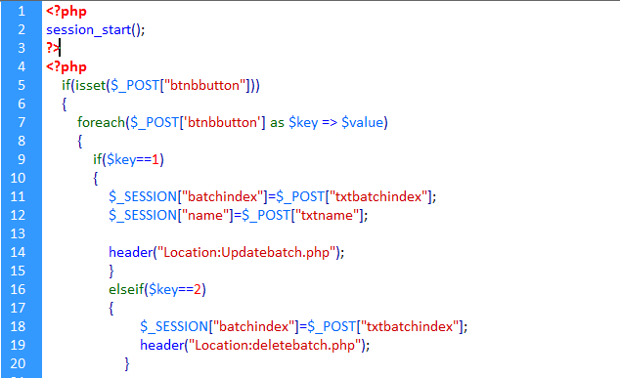As there are two buttons named update and delete we need a redirect page to proceed it. Above image shows the codes which are included in the redirect page. We have used session variables here to pass the text box values in update and delete page to the next page which contains the update SQL query. Using an IF function we have controlled it. When the relevant button is clicked only the values will be passed.

Figure 47 - Batch Redirect page

Figure 48 - Batch Update Code

Above image shows the update query given for the batch. In here those session variables in redirect are called in here again and assigned into another variable, so we can write the query easily. After that update query is written to update the details in batch table by setting each column with the values given in the variable. If the query is successful it will show a successful message.

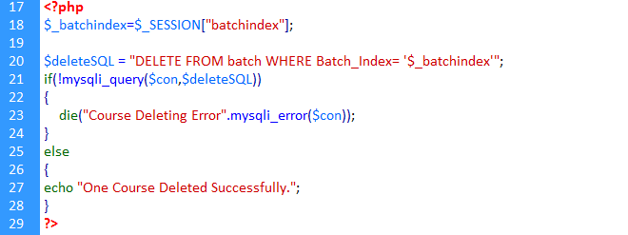

Figure 49 - Batch Delete Code

Above image shows the code written to delete a record. Again the session variables are called and assigned to another variable. Then, SQL query is written here to delete the record where the Batch Index is equal to the session variable value. If it is successful it will show a message as **“One batch deleted successfully”**

##### Assignment Upload

Assignment adding is necessary to administrator because he needs to upload the assignments on system so the students can log in and download the assignments. Let’s see how assignment uploading process takes place.

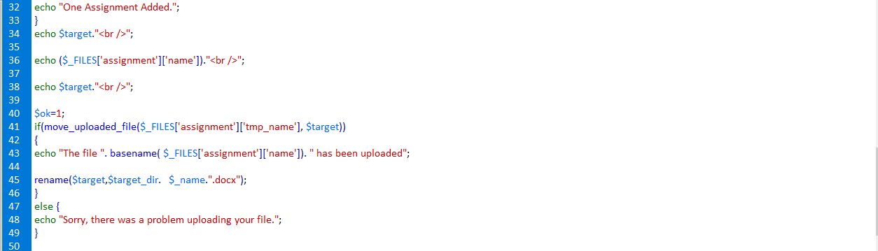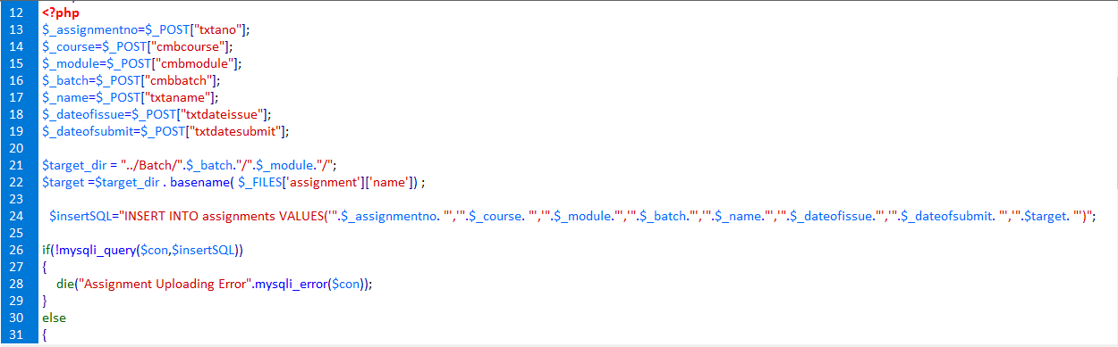

Figure 50 - Assignment Upload Insert Query code

Above image shows the code of the Assignment uploading for administrators. In here firstly. The inputs given by the user such as Assignment name, date of issue, date of submit, etc. are stored inside variables. To upload assignments in here we have used the file uploading code. **target_dir** means the file path where the uploaded documents needed to be stored. Using insert SQL query we insert the assignment details which are stored inside the variables and the variable **target_dir**, to store the path. If the record has been inserted successfully, the **move_upload_file** checks if the file is uploaded is a valid one and then uploads it to the destination specified and renaming the file.

##### Assignment Search, Update and Delete

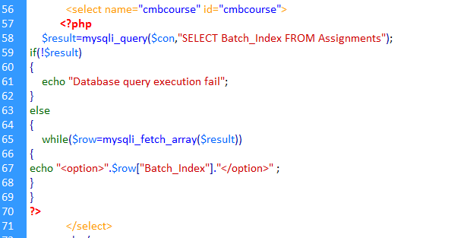Now we are going to discuss about how the assignment search, update and delete works in the system. To search, update and delete a batch first the user must click “Manage Assignment” button on the administrator main page. After clicking that first the user comes to search page. Administrator can update any fields, first let’s see how search works.

Figure 51 - Assignment Search Page Combo box code

Above image shows the code written when the user searches assignment details. After user comes into search page, there’s a combo box which includes batch names. By selecting one of those values it would display the assignments. A SQL query is written here to get the batch names into the combo box. If the query isn’t successful it would display an error message.

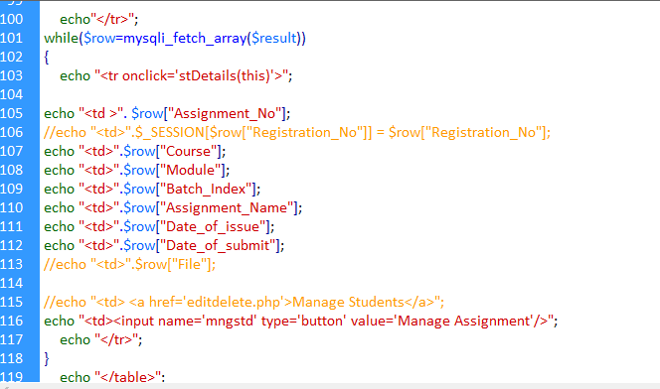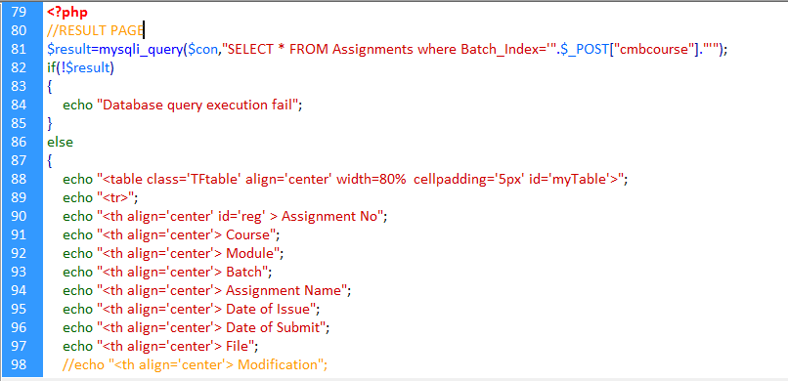

Figure 52 - Assignment Displaying Table Code

After the user selects a batch name from the combo box, the assignments will be displayed in a table with their full details. Above image shows its code. A query has been written here to select all the assignments where the batch index should be equal to the value that the user selected in the combo box. If the query is executing successfully, the table will be created showing the columns first. After the details are added inside an array, they will be added in each row. By naming the field names in the assignment table will bring each detail to the relevant row.

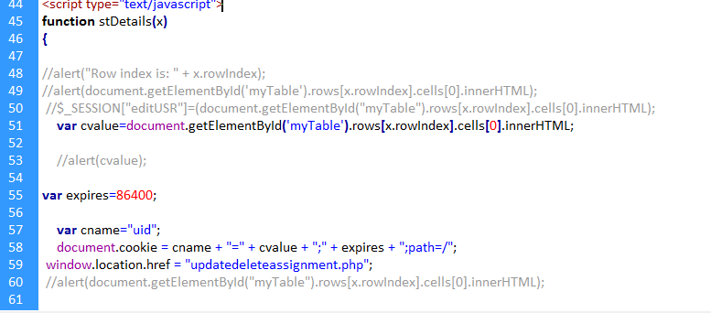Then there will be another button named “Manage Assignments” which will direct to the edit and delete page and the selected assignment details will be set to the text boxes for editing purposes. To do that so, we need the Assignment Number to bring those values to the text boxes. So for that a JavaScript code has been written which is shown below.

Figure 53 - JavaScript Code

In here **cvalue** variable takes the value which are in 0th row index. It means it contains the Assignment Number. After that it is assign to a cookie and passes it to the update delete page.

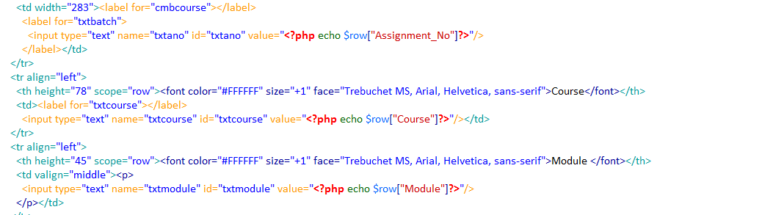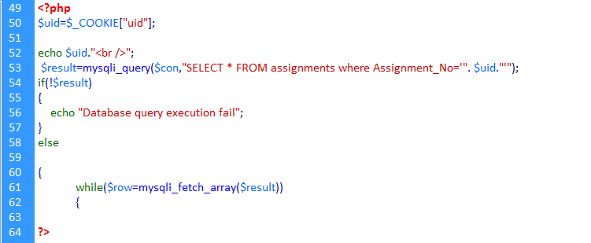

Figure 54 - Calling Cookie and setting text to the text boxes

Above image shows the code written to call the cookie which is need to extract the details to the text box. The cookie is assigned to variable. Then, SQL query is written here to select all the assignments where the Assignment Number is equal to the cookie value. If the query is successful it will display the full details of the assignment into the text boxes by setting the column names into the relevant text boxes. Else it will show an error message

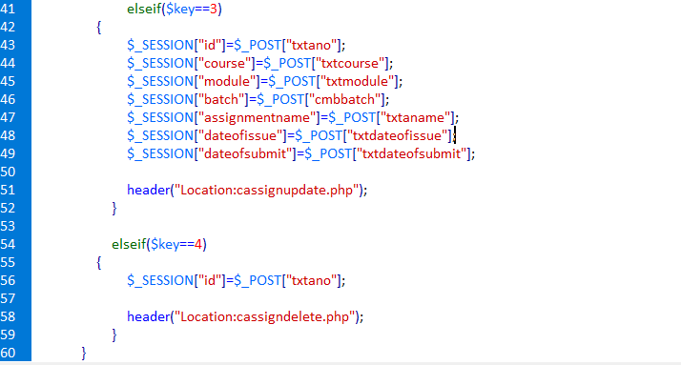

Figure 55 - Redirect Assignment Page

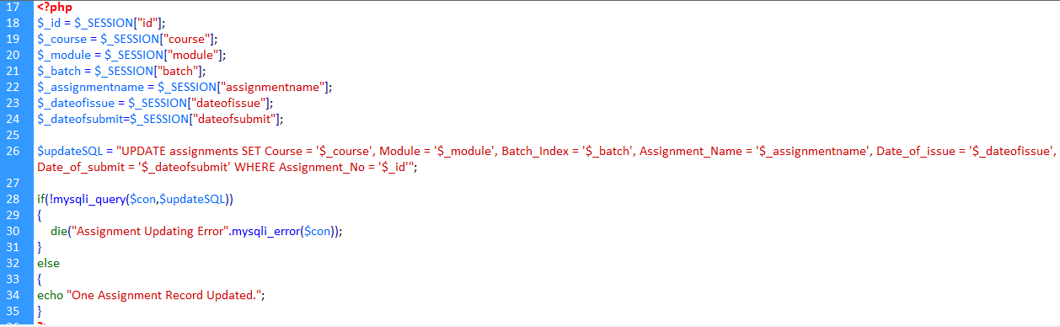As there are two buttons named update and delete we need a redirect page to proceed it. Above image shows the codes which are included in the redirect page. We have used session variables here to pass the text box values in update and delete page to the next page which contains the update SQL query. Using an IF function we have controlled it. When the relevant button is clicked only the values will be passed.

Figure 56 - Assignment Update Code

Above image shows the update query given for the assignment. In here those session variables in redirect are called in here again and assigned into another variable, so we can write the query easily. After that update query is written to update the details in assignment table by setting each column with the values given in the variable. If the query is successful it will show a successful message.

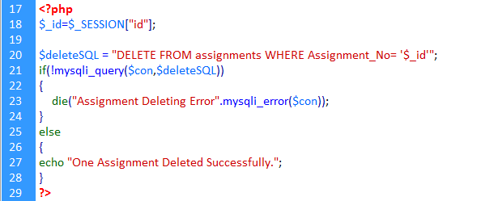

Figure 57 - Assignment Delete Code

Above image shows the code written to delete a record. Again the session variables are called and assigned to another variable. Then, SQL query is written here to delete the record where the Batch Index is equal to the session variable value. If it is successful it will show a message as **“One Assignment deleted successfully”**

## Student Main Page

Now we are going to discuss about student main page. There are some buttons which shows the options that the student can do. Students can view their profile, course details, download assignments and submit assignments into the system. So let’s discuss its components now.

##### Student Profile

Figure 58 - Student Profile code

Above image is the code written for the viewing of currently logged user’s details. First a session variable has been used here to take the username given by the user in the login page. A SQL query has been written here to select all the students where the registration number is equal to the value given in the variable **$username.** If the query execution is successful, it would assign the values to each text box by naming the field names to the relevant text box

##### Assignment Schedules

Now we are going to discuss about Assignment Schedules option in Student main page. In here students can view assignments that have been uploaded by the administrator and download them. So let’s see how this work.

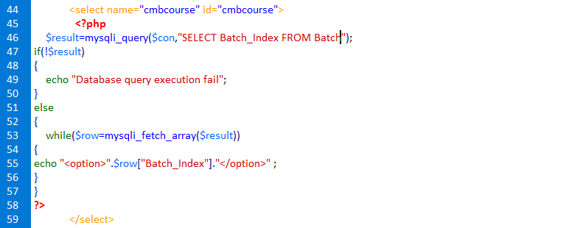

Figure 59 - Search Assignment Schedules Combo Box

Above image is the code written here to search the assignment schedules of the relevant batch and course for students. A SQL query is written here to add the batch indexes to the search combo box so that the student can select his relevant batch. Batch Index includes such as HND IT 19, HND BM 20 likewise. If the query is successful, the values will be added into the combo box. Else it would show an error message.

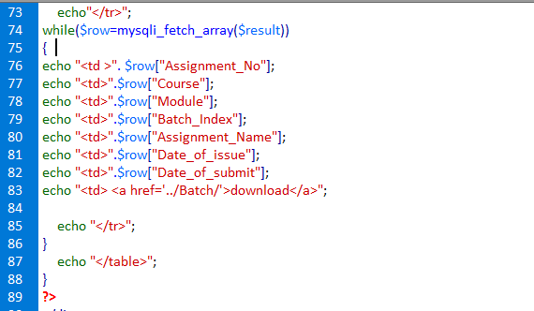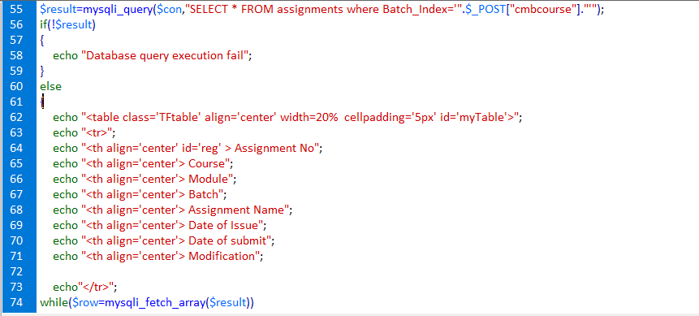

Figure 60 - Assignment Displaying Table code

After the user selects a batch index from the combo box, the assignments will be displayed in a table with their full details. Above image shows its code. A query has been written here to select all the assignments where the batch index should be equal to the value that the user selected in the combo box. If the query is executing successfully, the table will be created showing the columns first. After the details are added inside an array, they will be added in each row. By naming the field names in the assignment table will bring each detail to the relevant row.

Then there will be a link named “Download” which will direct to another page where you can see the files to download. The student has to select the file and save it.

##### Assignment Submission

In this section we are going to discuss about the Assignment Submission function in this system. In here students can submit assignments to the system.

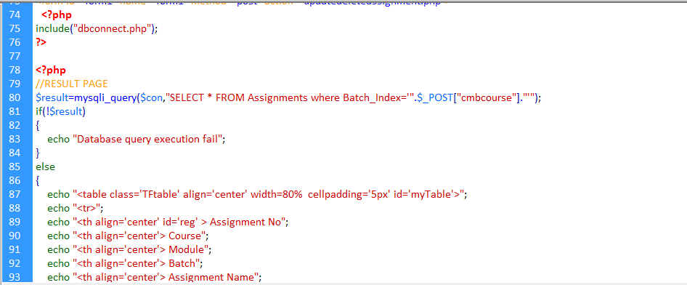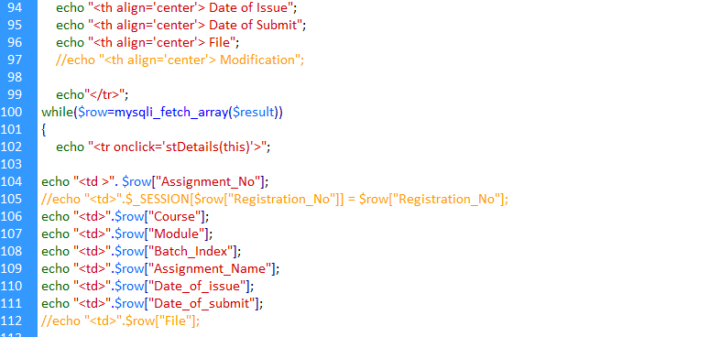

Figure 61 - Assignment Submission Displaying Table code

When the user clicks “Assignment Submission” button, a search page appears asking the user to select the batch index to view the relevant assignment details. After that the assignments will be displayed in a table with their full details. Above image shows its code. A query has been written here to select all the assignments where the Batch_Index should be equal to the value that the user selected in the combo box. If the query is executing successfully, the table will be created showing the columns first. After the details are added inside an array, they will be added in each row. By naming the field names in the assignments table will bring each detail to the relevant row.

Then there will be another button named “Submit” which will direct to the Assignment Submission page and the selected assignment detail values will be set to the text boxes. To do that so, we need the Assignment_No to bring those values to the text boxes. So for that a JavaScript code has been written which is shown below.



Figure 62 - JavaScript Code

In here **cvalue** variable takes the value which are in 0th row index. It means it contains the Assignment_No. After that it is assign to a cookie and passes it to the assignment submission page.

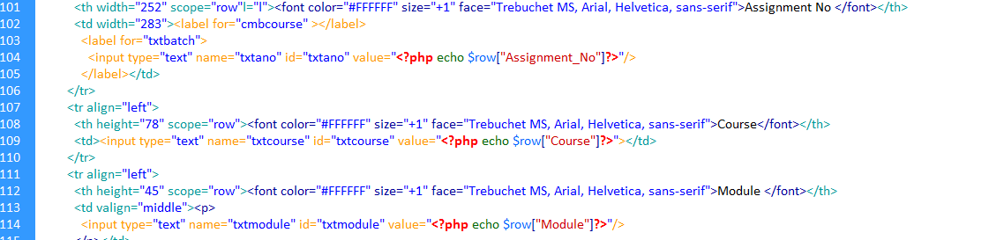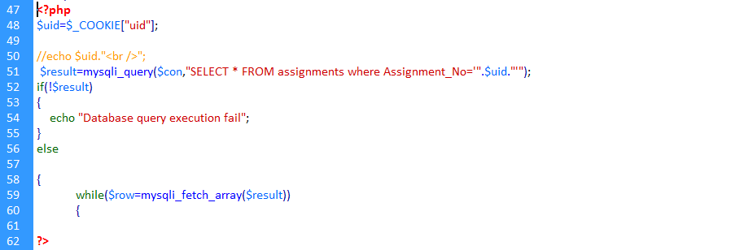

Figure 63 - Calling Cookie and setting text to the text boxes

Above image shows the code written to call the cookie which is need to extract the details to the text box. The cookie is assigned to variable. Then, SQL query is written here to select all the assignments where the Batch Index is equal to the cookie value. If the query is successful it will display the full details of the relevant assignment into the text boxes by setting the column names into the relevant text boxes. Else it will show an error message.

In here the students have to enter their Student NIC and their Name for the assignment before submitting.

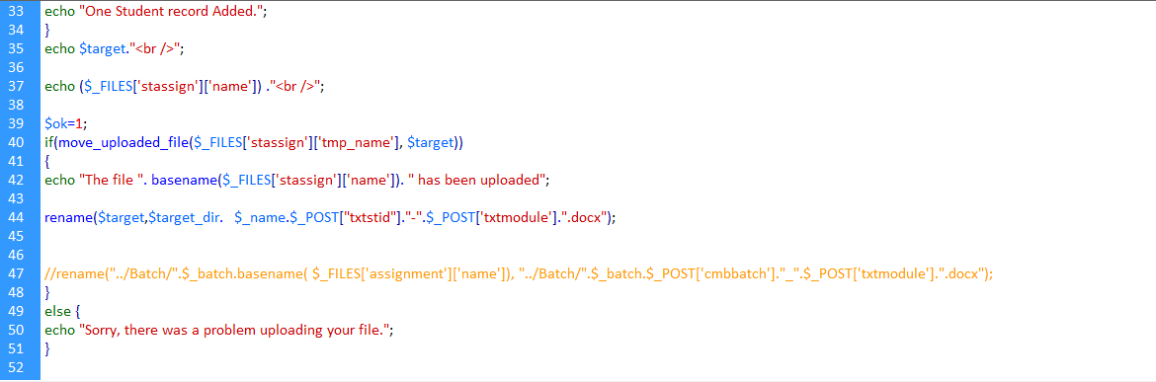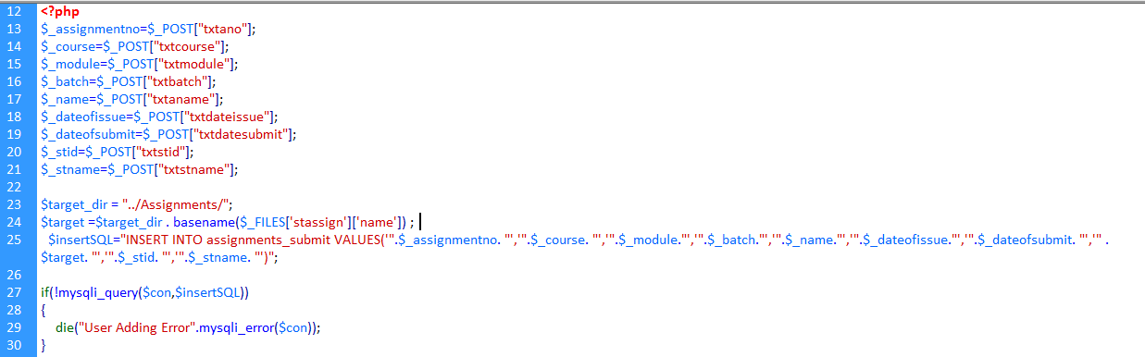

Figure 64 - Assignment Submission insert code and file uploading

Above image shows the code written here to insert the assignment details and the uploaded student assignment to the system. The values in the text boxes such as Assignment name, date of issue, date of submit, etc. are stored inside variables. To submit assignments in here we have used the file uploading code. **target**_**dir** means the file path where the uploaded documents needed to be stored. Also in here we have used rename option to rename the uploading files with the assignment name, Student NIC and the module name. Using insert SQL query we insert the assignment details and the student details which are stored inside the variables and the variable **target**_**dir**, to store the path. If the record has been inserted successfully, the **move**_**upload**_**file** checks if the file is uploaded is a valid one and then uploads it to the destination specified.

##### Course Details

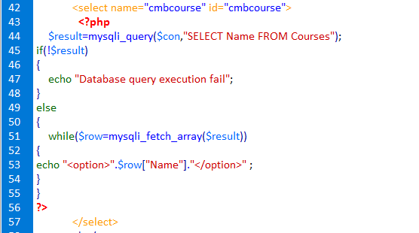

Figure 65 - Course Details Search Code

Above image is the code written here to search the course details for students. A SQL query is written here to add the course names to the search combo box so that the student can select his relevant course. If the query is successful, the values will be added into the combo box. Else it would show an error message.

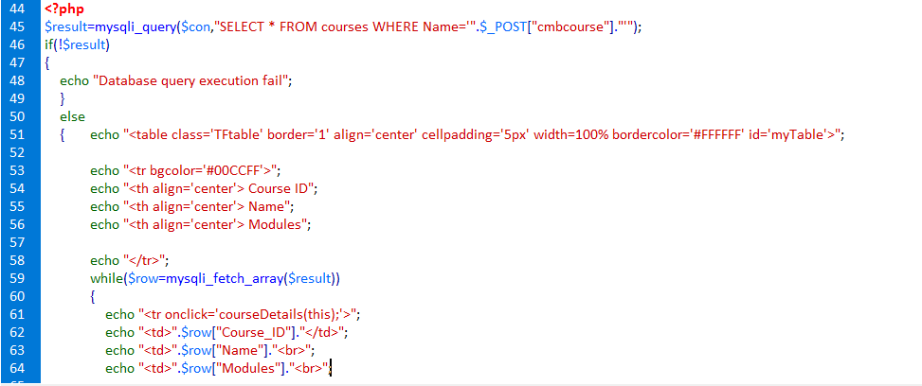

After the user selects a course from the combo box, the course details will be displayed in a table with their full details. Above image shows its code. A query has been written here to select all the courses where the batch index should be equal to the value that the user selected in the combo box. If the query is executing successfully, the table will be created showing the columns first. After the details are added inside an array, they will be added in each row. By naming the field names in the course table will bring each detail to the relevant row.

# Task 05

## Demonstrating the developed system

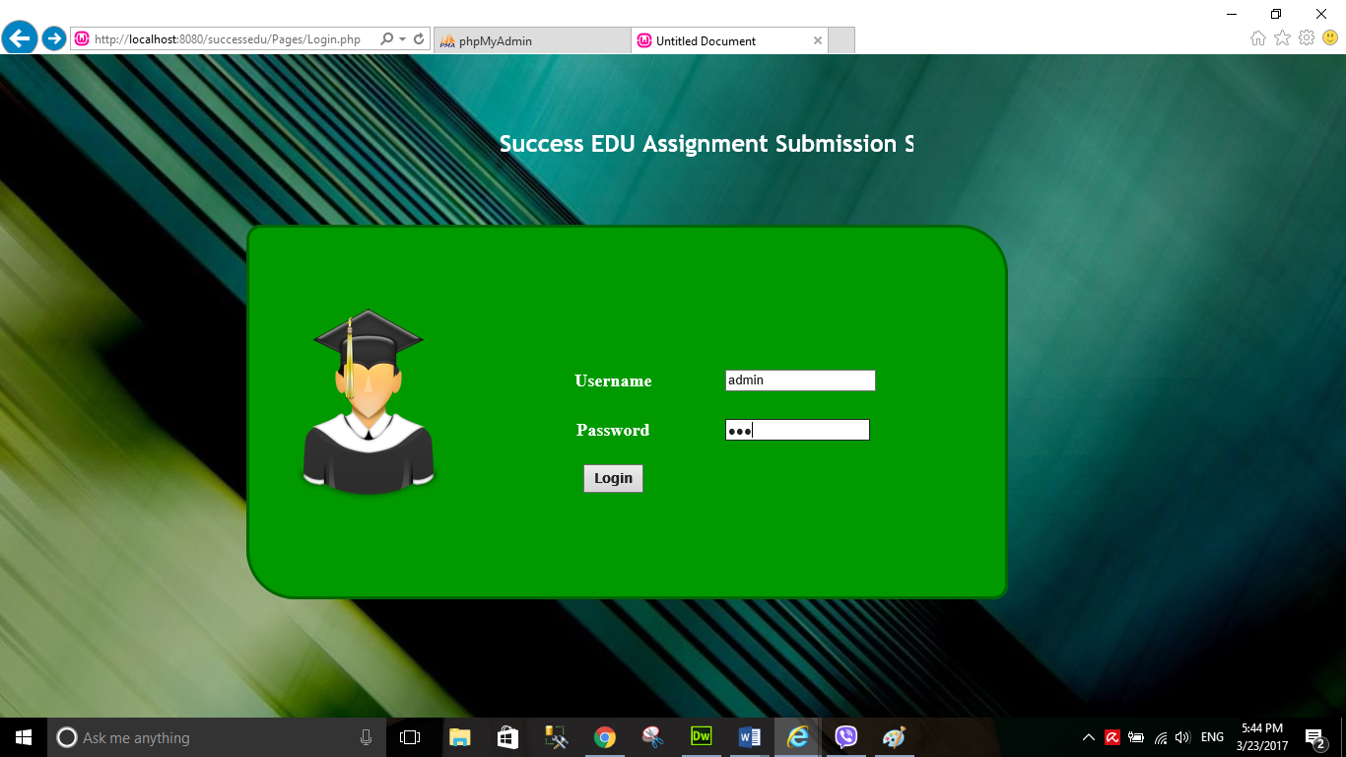In the previous task, we discussed about how the system has been developed by using PHP, HTML, CSS and JavaScript. So, now the learner is going to demonstrate the developed system. Also, in here we’ll be discussing about the user inputs. First of let’s see the Login page of the system below.

Figure 66 - Login Page

Above image shows the Login page of Success EDU online assignment submission system. To proceed to system first you have to input username and password in here. You can see that the learner has input administrator username and password to log into the system. In here for the username, a normal text box is used here. But in password we have used a special textbox to hide the characters in it. Because password is sensitive data, it should be well protected by hiding from unauthorized users. Else someone can log into the system by observing the characters. After the user clicks “Log in”, the system takes the values checks in the database whether these values are valid or not. If it is valid it would take you to the main page. Else it would show up an error message like this. For student the system would direct them to the student main page and for admin they will be directed to administrator main page

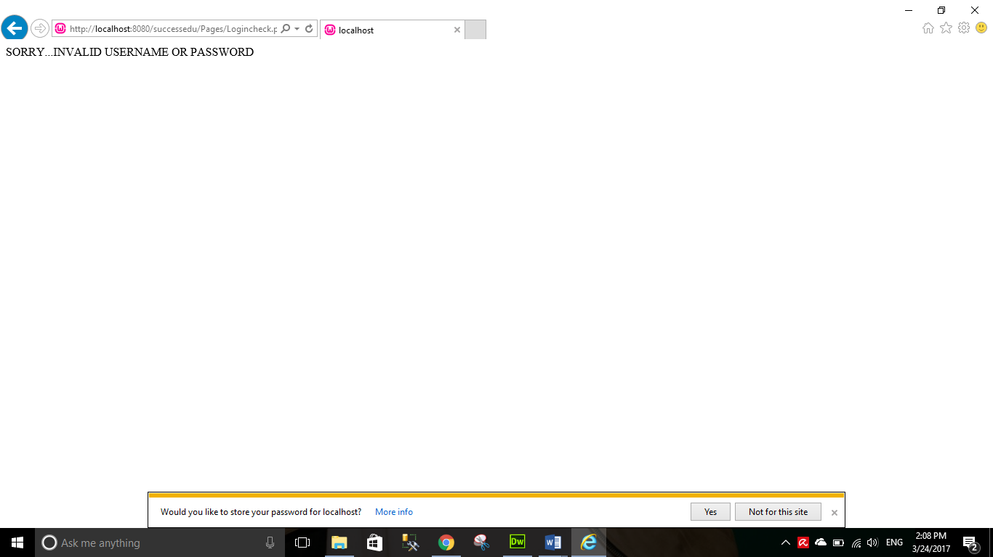

Figure 67 - Login Error message

In here the learner has used a simple html named marquee to scroll text from left to right.

Next we will discuss about the main pages in this system.



Figure 68 - Administrator Main Page

This the main page of the administrator type users of the Success EDU Student Management System. You can see the functions which are available for the administrator in this system. He can add, update, delete and search students, assignments, courses and batches. If we want he can log out of the system by simply clicking “Logout” button. In the next section will discuss each of these functions.

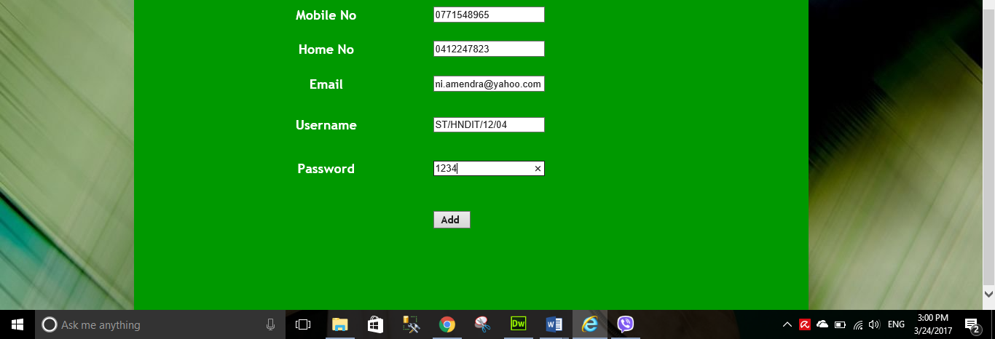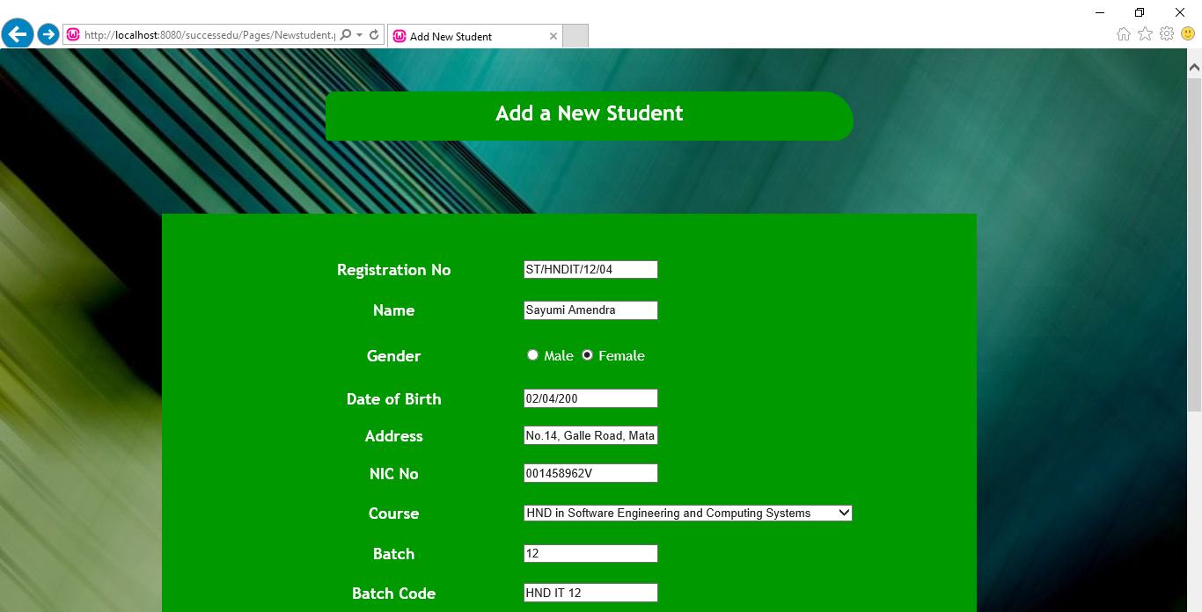

Figure 69 -Add New Student Page

Above image shows the Add New Student page. In here, administrator can create or add new students to the system, so that they can also log into the system and submit assignments online. In this page we have used text boxes for user inputs, radio buttons to select the gender and combo box to select the course. Student has to fill all the details especially Registration Number, Batch, Mobile No, etc. else it would show up error messages like this.

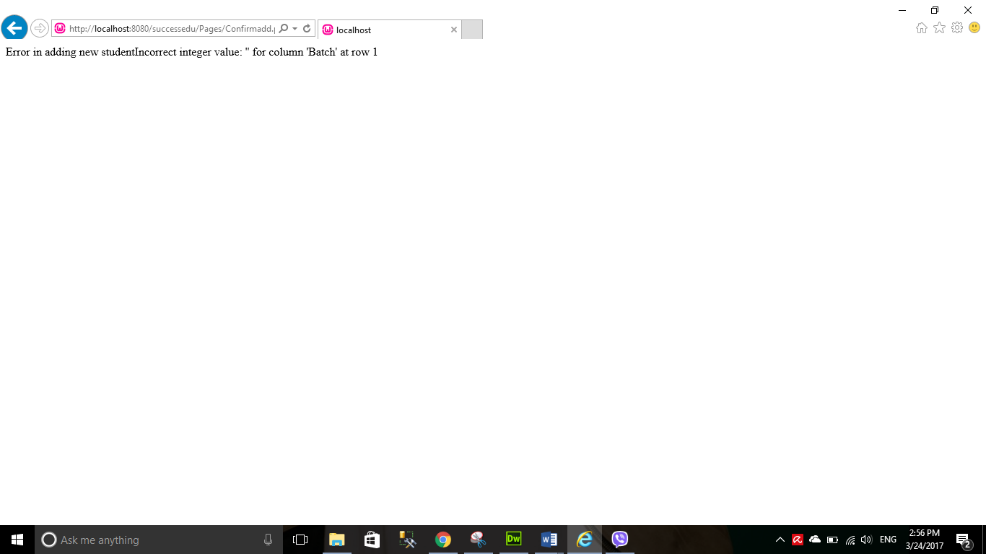

Figure 70 - Add New Student Error message

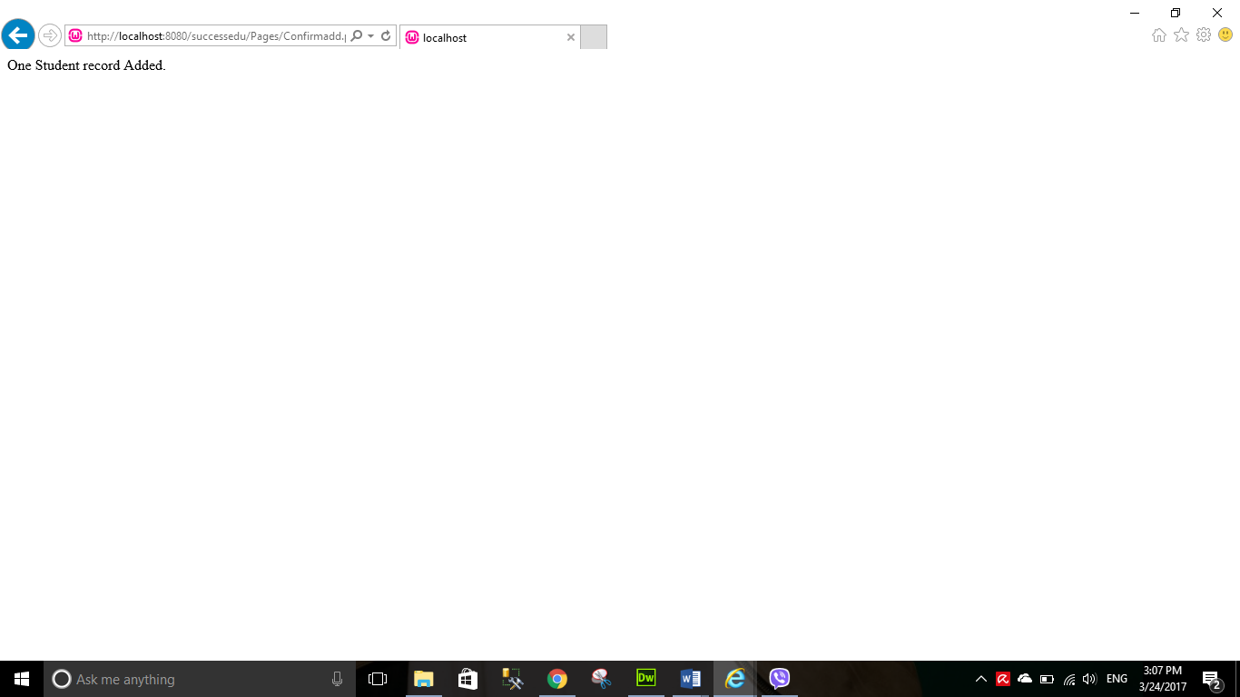If the it is successful it would send up this message.

Figure 71 - Add New Student Message if Successful



Figure 72 - Add Student Database record

You can see in the above picture that the student has been added into the database. Therefore, we can conclude that there aren’t any errors in accepting user inputs. Now let’s discuss about the manage students page. In there you can search update and delete students. When you click “Manage Students” page first you will see the search student page. User must first search and select the student in order to proceed.

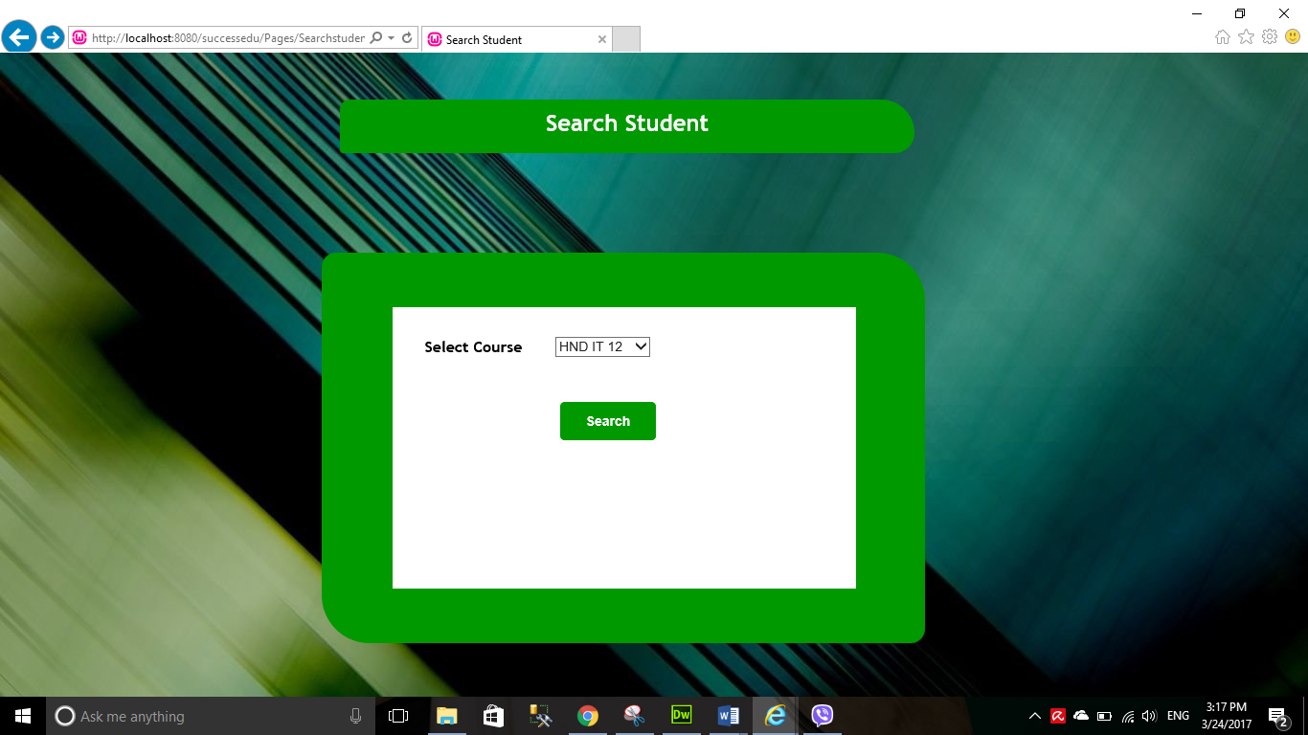

Figure 73 - Search Student

Above image shows the search student page. In here, first the user has to select the course to proceed. In here the picture shows that HND IT 12 has been selected. We have used combo box to select courses. After the user has selected, he has to just click search to proceed.

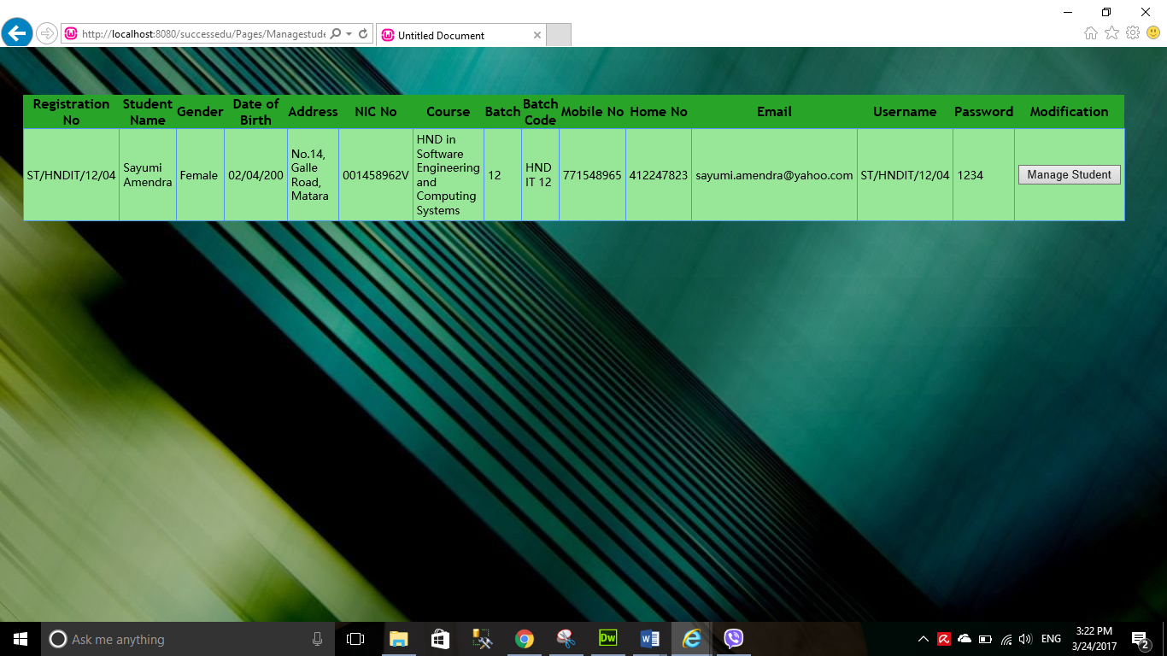

Figure 74 - Search Student showing results

You can that the system shows the results of the student who’s under course “**HND IT 12”**. It shows the student’s full details. To update or delete them we just need to click “Manage Student” button.

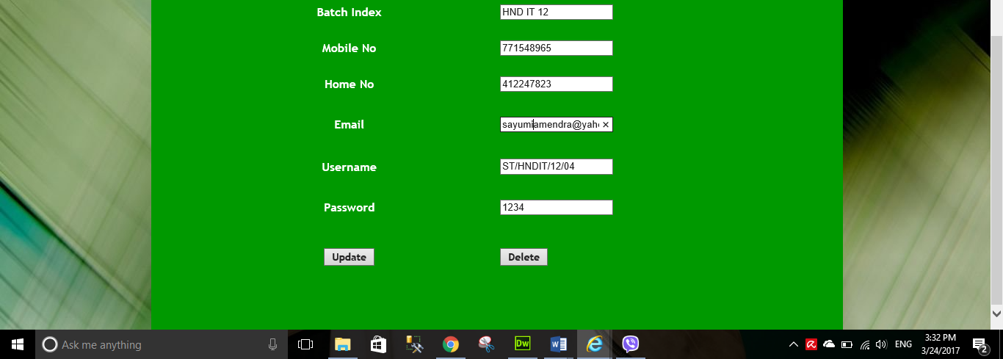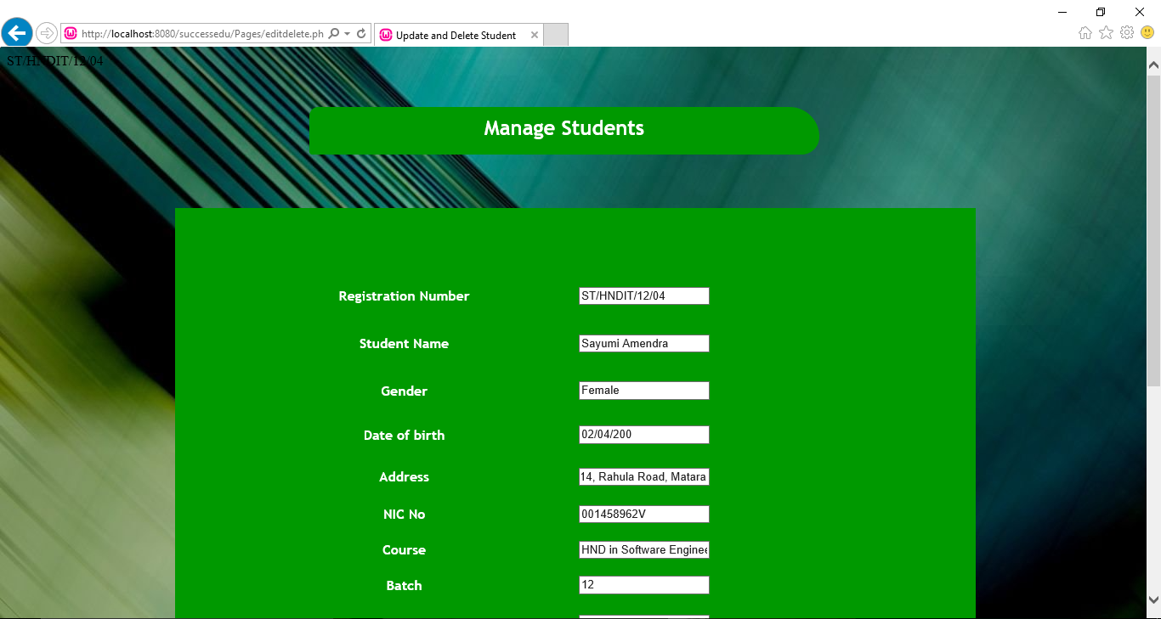

Figure 75 - Manage Students

Above image shows the update and delete or manage students page. In here I have edited some details to proceed up. After editing just click Update to update the details. Below image shows the message if the update is successful.

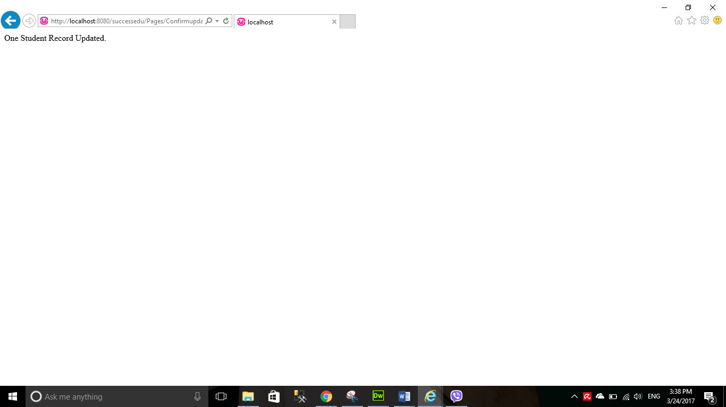

Figure 76 - Update Message

This is the message you’ll get when the record is deleted.

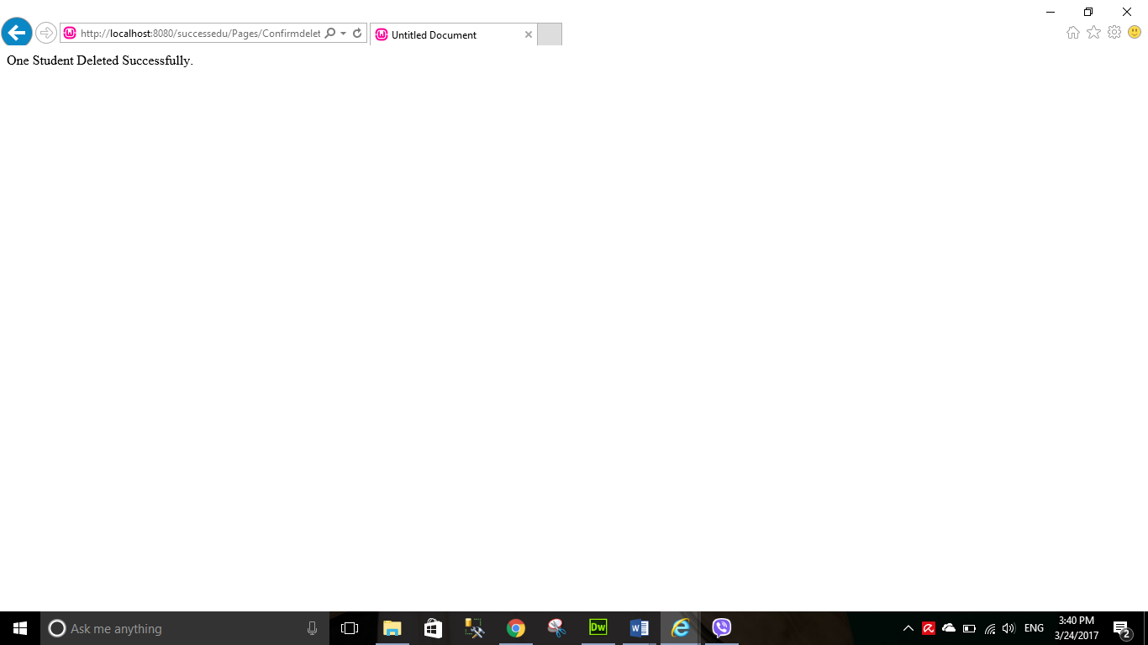

Figure 77 - Delete Message

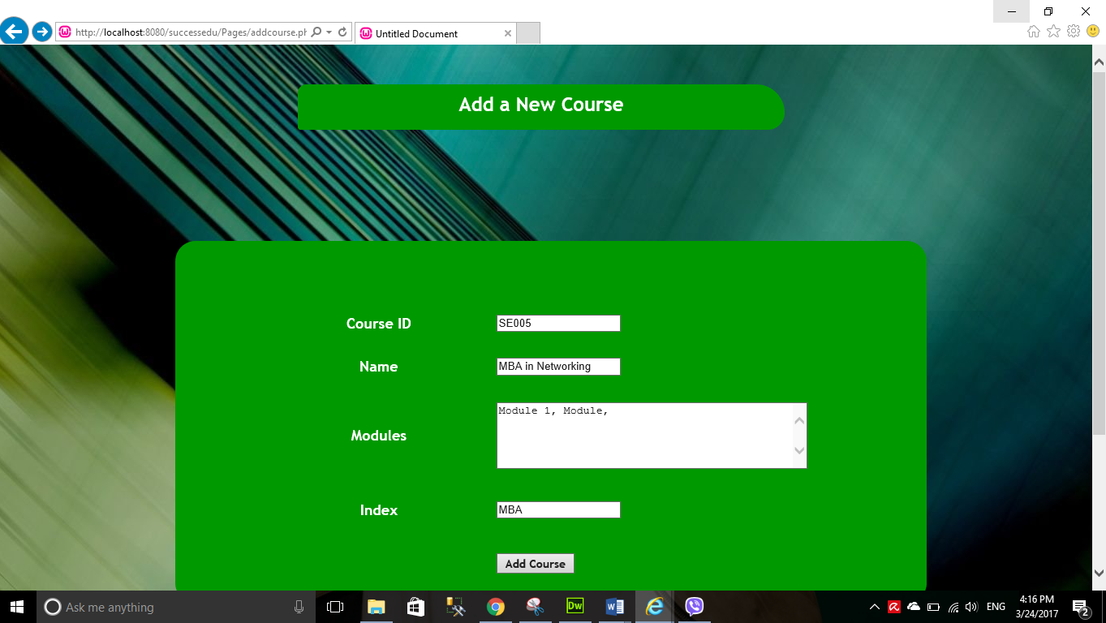

Figure 78 - Add Course

This is the add course page. In this page user can add new courses.

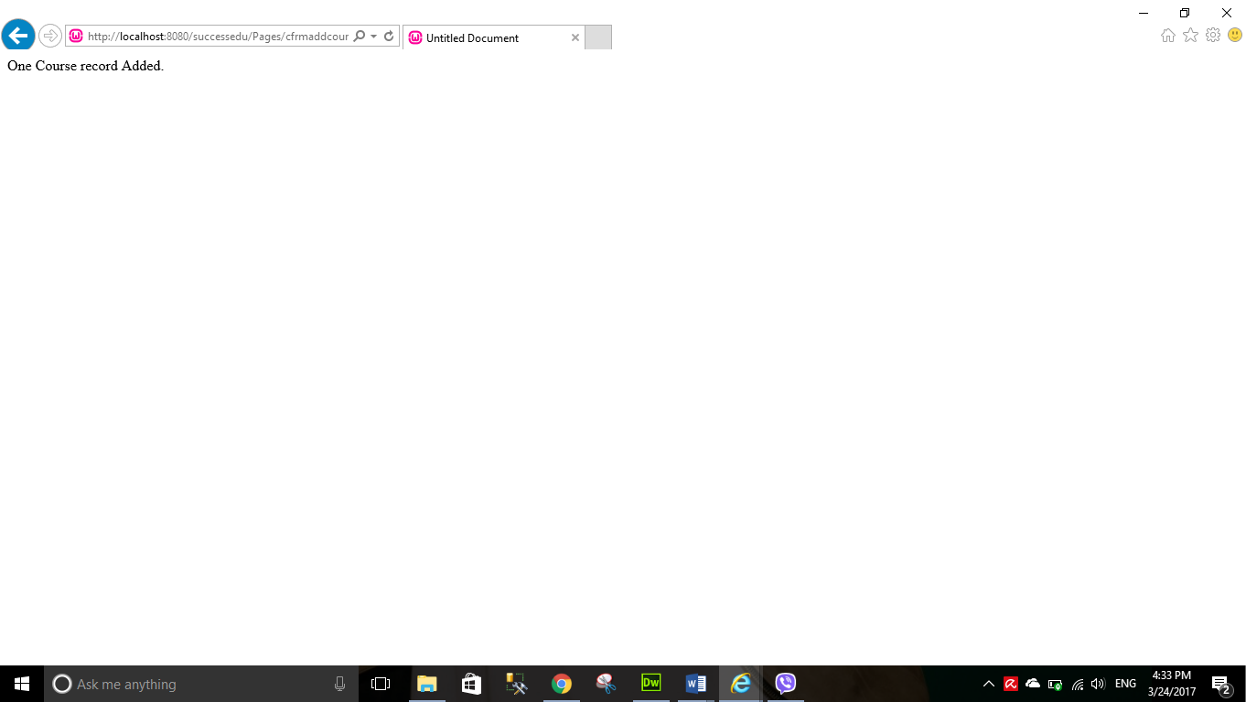

Figure 79 - Add Course Message

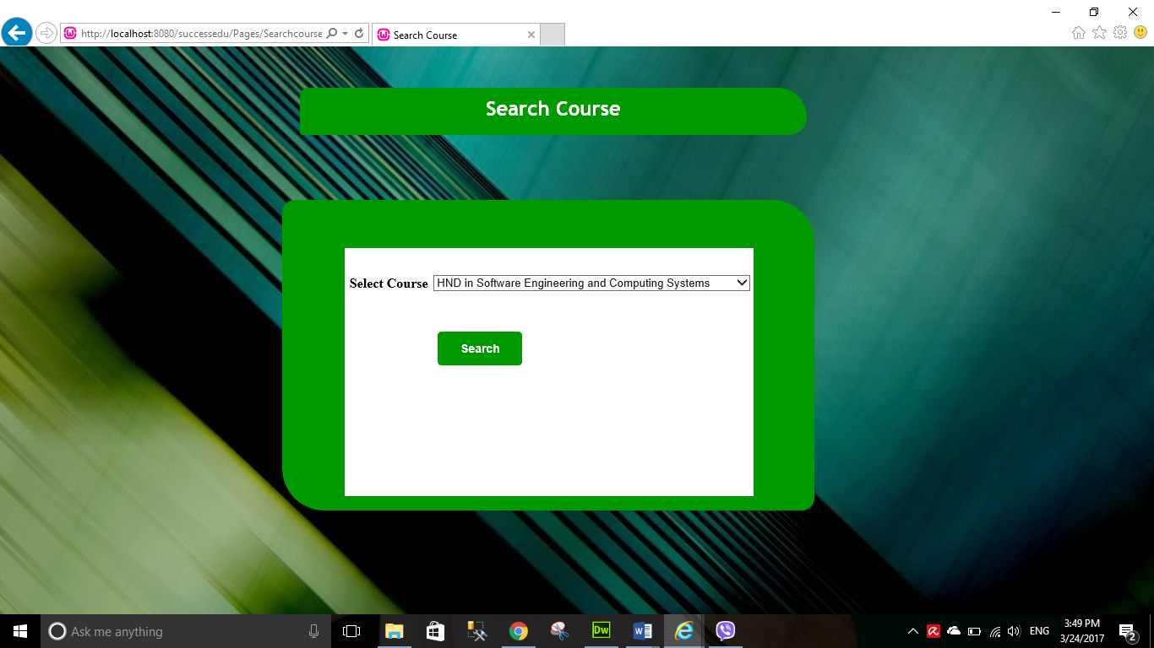

Figure 80 - Search course

This the search course page. User can search courses by selecting them from the combo box.

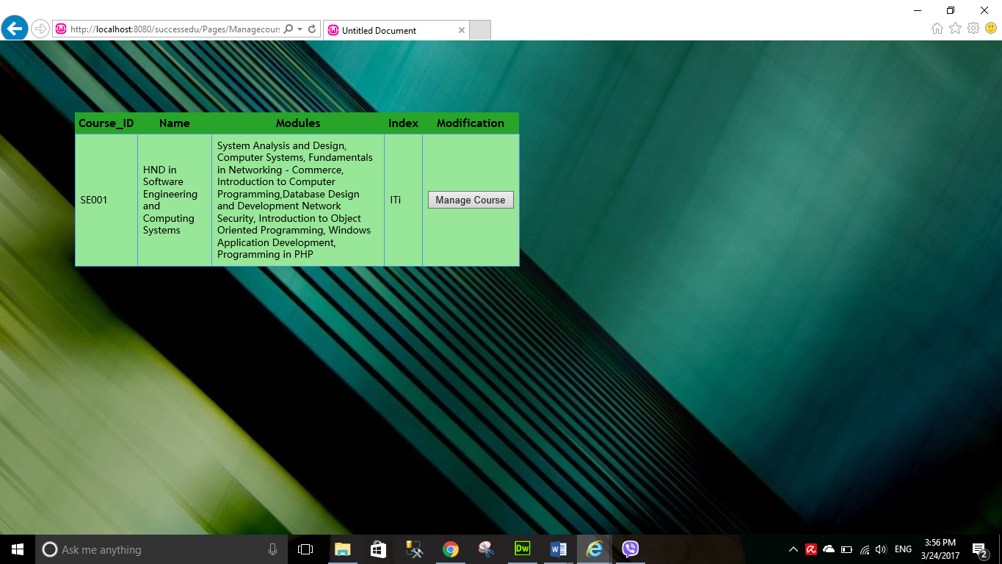

Figure 81 - Search Couse details in table

After you select a course and click Search, you will get the results as in the above image. To proceed select “Manage Course” button.

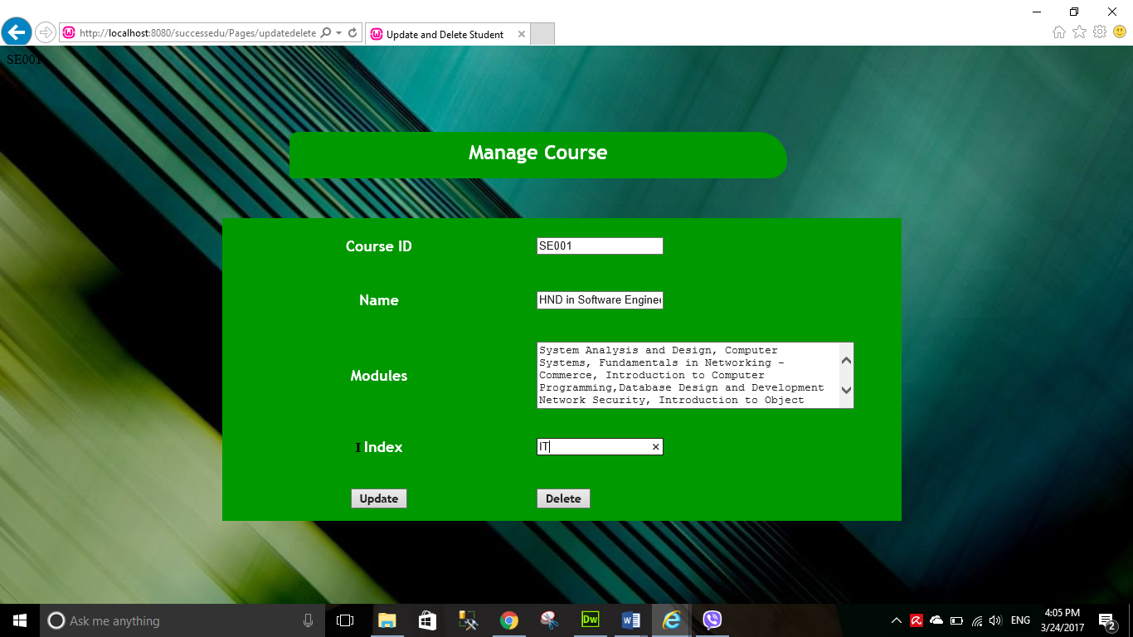

Figure 82 - Manage Course

This the update and delete page of the courses. Users can update and delete courses in here.

These are the messages you get when the update and delete is successful.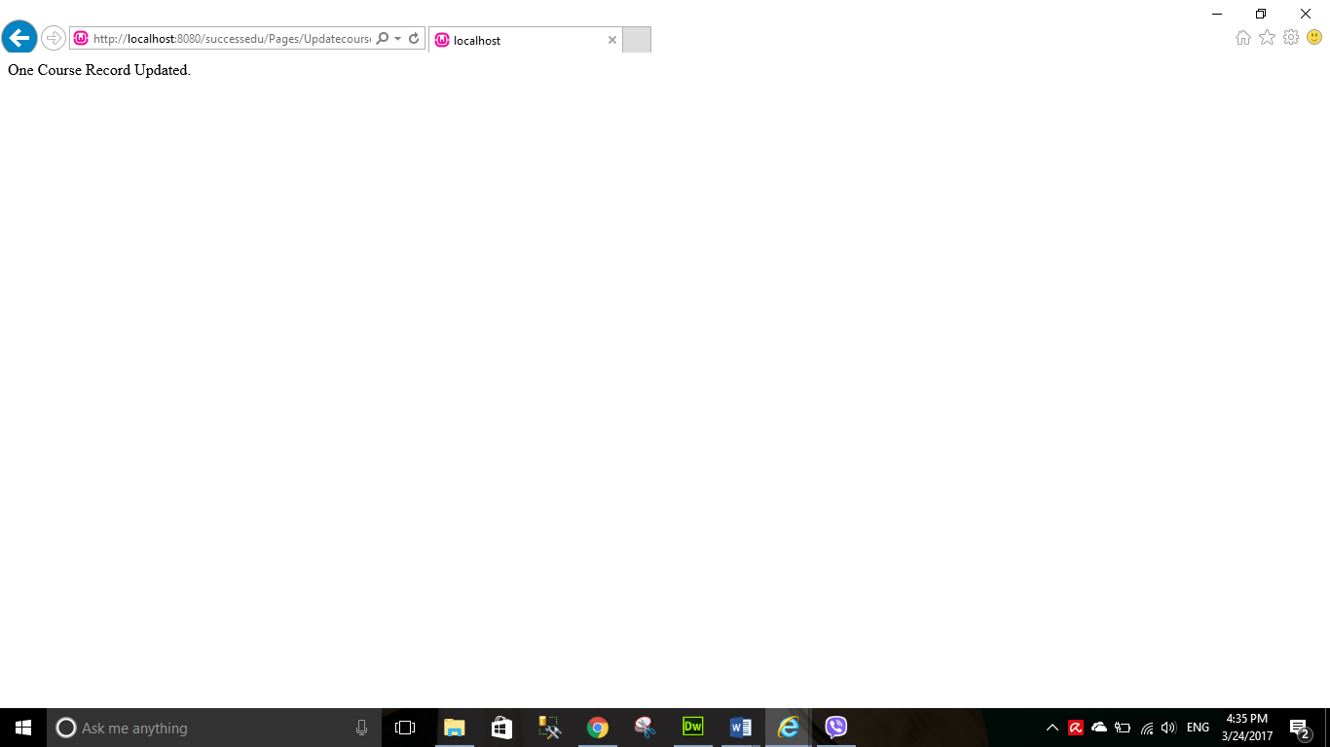

Figure 83 - Update Message

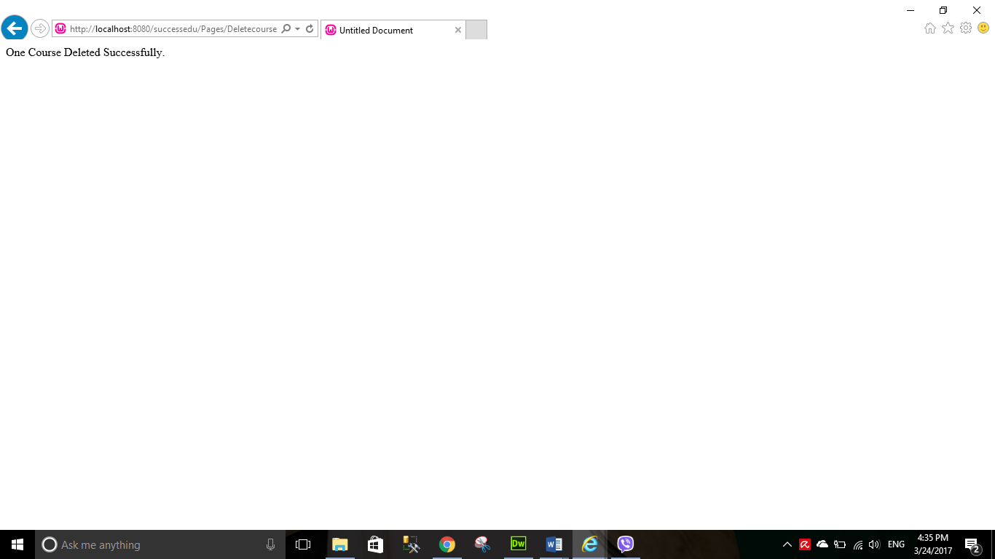

Figure 84 - Delete message

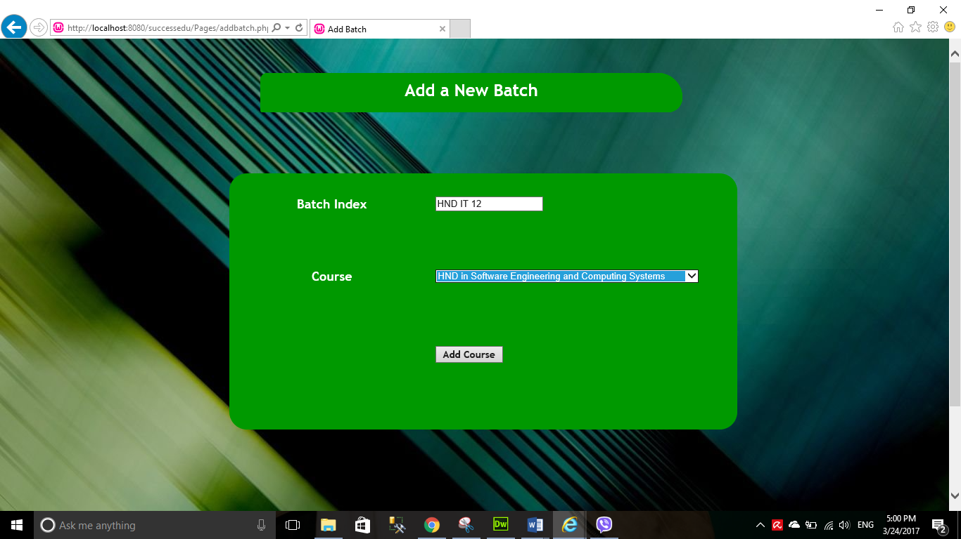Now we are going to talk about the Batch Adding of administrator main page.

Figure 85 - Add New Batch

This the Add Batch page. In here users can add new batches.

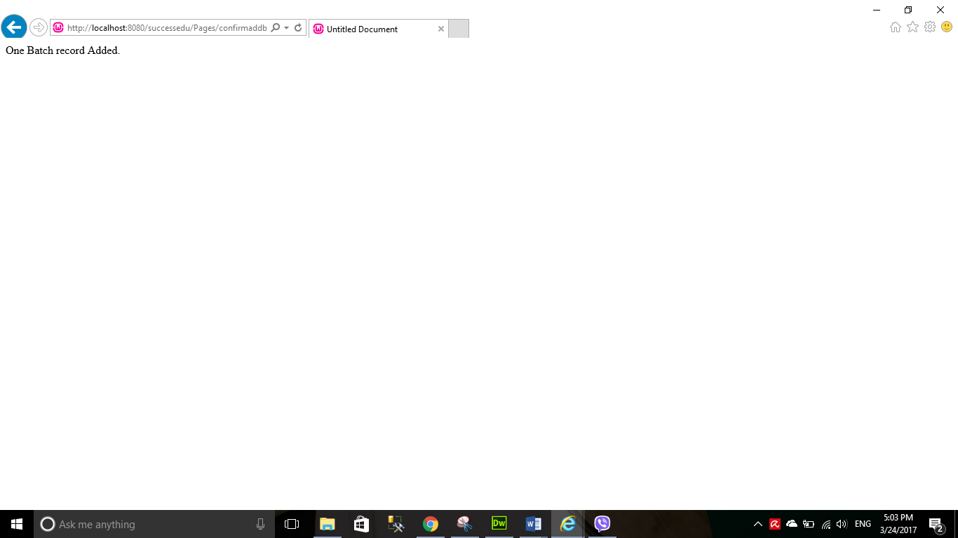

Figure 86 - Add Batch Message

This is the message you get when have add a new batch successfully.

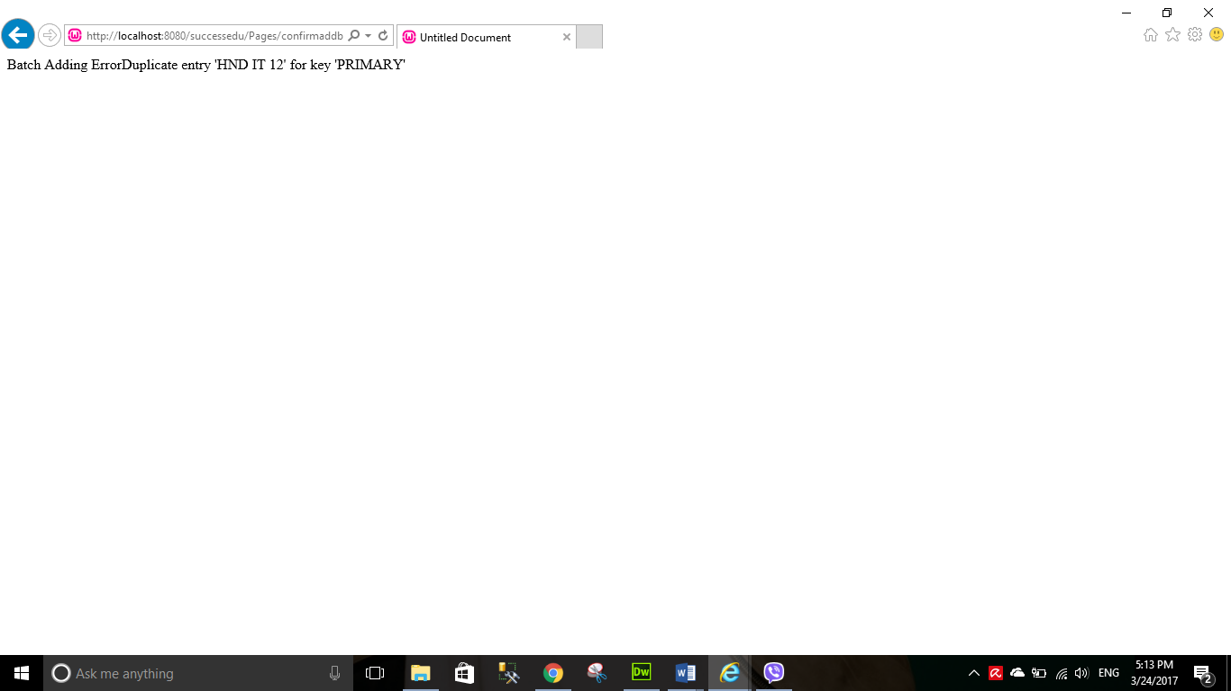

Figure - Error Message

This is the error message you would get if there is an error in adding new batch.

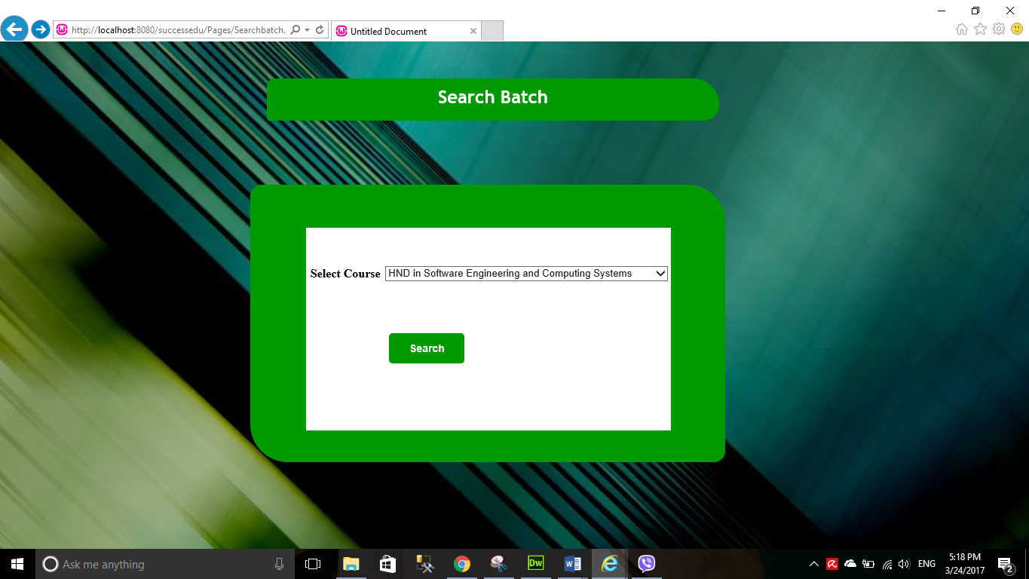Now we are going to discuss about batch updating and delete. First you will see the search page of batch. To update or delete users first must search by selecting a course.

Figure 88 - Search Batch

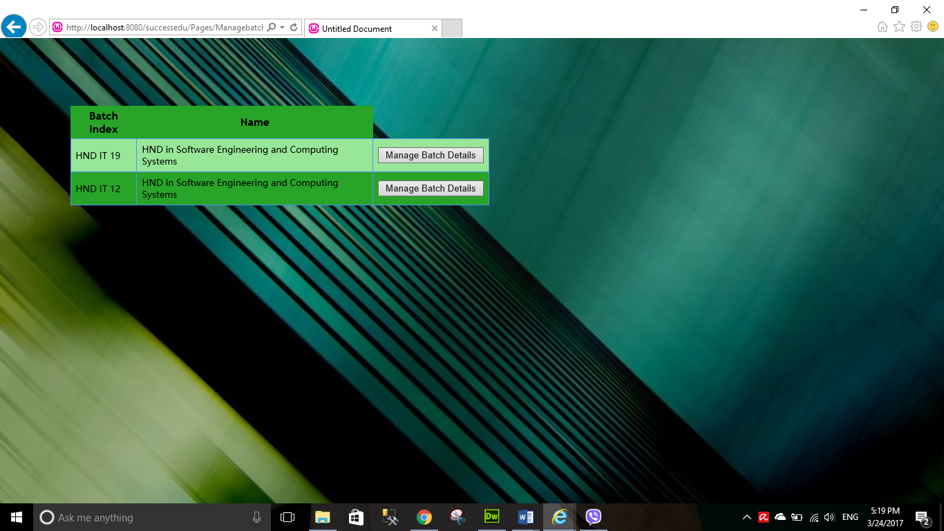Below is the result you get after searching a batch.

Figure 89 - Batch Table results

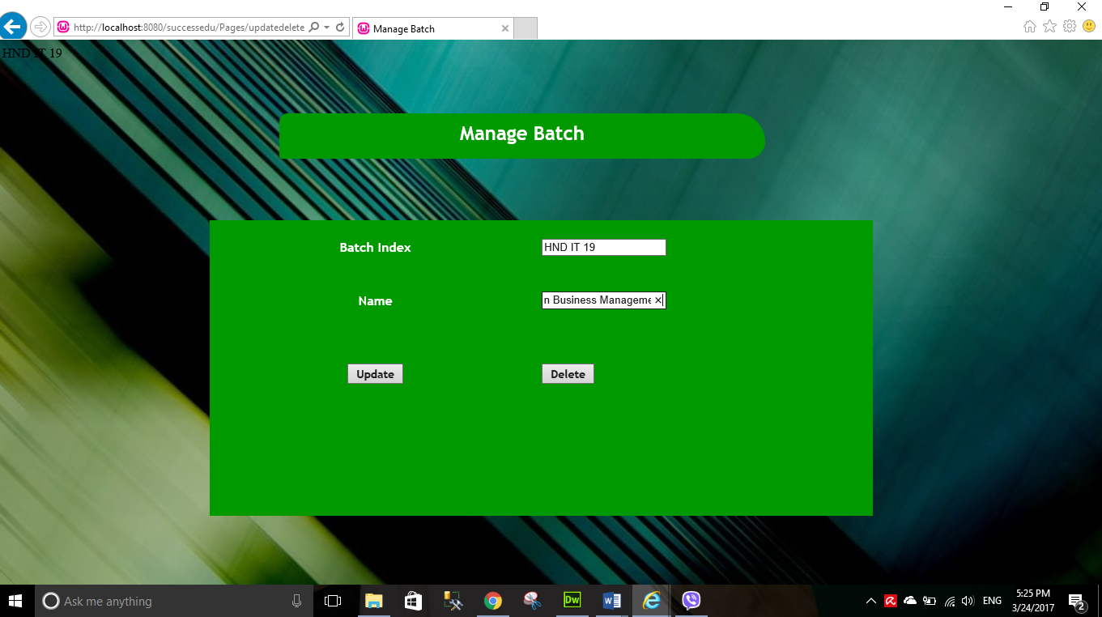After the user clicks “Manage Batch” he will be directed to the Manage Batch page/ In their user can update and delete records.

Figure 90 - Manage Batch

This is the message you would get after updating batch details.

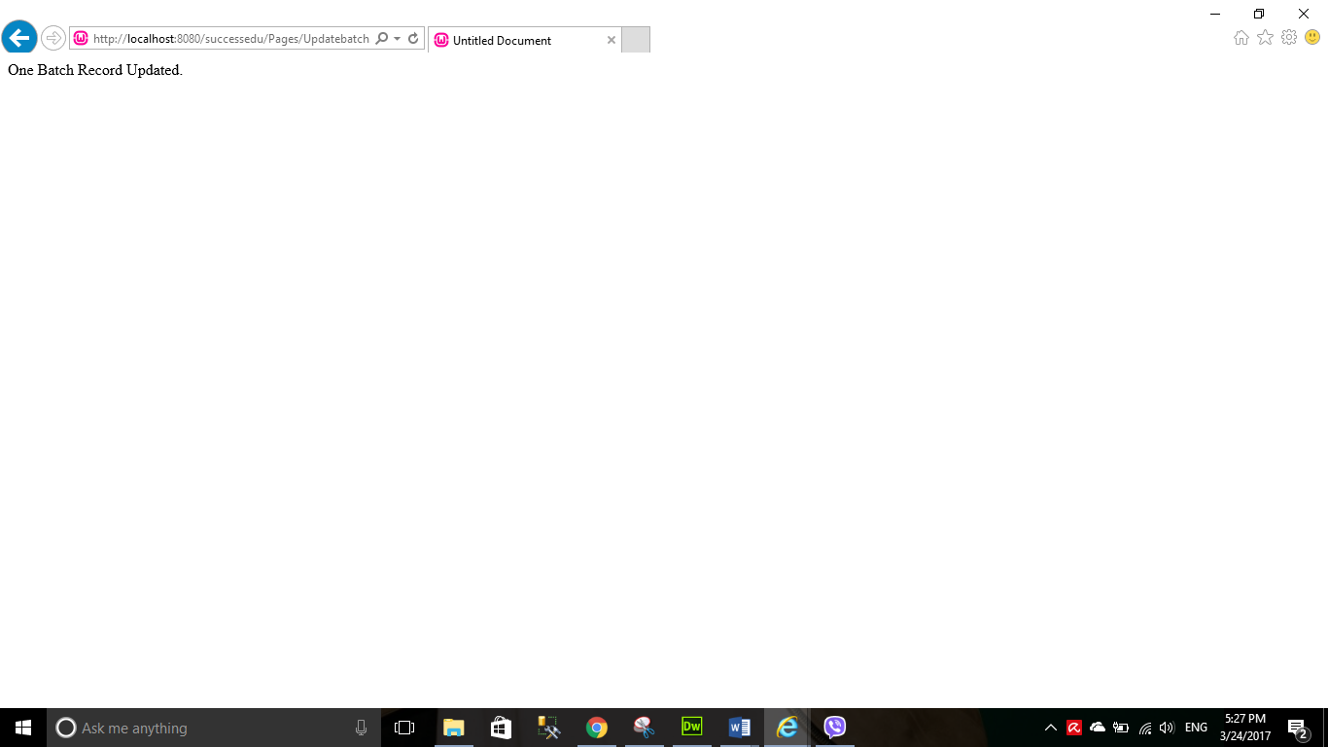

Figure 91 - Batch Delete Message

This is the message you would get after deleting a record successfully.

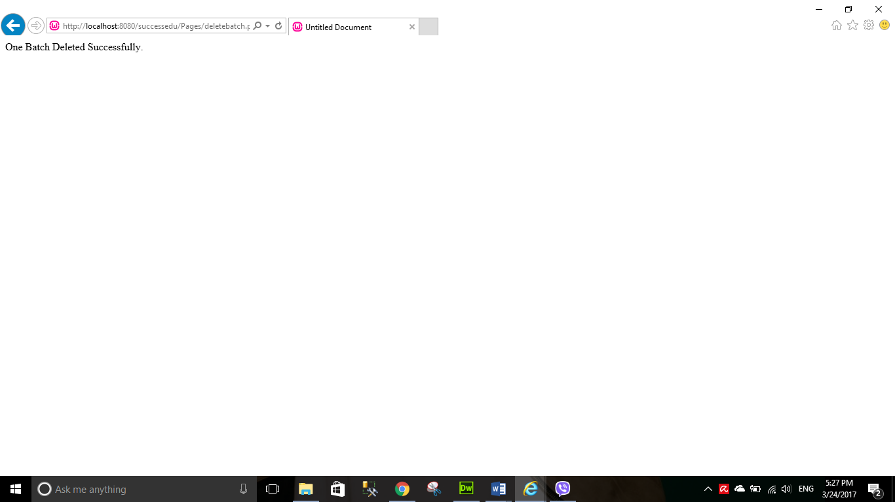

Figure 92 -Batch Delete Message

Now we are going to discuss about assignment adding, updating and delete. First let’s see the interface of Assignment adding.

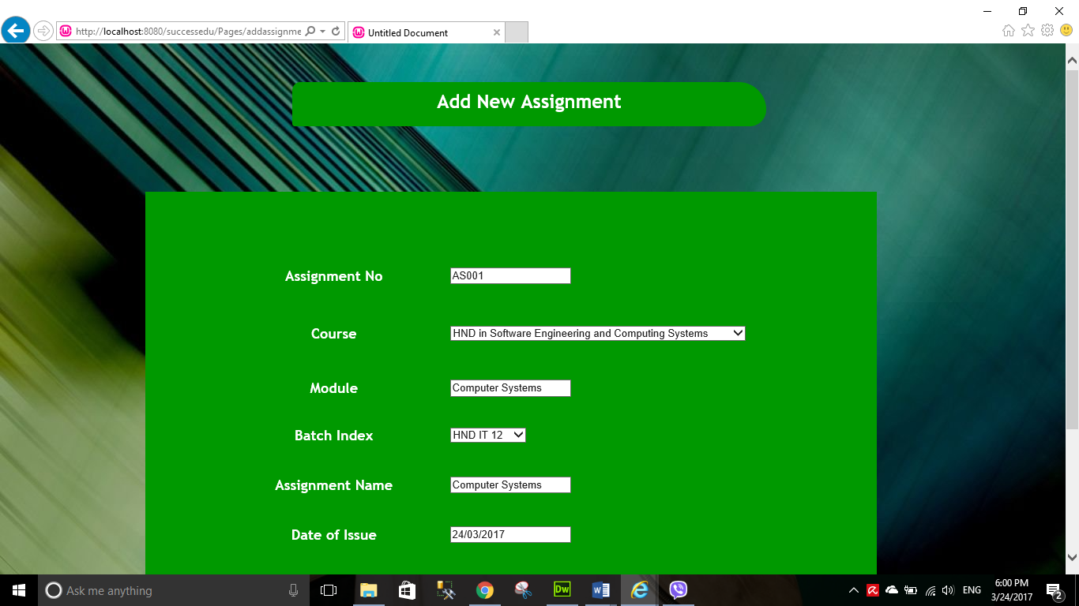

Figure 93 - Add Assignment

Above image shows the assignment adding page. In here users can add assignments. Below is the image of the message you get when data is added successfully.

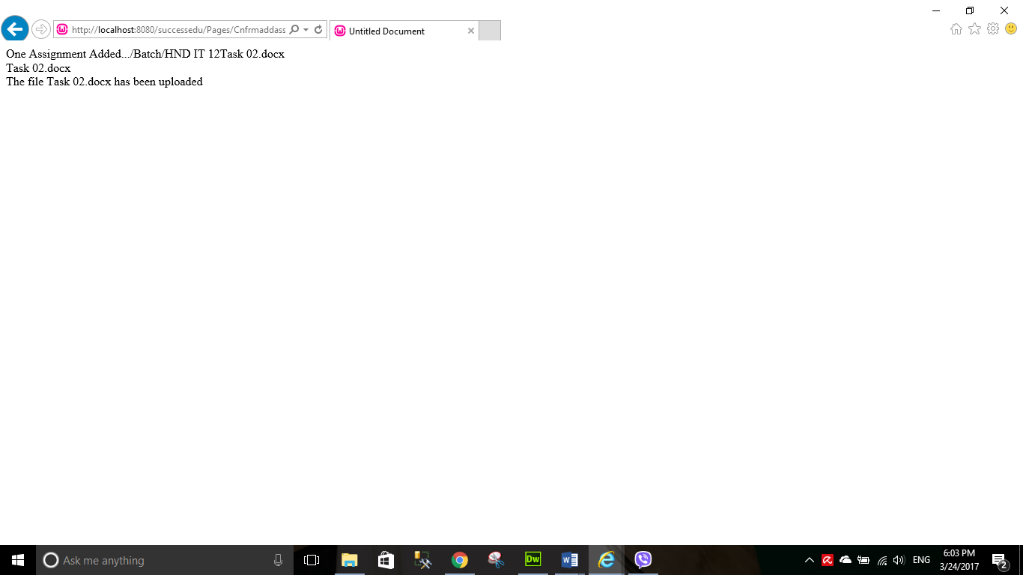

Figure 94 - Add Assignment Message

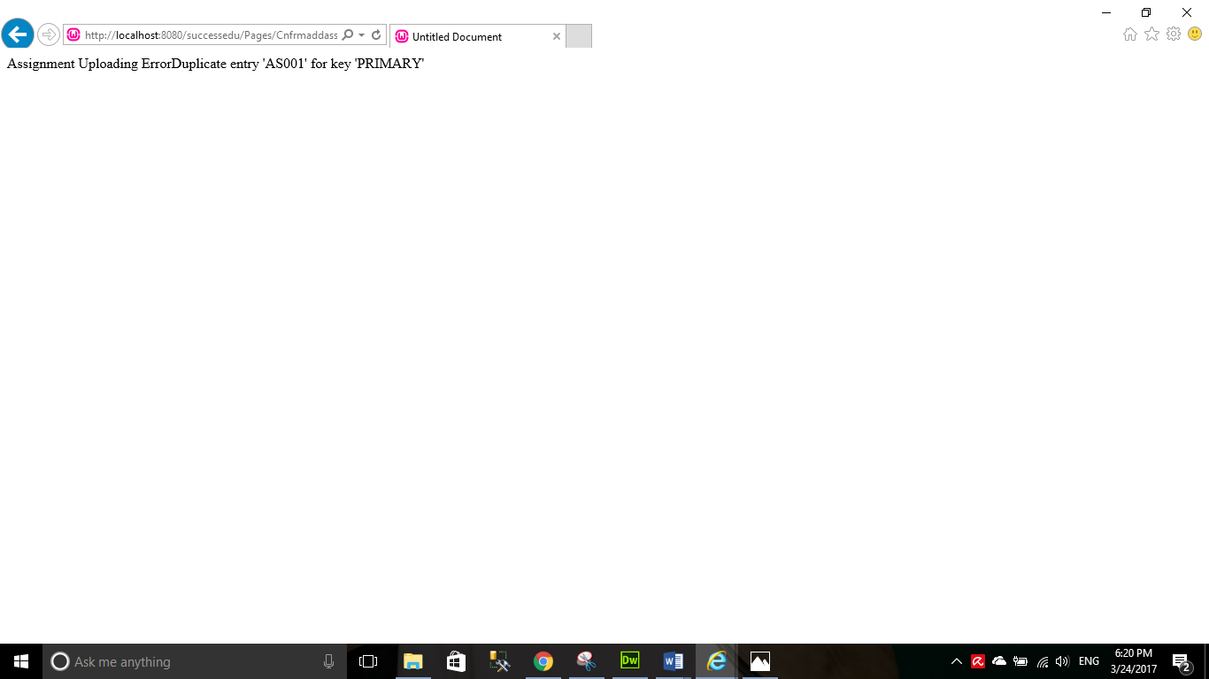Bellow image shows an error message when you add assignments incorrectly

Figure 95 - Add Assignment Error

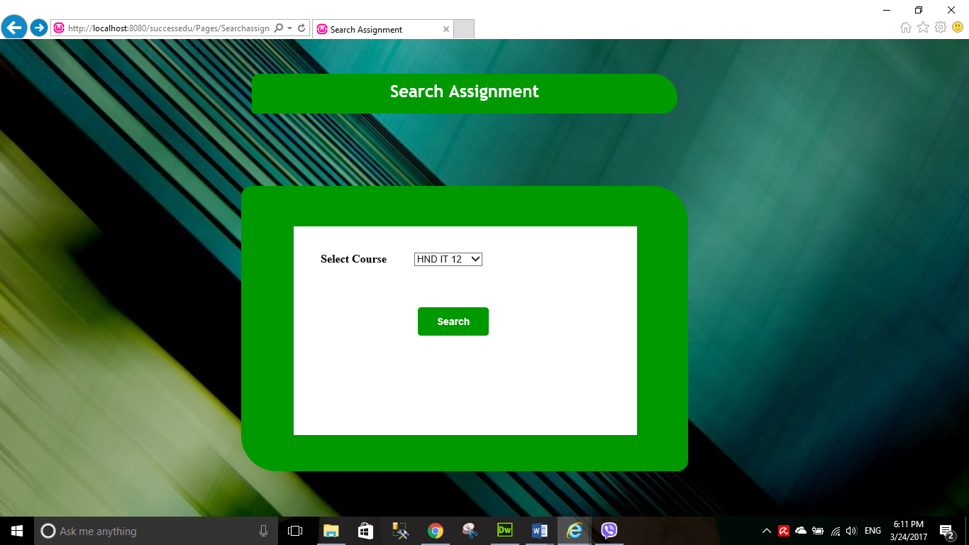Below image shows the assignment searching page.

Figure 96 - Search Assignment

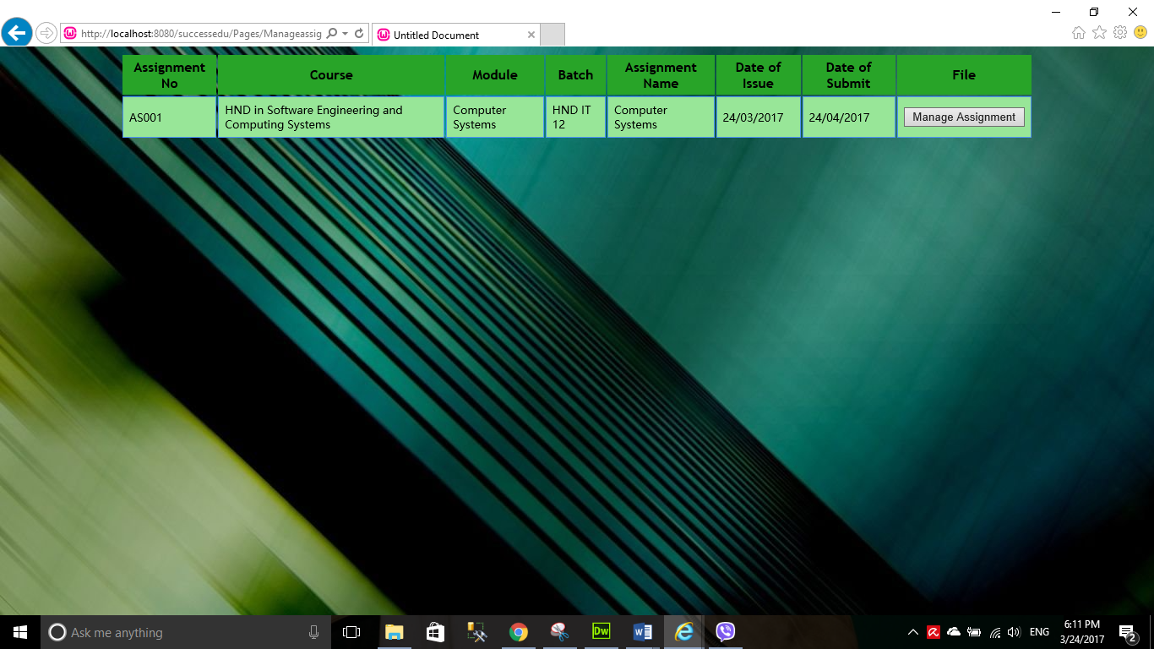This is the result page you get after searching assignments.

Figure 97 - Assignment Details

This is the update delete page of assignments.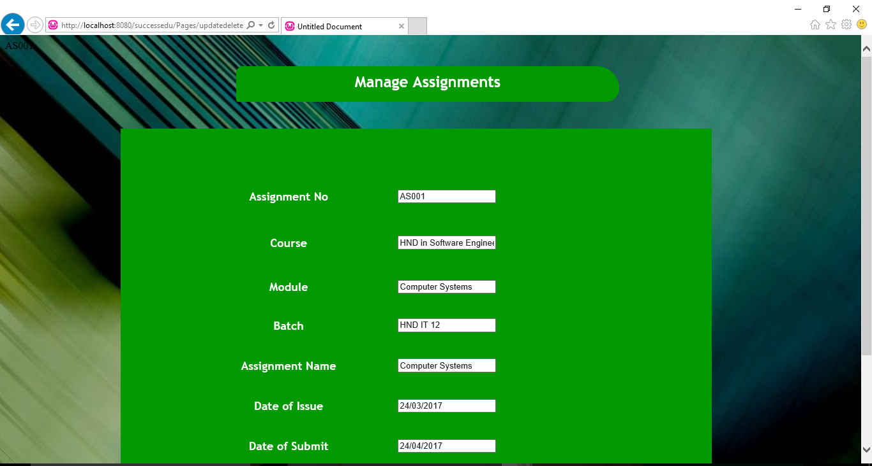

Figure 98 - Manage Assignments

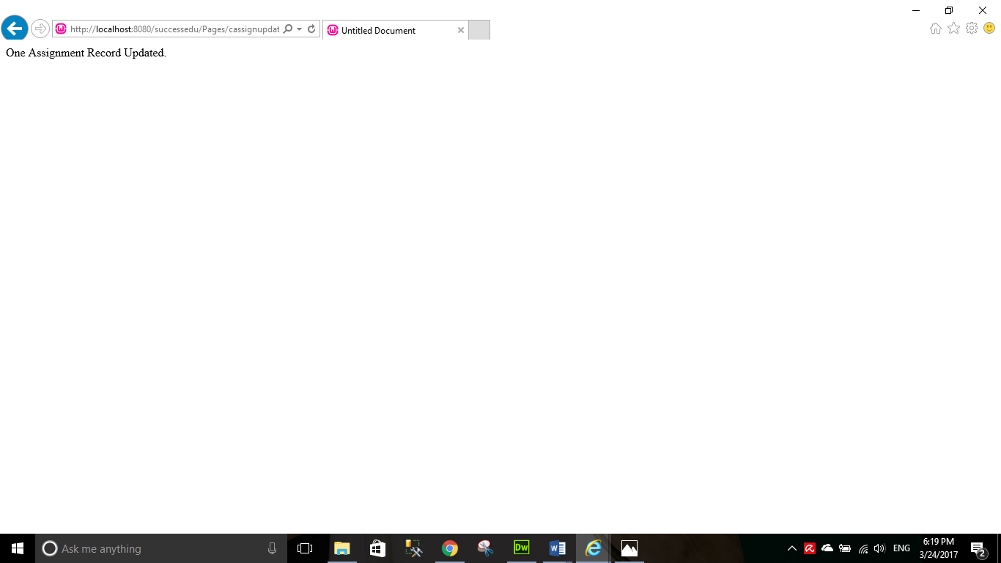This is the message you would get after you update the assignment successfully.

Figure 99 - Assignment Update Message

This is the message you would get after deleting assignment.

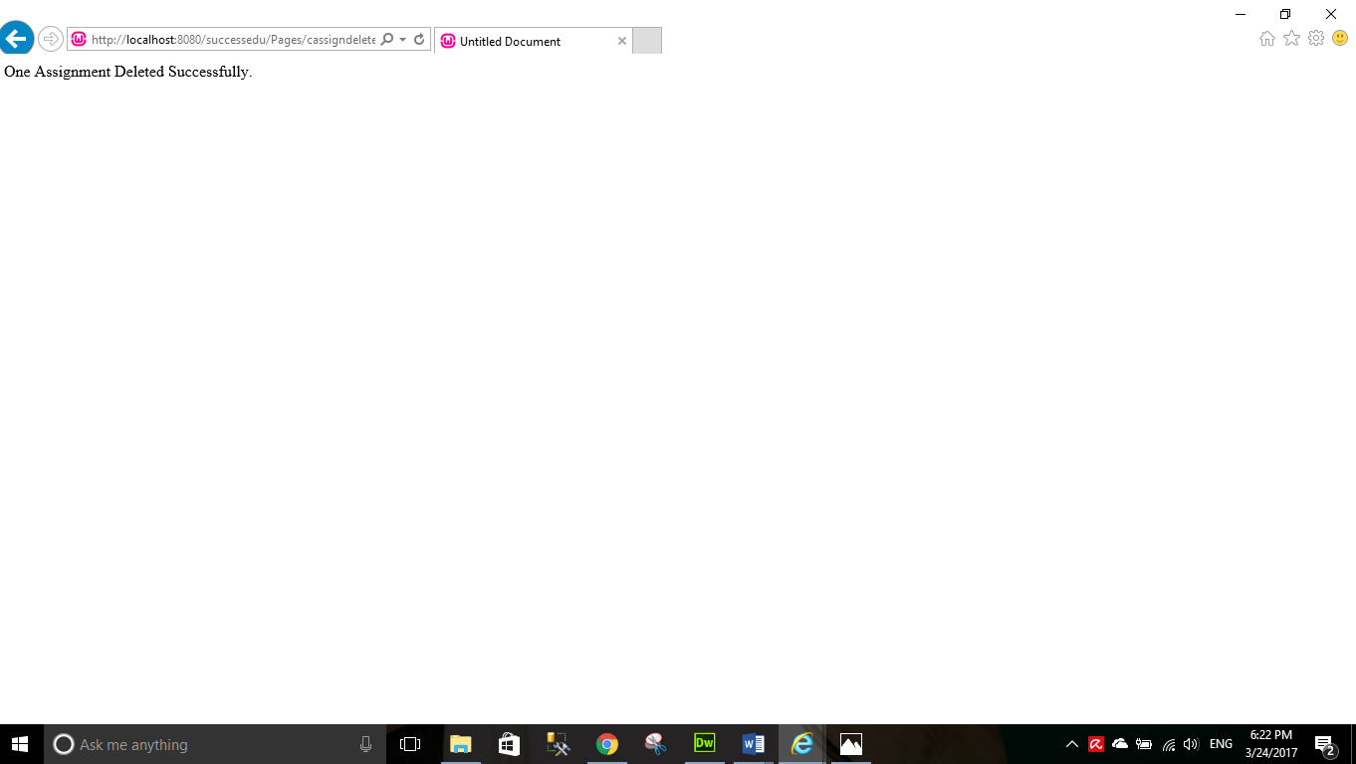

Figure 100 - Assignment Delete Message



Figure 101 - Student Main

Above image shows the student main page. In here students can view their profile, download assignments, submit assignments and view course details. Let’s see each of these functions.

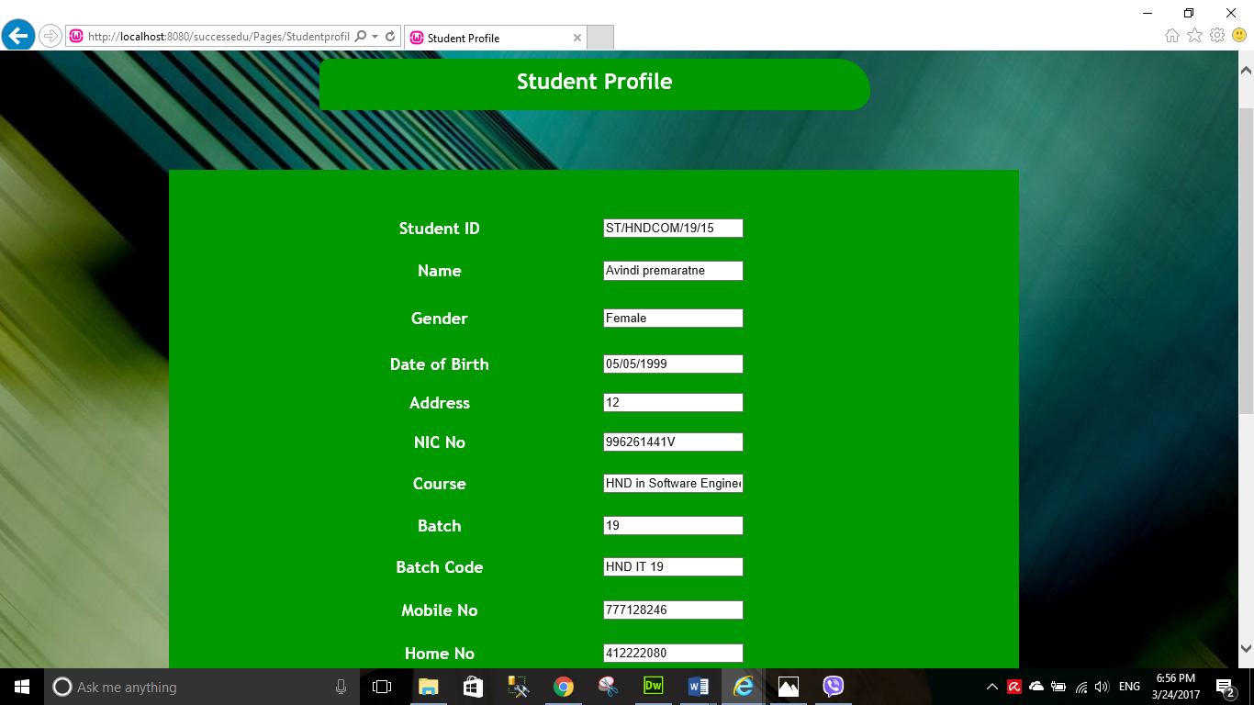Below is the image shows student profile.

Figure 102 - Student Profile

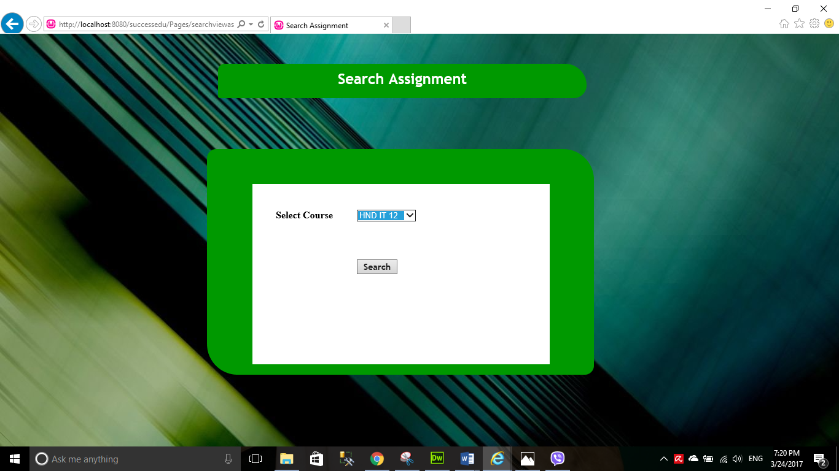Next image you can see the Assignment schedules search assignment page. In here students can search relevant assignment and download it.

Figure 103 - Search Assignment

After you select a course and click Search button the results will be displayed like below.

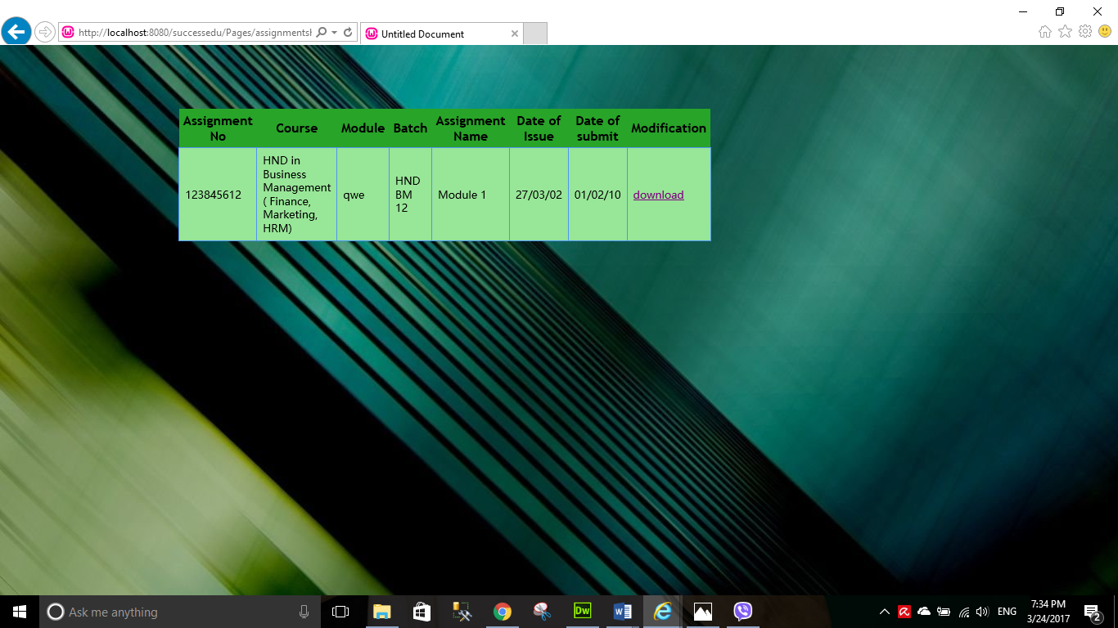

Figure 104 - Assignments View

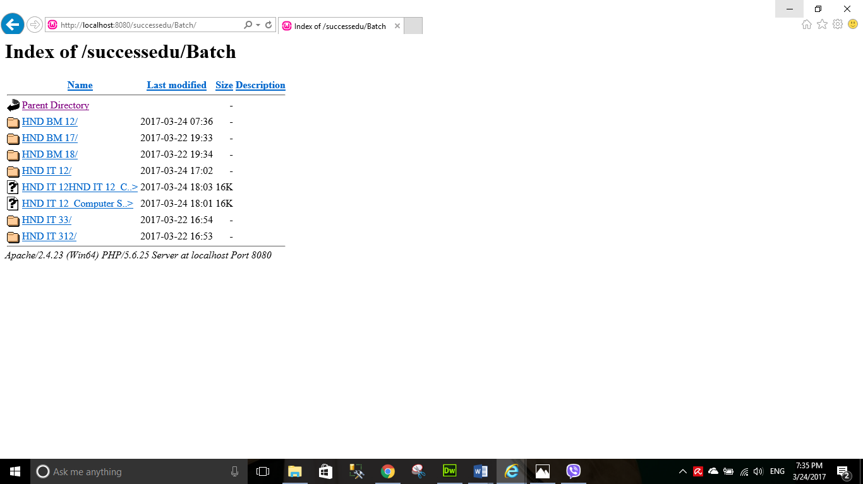After you click download, the button will direct you to this page. You have to select the file and download it.

Figure 105 - Assignment Download

Below image shows the assignment submission of the system. In here first the user have to search their relevant course (batch index) to submit.

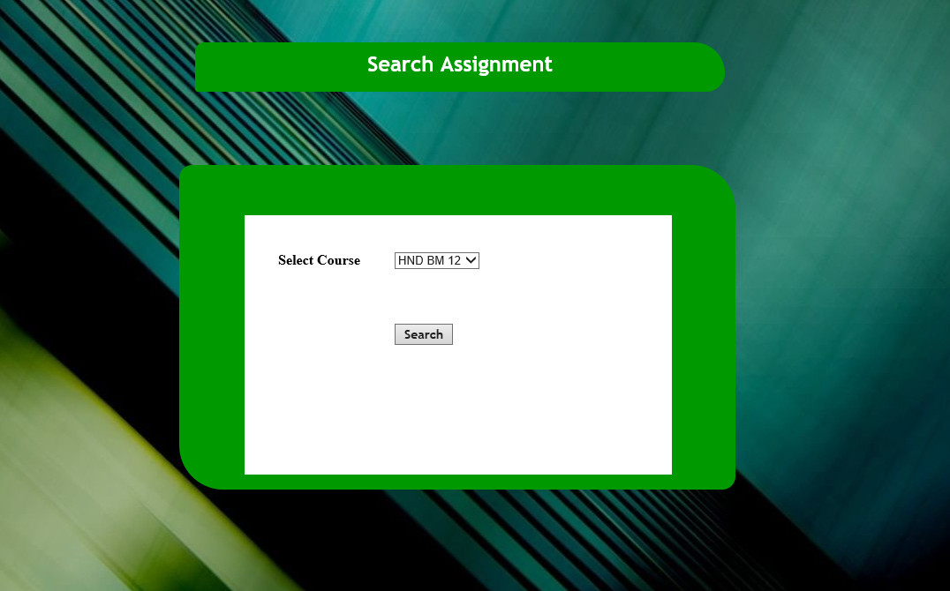

Figure 106 - Search Assignment

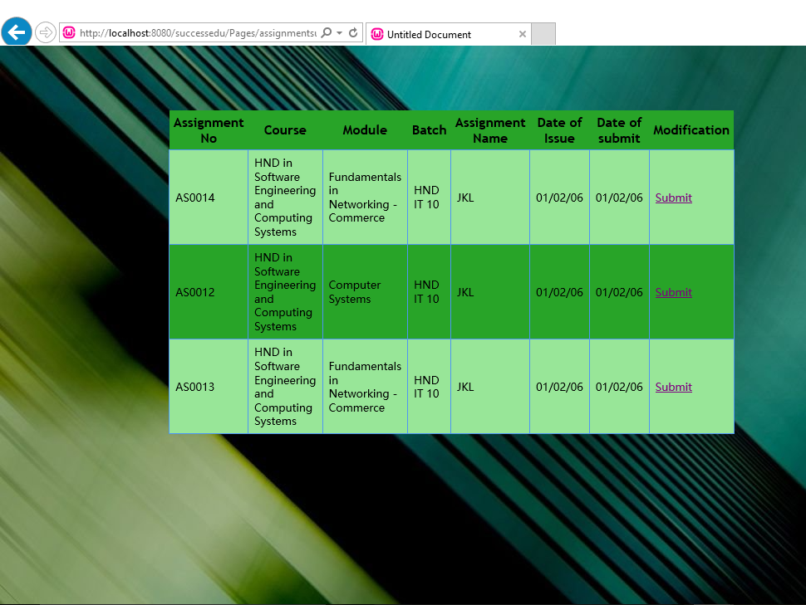Next, the user has to select the relevant assignment to submit. To do so, there’s a hyperlink named “Submit” which will direct to the assignment submission page.

Figure 107 - Assignment Submission Table

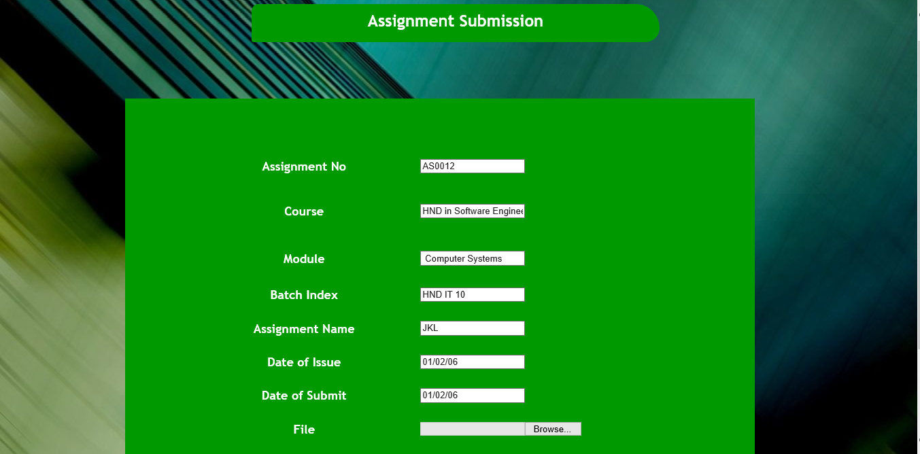After you come to submission page we need to enter Student NIC number, name and upload the file to submit it.

Figure 108 - Assignment Submission

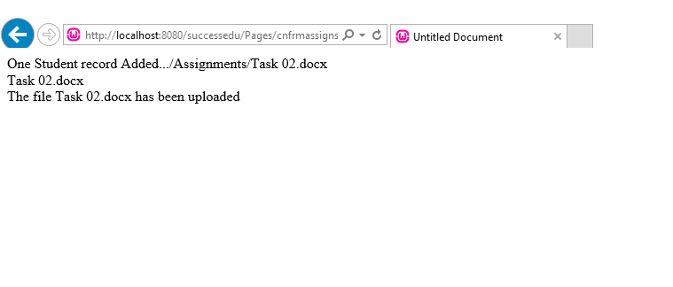If the assignment submission was successful you would get this message.

Figure 109 - Assignment Submit Message

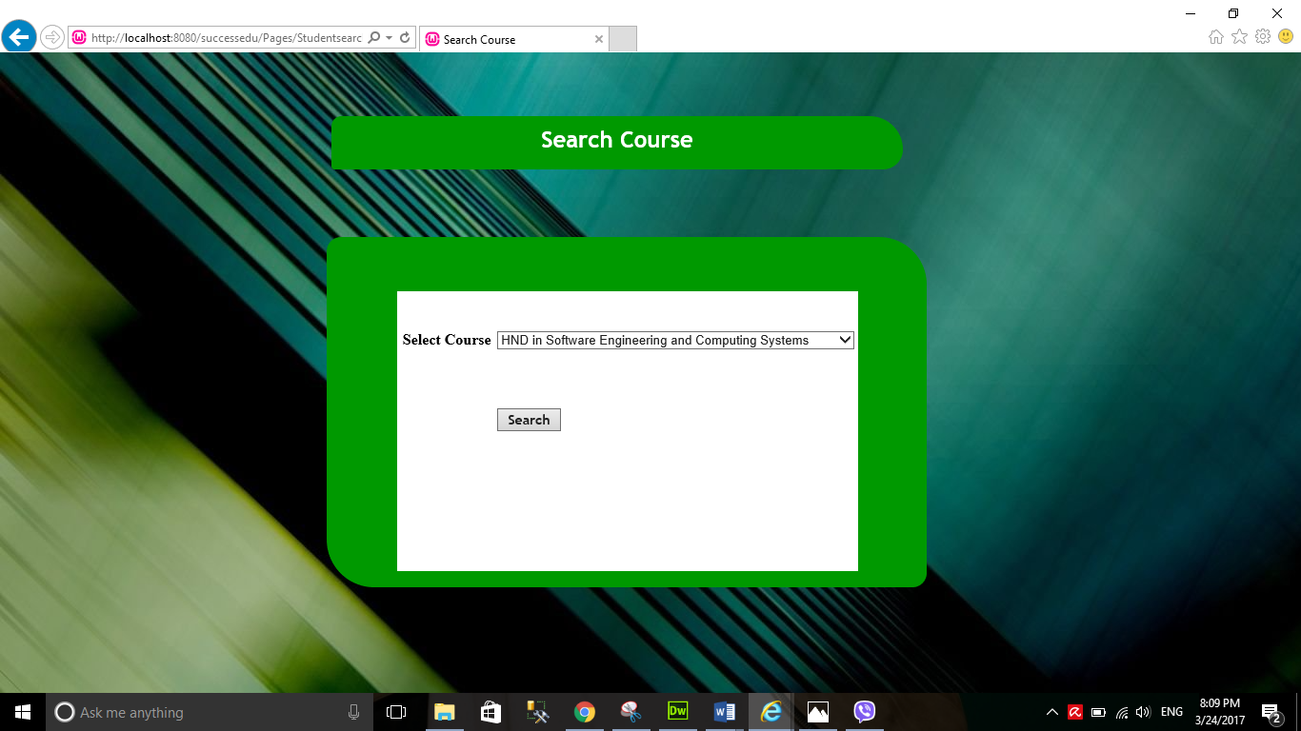Below image shows the course details search page. In here user have to select a course name and click to find course details.

Figure 110 - Search Course Details

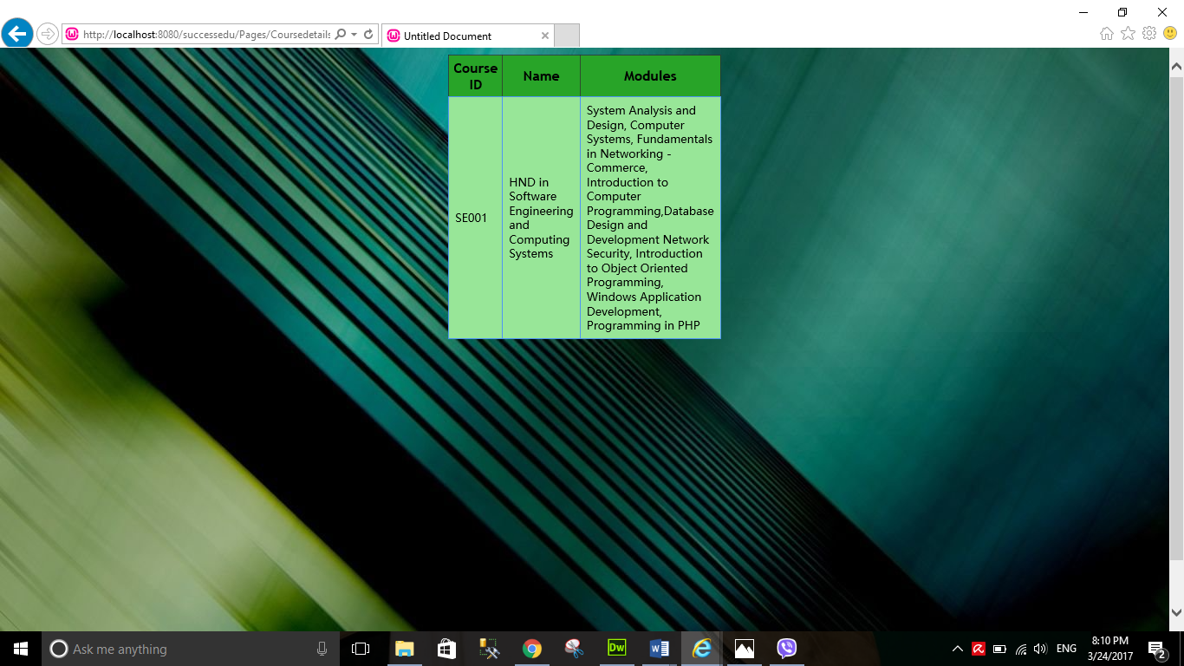Below image shows the result after you select the course name. You can see the courses with the full details.

Figure 111 - Course Details

# Task 06



## System Testing

System testing means testing each and every component of the system whether the expected output is received or not when giving the input to the system Before implementing this system to the Success EDU institute it is needed to be tested. There are three different types of system testing.

1. Black Box Testing
2. White box testing
3. Grey box testing
4. **Black Box Testing**

In Black box testing we examine whether the system has achieved the user’s requirements. In here we check the interface of the application, performance errors and check whether we get the expected output from the application when data inserted. This technique is very easy to follow because we are not testing the interior parts of the system. We check only the exterior parts. Also programming language knowledge isn’t necessary in here. We can start the test case too quickly.

1. **White Box Testing**

In white box testing we test the interior part of the system like examining the codes, design, conditions. This testing technique is more through because of this. For this testing the interface isn’t needed.

1. **Grey Box Testing**

Grey box testing is a combination of white box and black box testing. In here the tester knows only the interior part to some extent only

So among these three testing techniques we have to choose a one for our application to test. When we consider about black box testing technique, we have to test only the exterior part of the application. Also its easy to start and we can start test cases too, programming knowledge isn’t required for this. But in white box testing, we have to test only the interior part of the application. We need the programming knowledge for this and we have to examine the code, interior structure and design error handlings etc.... So it takes time when doing this type of testing. Grey box testing is a combination of both black box and white box testing. Though it’s a hybrid of both the techniques the tester can’t get access to test the source code. Therefore, by comparing these three techniques the leaner chooses Black Box Testing for this application. It is because, as mentioned before this technique is easy and we can start the test case too and many other benefits mentioned above.

## Test Case

“A test case is a set of conditions or variables under which a tester will determine whether a system under test satisfies requirements or works correctly. The process of developing test cases can also help find problems in the requirements or design of an application.” (Software Testing Fundamentals, 2016)

|  |  |  |  |  |
| --- | --- | --- | --- | --- |
| **Test Description** | **Changes made** | **Expected Result** | **Actual Result** | **Pass / Fail** |
| Administrator Log into the system | Enter a valid username and password | Login successful and opens the administrator main page. | Login successful and opened the administrator main page. | Pass |
| Administrator Log into the system | Enter a invalid username or password | Display the Error message and system will not open the administrator main page | Display the Error message and system will not open the administrator main page | Pass |
| Student log into the system | Enter a valid username and password | Login successful and open the student main page. | Login successful and open the student main page. | Pass |
| A student log into the system | Enter an invalid username and password | Error message and system will not open the student main page | Error message and system will not open the student main page | Pass |

Table 1 - Test Case 1

|  |  |  |  |  |
| --- | --- | --- | --- | --- |
| **Test Description** | **Changes made** | **Expected Result** | **Actual Result** | **Pass / Fail** |
| Create a new student | Enter a valid details and click add | Displayed a message “One student record added” | Displayed a message “One student record added” | Pass |
| Create a new student | Enter an invalid details and click “Add” | Displayed an error message. | Displayed an error message | Pass |
| Update Student | Search a course from search page, Click Manage Student, Update values and click “Update” | Displayed a message “One Student record updated ” | Displayed a message “One Student record updated ” | Pass |
| Delete Student | Search a course from search page, Click Manage Student, Update values and click “Delete” | Displayed a message “One student record deleted” | Displayed a message “One student record added” | Pass |
| Add new course | Enter an valid details and click “Add” | Displayed a message “One course record updated” message. | Displayed a message “One course record updated” message. | Pass |
| Search course | Select course with invalid details from the combo box and click button. | No results came | No results came | Pass |
| Update Course | Search a course from search page, Click Manage Student, Update values and click “Update” | Displayed a message “One Student record updated ” | Displayed a message “One Student record updated ” | Pass |
| Delete Course | Displayed a message “One course record updated” message. | Displayed a message “One course record deleted” | Displayed a message “One course record added” |  |

Table 2 - Test Case 2

|  |  |  |  |  |
| --- | --- | --- | --- | --- |
| **Test Description** | **Changes made** | **Expected Result** | **Actual Result** | **Pass / Fail** |
| Add new batch | Enter an valid details and click “Add” | Displayed a message “One batch record updated” message. | Displayed a message “One batch record updated” message. | Pass |
| Add new batch | Enter an invalid details and click “Add | Displayed an error message | Displayed error message | Pass |
| Update Batch | Search a course from search page, Click Manage Batch, Update values and click “Update” | Displayed a message “One Batch record updated ” | Displayed a message “One Batch record updated ” | Pass |
| Delete Batch | Displayed a message “One batch record deleted” message. | Displayed a message “One batch record deleted” | Displayed a message “One batch record deleted” | Pass |

Table - Test Case 3

|  |  |  |  |  |
| --- | --- | --- | --- | --- |
| **Test Description** | **Changes made** | **Expected Result** | **Actual Result** | **Pass / Fail** |
| Add new Assignment (Administrator) | Enter valid details and click “Add” | Displayed a message “One assignment added successfully” message. | Displayed a message “One assignment assed successfully” message. | Pass |
| Add new assignment | Enter an invalid details and click “Add | Displayed an error message | Displayed error message | Pass |
| Assignment Update | Search a course from search page, Click Manage Assignments “Update values and click “Update” | Displayed a message “One assignment record updated ” | Displayed a message “One assignment record updated ” | Pass |
| Delete Assignment | Displayed a message “One assignment record deleted” message. | Displayed a message “One assignment record deleted” | Displayed a message “One assignment record deleted” | Pass |

Table 4 - Test Case 4

|  |  |  |  |  |
| --- | --- | --- | --- | --- |
| **Test Description** | **Changes made** | **Expected Result** | **Actual Result** | **Pass / Fail** |
| Assignment Schedules(Download Assignments) | Click download link and select the assignment and download | Assignment Download Successfully. | Assignment Downloaded Successfully. | Pass |
| Assignment Submission | Select the assignment, upload the file and click the “Add” button to download | Assignment Upload Successfully | Assignment Uploaded Successfully | Pass |
| Course Details | Select the course from the combo box and click button. | Course Details show | Course Details shown | Pass |

Table 5 - Test Case 5



## Actual Test Results

|  |  |  |  |  |
| --- | --- | --- | --- | --- |
| **Test Description** | **Changes made** | **Expected Result** | **Actual Result** | **Pass / Fail** |
| Administrator Log into the system | Enter a valid username and password | Login successful and opens the administrator main page. | Login successful and opened the administrator main page. | Pass |
| Administrator Log into the system | Enter an invalid username or password | Display the Error message and system will not open the administrator main page | Display the Error message and system will not open the administrator main page | Pass |

**Actual Result after entering valid Login details**



**Actual Result after entering invalid Login details**

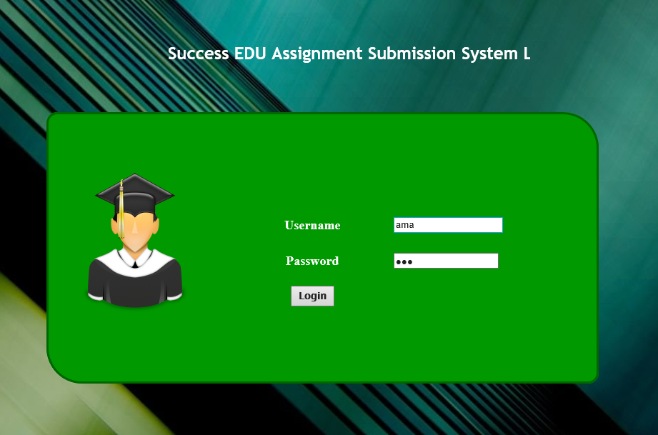



|  |  |  |  |  |
| --- | --- | --- | --- | --- |
| **Test Description** | **Changes made** | **Expected Result** | **Actual Result** | **Pass / Fail** |
| Student log into the system | Enter a valid username and password | Login successful and open the student main page. | Login successful and open the student main page. | Pass |
| A student log into the system | Enter an invalid username and password | Error message and system will not open the student main page | Error message and system will not open the student main page | Pass |

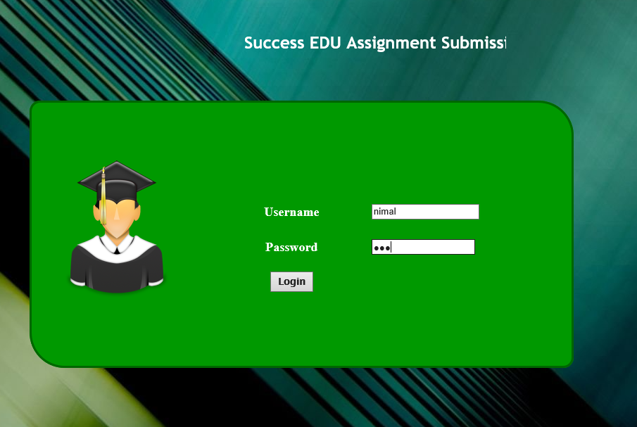**Actual Result after entering valid Login details**



**Actual Result after entering invalid Login details**

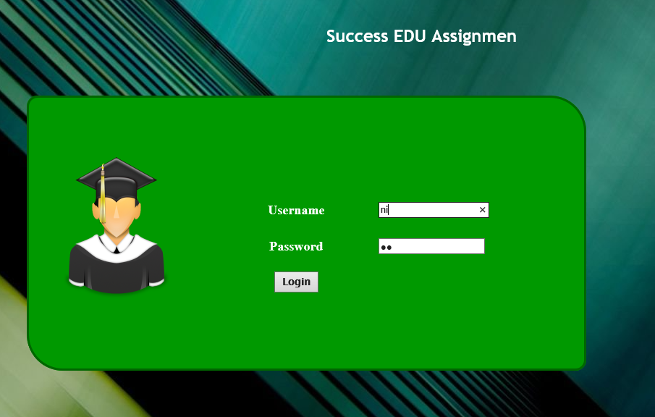



|  |  |  |  |  |
| --- | --- | --- | --- | --- |
| **Test Description** | **Changes made** | **Expected Result** | **Actual Result** | **Pass / Fail** |

|  |  |  |  |  |
| --- | --- | --- | --- | --- |
| Create a new student | Enter a valid details and click add | Displayed a message “One student record added” | Displayed a message “One student record added” | Pass |
| Create a new student | Enter an invalid details and click “Add” | Displayed an error message. | Displayed an error message | Pass |

 **Actual Result after entering valid Student details**



**Actual Result after entering invalid Student details**

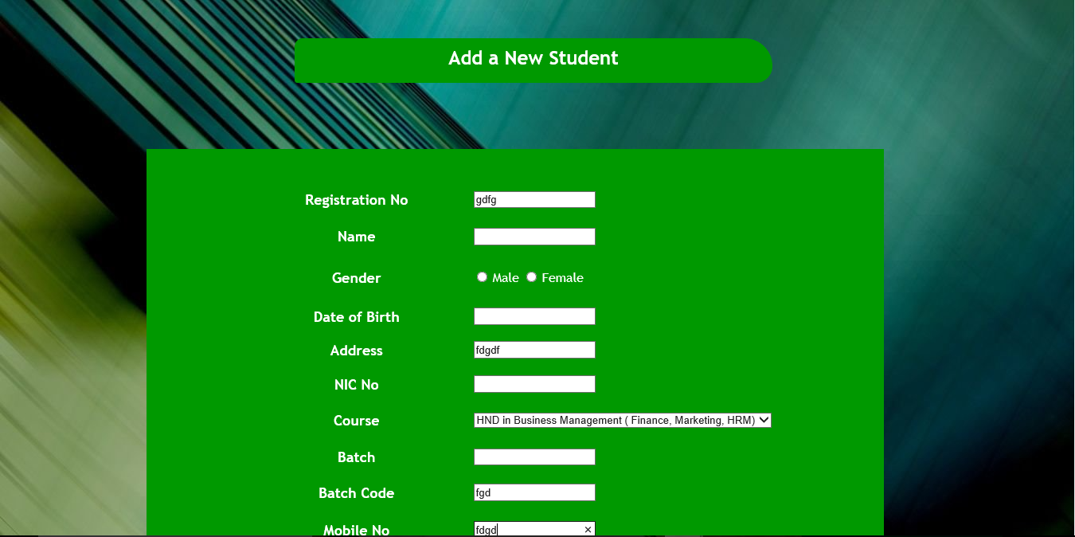

|  |  |  |  |  |
| --- | --- | --- | --- | --- |
| **Test Description** | **Changes made** | **Expected Result** | **Actual Result** | **Pass / Fail** |

|  |  |  |  |  |
| --- | --- | --- | --- | --- |
| Update Student | Search a course from search page, Click Manage Student, Update values and click “Update” | Displayed a message “One Student record updated ” | Displayed a message “One Student record updated ” | Pass |

**Actual Result after updating Student details**

|  |  |  |  |  |
| --- | --- | --- | --- | --- |
| Delete Student | Search a course from search page, Click Manage Student, Update values and click “Delete” | Displayed a message “One student record deleted” | Displayed a message “One student record added” | Pass |

|  |  |  |  |  |
| --- | --- | --- | --- | --- |
| Delete Student | Search a course from search page, Click Manage Student, Update values and click “Delete” | Displayed a message “One student record deleted” | Displayed a message “One student record added” | Pass |

|  |  |  |  |  |
| --- | --- | --- | --- | --- |
| Delete Student | Search a course from search page, Click Manage Student, Update values and click “Delete” | Displayed a message “One student record deleted” | Displayed a message “One student record added” | Pass |



|  |  |  |  |  |
| --- | --- | --- | --- | --- |
| **Test Description** | **Changes made** | **Expected Result** | **Actual Result** | **Pass / Fail** |

|  |  |  |  |  |
| --- | --- | --- | --- | --- |
| Delete Student | Search a course from search page, Click Manage Student, Update values and click “Delete” | Displayed a message “One student record deleted” | Displayed a message “One student record added” | Pass |

**Actual Result after updating Student details**

**Actual Result after updating Student details**



|  |  |  |  |  |
| --- | --- | --- | --- | --- |
| **Test Description** | **Changes made** | **Expected Result** | **Actual Result** | **Pass / Fail** |

|  |  |  |  |  |
| --- | --- | --- | --- | --- |
| Add new course | Enter an valid details and click “Add” | Displayed a message “One course record added” message. | Displayed a message “One course record added” message. | Pass |
| Add new course | Enter an invalid details and click “Add” | Displayed an error message. | Displayed an error message | Pass |

**Actual Result after Adding New Course**





**Actual Result after Adding New Course** **with invalid details**

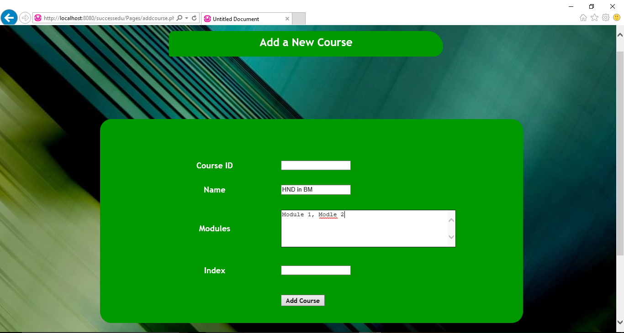

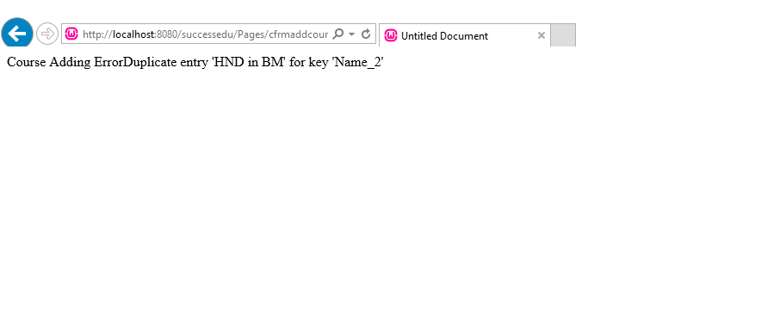

|  |  |  |  |  |
| --- | --- | --- | --- | --- |
| Update Student | Search a course from search page, Click Manage Student, Update values and click “Update” | Displayed a message “One Student record updated ” | Displayed a message “One Student record updated ” | Pass |

|  |  |  |  |  |
| --- | --- | --- | --- | --- |
| **Test Description** | **Changes made** | **Expected Result** | **Actual Result** | **Pass / Fail** |

**Actual Result after Updating Course** 



**Actual Result after Deleting Course**

|  |  |  |  |  |
| --- | --- | --- | --- | --- |
| **Test Description** | **Changes made** | **Expected Result** | **Actual Result** | **Pass / Fail** |

|  |  |  |  |  |
| --- | --- | --- | --- | --- |
| Delete Course | Displayed a message “One course record updated” message. | Displayed a message “One course record deleted” | Displayed a message “One course record added” |  |



|  |  |  |  |  |
| --- | --- | --- | --- | --- |
| **Test Description** | **Changes made** | **Expected Result** | **Actual Result** | **Pass / Fail** |
| Add new batch | Enter an valid details and click “Add” | Displayed a message “One batch record updated” message. | Displayed a message “One batch record updated” message. | Pass |
| Add new batch | Enter an invalid details and click “Add | Displayed an error message | Displayed error message | Pass |

**Actual Result after Adding new batch**





**Actual Result after Adding new batch with invalid details**



|  |  |  |  |  |
| --- | --- | --- | --- | --- |
| Update Batch | Search a course from search page, Click Manage Batch, Update values and click “Update” | Displayed a message “One Batch record updated ” | Displayed a message “One Batch record updated ” | Pass |

|  |  |  |  |  |
| --- | --- | --- | --- | --- |
| **Test Description** | **Changes made** | **Expected Result** | **Actual Result** | **Pass / Fail** |

**Actual Result after updating batch**



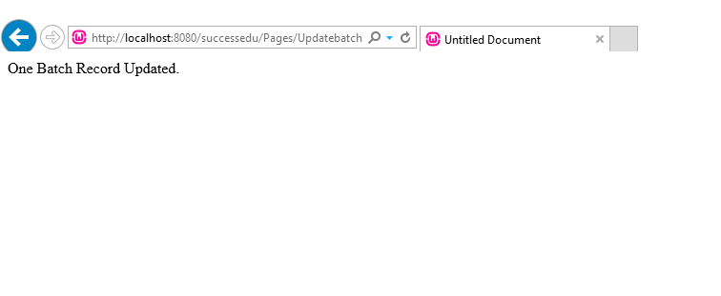

|  |  |  |  |  |
| --- | --- | --- | --- | --- |
| **Test Description** | **Changes made** | **Expected Result** | **Actual Result** | **Pass / Fail** |

|  |  |  |  |  |
| --- | --- | --- | --- | --- |
| Delete Batch | Displayed a message “One batch record deleted” message. | Displayed a message “One batch record deleted” | Displayed a message “One batch record deleted” | Pass |

**Actual Result after deleting batch**



|  |  |  |  |  |
| --- | --- | --- | --- | --- |
| **Test Description** | **Changes made** | **Expected Result** | **Actual Result** | **Pass / Fail** |
| Add new Assignment (Administrator) | Enter valid details and click “Add” | Displayed a message “One assignment added successfully” message. | Displayed a message “One assignment assed successfully” message. | Pass |
| Add new assignment | Enter an invalid details and click “Add | Displayed an error message | Displayed error message | Pass |

**Actual Result adding new assignment**





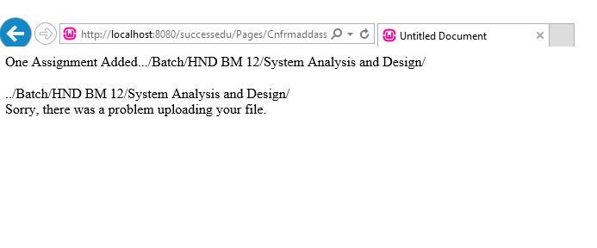**Actual Result adding new assignment with invalid details**

|  |  |  |  |  |
| --- | --- | --- | --- | --- |
| Assignment Update | Search a course from search page, Click Manage Assignments “Update values and click “Update” | Displayed a message “One assignment record updated ” | Displayed a message “One assignment record updated ” | Pass |
| Delete Assignment | Displayed a message “One assignment record deleted” message. | Displayed a message “One assignment record deleted” | Displayed a message “One assignment record deleted” | Pass |

|  |  |  |  |  |
| --- | --- | --- | --- | --- |
| **Test Description** | **Changes made** | **Expected Result** | **Actual Result** | **Pass / Fail** |

**Actual Result updating assignment**



**Actual Result after deleting assignment**



|  |  |  |  |  |
| --- | --- | --- | --- | --- |
| **Test Description** | **Changes made** | **Expected Result** | **Actual Result** | **Pass / Fail** |
| Assignment Schedules(Download Assignments) | Click download link and select the assignment and download | Assignment Download Successfully. | Assignment Downloaded Successfully. | Pass |

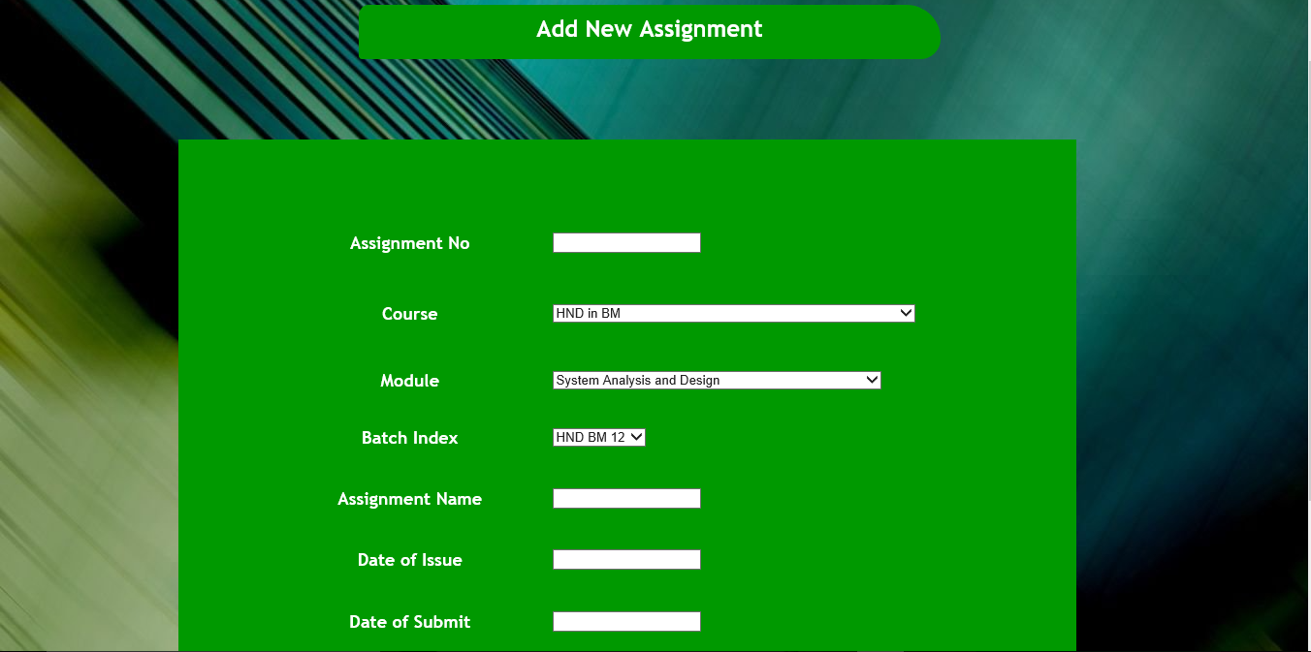**Actual Result after Assignment downloading.**



|  |  |  |  |  |
| --- | --- | --- | --- | --- |
| Assignment Submission | Select the assignment, upload the file and click the “Add” button to download | Assignment Upload Successfully | Assignment Uploaded Successfully | Pass |

|  |  |  |  |  |
| --- | --- | --- | --- | --- |
| **Test Description** | **Changes made** | **Expected Result** | **Actual Result** | **Pass / Fail** |



**Actual Result after Assignment Submission.**



|  |  |  |  |  |
| --- | --- | --- | --- | --- |
| **Test Description** | **Changes made** | **Expected Result** | **Actual Result** | **Pass / Fail** |

|  |  |  |  |  |
| --- | --- | --- | --- | --- |
| Course Details | Select the course from the combo box and click button. | Course Details show | Course Details shown | Pass |

**Actual Result after Course Details Search**



# Task 07



## User Manual

**SUCCESS EDU ONLINE ASSIGNMENT SUBMISSION SYSTEM**

**USER MANUAL**

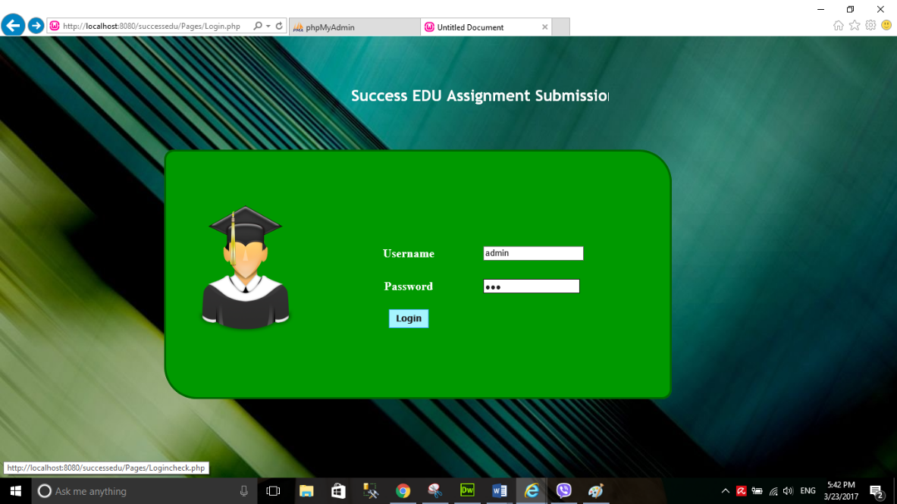

# How to Login into the system?

* Enter valid username and password.
* Click “Login”.



# For Administrator Users



## How to Add New Student?

* Select **“Add a New Student”** in the Administrator main page

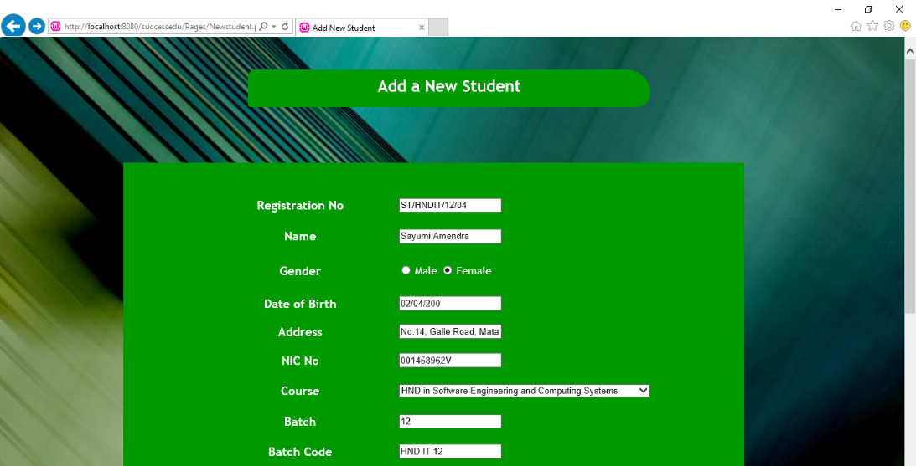

* Add necessary Student details and click “Add”.



## How to Update, Delete and Search Student?

* Select **“Manage Students”** in the Administrator main page



* After you have arrived to the Search Student page, select a course from the combo box to proceed.



* Now you have got the records like this in a table. To update and delete, there’s a button right side name “**Manage Student**” Click that button to proceed



* The student details are set into the text boxes. Now you can update the details. If you’re done, click “Update”. To delete record just click “Delete”



## How to Add New Course?

* Select **“Add New Course”** in the Administrator main page



* Add necessary Course details and click “Add”.
* Select **“Manage Courses”** in the Administrator main page



## How to Search, Update and Delete Course?



* After you have arrived to the Search Course page, select a course from the combo box to proceed.



* Now you have got the records like this in a table. To update and delete, there’s a button right side name “**Manage Course**” Click that button to proceed.



* The course details are set into the text boxes. Now you can update the details. If you’re done, click “Update”. To delete record just click “Delete”



## How to Add New Batch?

* Select **“Add New Batch”** in the Administrator main page



* Add necessary Batch details and click “Add”.



## How to Update, Delete and Search Batch?

* Select **“Manage Batch”** in the Administrator main page



* After you have arrived to the Search Batch page, select a course from the combo box to proceed.



* Now you have got the records like this in a table. To update and delete, there’s a button right side name “**Manage Batch**” Click that button to proceed.



* The batch details are set into the text boxes. Now you can update the details. If you’re done, click “Update”. To delete record just click “Delete”



## How to Add New Assignment?

* Select **“Add a New Assignment”** in the Administrator main page



* Add necessary Assignment details and upload the file. Then click “Add Assignment”.





## How to Update, Delete and Search Assignment?

* Select **“Manage Assignments”** in the Administrator main page



* After you have arrived to the Search Assignment page, select a course from the combo box to proceed.



* Now you have got the records like this in a table. To update and delete, there’s a button right side name “**Manage Assignment**” Click that button to proceed.



* The assignment details are set into the text boxes. Now you can update the details. If you’re done, click “Update”. To delete record just click “Delete”



# For Student



## How to view your profile details?

* Select **“Student Profile”** in the Administrator main page





#### How to submit assignments?

* Select **“Assignment Submission”** in the Student Main Page



* Select the relevant Batch Index to continue in Search page.



* Select the relevant assignment that needs to be submitted by clicking “Submit” link.



* Enter Student NIC number, name and upload your file to submit. After that your assignment would be submitted.





#### How to view course details?

* Select **“Course Details”** in the Student main page

## Conclusion

Now we have developed an online assignment submission system for the Success EDU education institute. We think that we have developed a successful system for them. To develop it we used HTML, PHP, JavaScript and CSS. We used WampServer as our web server software to test the web pages and Adobe Dreamweaver as the IDE to develop interfaces of the system. Before developing the system first we compared different server scripting languages and selected PHP as the suitable language for the system. Next we compared different web servers and selected Wampserver as the web server software. Then we recorded user’s requirements by creating requirement specification document. Next we designed our database using ERD and Normalized Relational Schema and designed our system using Use Case and Sequence Diagrams.

After that we implemented a database driven web application system based on the designs. We add screenshots of the codes and described how web application is coded. Next we demonstrated the developed system by adding screenshots of the interfaces and describing how the system functions. After demonstration, we tested the whole system using test cases and showed the actual test results. Finally, we created a user manual for the institute, showing how to use the system easily.

After considering all these points, we conclude that we have built up a good online assignment submission system for the Success EDU education institute.

## Recommendation

So finally we have developed a good online assignment submission system for the success EDU education institute. Now in this section, the learner would like to recommend some features to increase the quality of the system. The system shows messages just in a new page with plain text. So when the message is displayed user has to always press back button to go back to the previous page. As a solution for this we can use message boxes to display messages. We can display message boxes using JavaScript language. Also we can provide students to upload profile photos to the system which can also improve the quality of the system.

We can develop the user interfaces of this system more with features like animations, sounds, slideshows etc. so it will have good graphical user interface. Also users get attract to the system’s good user interface. To increase more security of the system, we can add a firewall to the system to avoid attacks for the web application.

So, following these recommendations we can increase the quality of the system. Not only these features we can add loads of other features to improve its quality.

## Gantt Chart

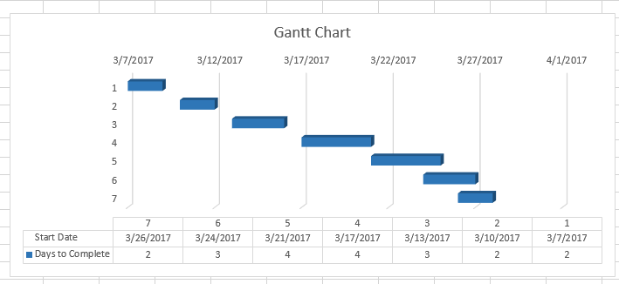



## References

Wodehouse, C. (2017). *Server-Side Scripting Languages - PHP scripts, Back-End Coding*. [online] Hiring | Upwork. Available at: https://www.upwork.com/hiring/development/server-side-scripting-back-end-web-development-technology/ [Accessed 18 Mar. 2017].

Computerhope.com. (2017). *What is server-side scripting?*. [online] Available at: http://www.computerhope.com/jargon/s/server-side-scripting.htm [Accessed 18 Mar. 2017].

Eliteinfoworld.com. (2017). *Top 10 Benefits of Using PHP in Web Development*. [online] Available at: http://www.eliteinfoworld.com/blog/top-10-benefits-using-php-web-development/ [Accessed 19 Mar. 2017].

Rouse, M. (2017). *What is Python? - Definition from WhatIs.com*. [online] Search Enterprise Linux. Available at: http://searchenterpriselinux.techtarget.com/definition/Python [Accessed 20 Mar. 2017].

www.tutorialspoint.com. (2017). *Python Overview*. [online] Available at: https://www.tutorialspoint.com/python/python_overview.htm [Accessed 20 Mar. 2017].

Rouse, M. (2017). *Web server*. [online] Whatis.techtarget.com. Available at: http://whatis.techtarget.com/definition/Web-server [Accessed 20 Mar. 2017].

Ward, J. (2017). *Web Server Features and Its Role in Web Hosting*. [online] Slideshare.net. Available at: https://www.slideshare.net/JohnWard23/web-server-features-and-its-role-in-web-hosting [Accessed 20 Mar. 2017].

Techopedia.com. (2017). *What is Apache Web Server? - Definition from Techopedia*. [online] Available at: https://www.techopedia.com/definition/4851/apache-web-server [Accessed 21 Mar. 2017].

Webopedia.com. (2017). *What is Apache Web Server? Webopedia Definition*. [online] Available at: http://www.webopedia.com/TERM/A/Apache_Web_server.html [Accessed 21 Mar. 2017].

FastWebHost India - Web Hosting Blog. (2017). *What is Web Server and Different Types of Web Servers?*. [online] Available at: http://www.fastwebhost.in/blog/what-is-web-servers-different-types-of-web-servers/ [Accessed 21 Mar. 2017].

Lunarpages. (2017). *How To Choose the Right Web Server – Which Server is Better Apache or IIS | nullLunarpages Web Hosting*. [online] Available at: https://lunarpages.com/apache-vs-iis-which-web-server-should-you-choose/ [Accessed 21 Mar. 2017].

Techterms.com. (2013). *WAMP (Windows, Apache, MySQL, and PHP) Definition*. [online] Available at: https://techterms.com/definition/wamp [Accessed 21 Mar. 2017].

Techopedia.com. (2017). *What is Windows/Apache/MySQL/PHP, Python, PERL (WAMP)? - Definition from Techopedia*. [online] Available at: https://www.techopedia.com/definition/4935/windowsapachemysqlphp-python-perl-wamp [Accessed 21 Mar. 2017].

Webopedia.com. (2017). *What is WAMP? Webopedia Definition*. [online] Available at: http://www.webopedia.com/TERM/W/WAMP.html [Accessed 21 Mar. 2017].

Softwaretestingfundamentals.com. (2017). *Black Box Testing – Software Testing Fundamentals*. [online] Available at: http://softwaretestingfundamentals.com/black-box-testing/ [Accessed 25 Mar. 2017].